That is Not My Cat

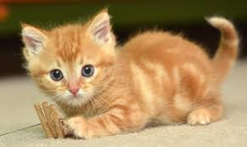

That is not my cat.
It is too big.

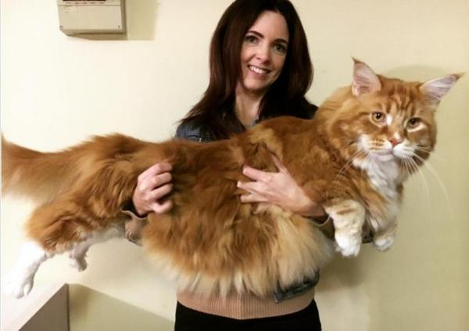
That is not my cat.
It is too little.

That is not my cat.
It is too rough.

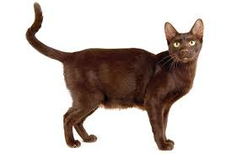
That is not my cat.
It’s tongue is too wet.
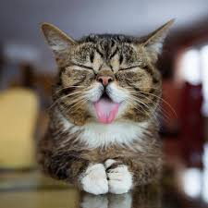
That is my cat.
It is very soft and cute.
