Name:
Date:

Reading Fluency: Airplanes

Fluency means being able to read a text quickly, accurately, and with expression. A fluent reader is better able to understand the text. Rereading and reading aloud is a good strategy for becoming a more fluent reader.
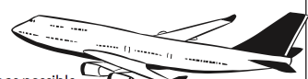

To practice reading fluently:
- Set a timer for one minute.
- Read the passage as quickly and accurately as possible.
- Mark the last word read when the timer goes off.
- Record the words per minute read in the chart at the bottom.

You have probably seen things flying in the sky. People saw birds flying in the air and wanted to do that. Humans made airplanes.

An airplane is able to fly through the air because it has an engine. The engine and wings help the plane stay in the air. A pilot controls it. A plane stays in the air even though there is gravity, the force that keeps us on earth.

Airplanes have many uses. Airplanes bring people from one place to another. The military uses airplanes to deliver people and goods. It uses airplanes to watch and protect people.

Word Count is 100.
To determine Words Per Minute, count the amount of correct words the student read in one minute. Record that number in the box.

Words Per Minute

1st Read
2nd Read
3rd Read

Education.com

