Germination: Planting Beans
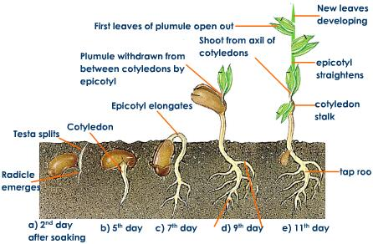

Planting MANY bean plants will address Life Science standards for most grade levels. Planting the bean seeds at intervals or for several days, will give ALL students the opportunity to observe the life cycle of a bean plant, the effects of environmental conditions on a plant, and similarities and differences in plants of the same species. Even when plants are grown on the same day, at the same time, and with the same variables, they will not all grow at the same rate or as well (in reference to height, number of leaves, flowers, and bearing fruit). Natural variations in growth provide opportunities for observation, discussion, and argument based on evidence. I have included teacher visual demonstrations for a class of varying degrees of visual abilities. Modeling the activity is a very important first step for all science lessons and for all students. When the teacher models the lesson while reviewing the procedure, any last minute changes can be made as needed by the classroom teacher as well as the T.V.I. (teacher of the visually impaired). If there are only one or two visually impaired students in the class, the T.V.I. should allow the student to feel each material as the teacher demonstrates and explains the procedure to the class. Ideally, the student’s T.V.I. will have a matching set of the materials. When additional materials are not available, the classroom teacher can pass the materials to the T.V.I., who will pass and explain or describe the materials to the student with visual impairments. The student does not need to complete the lesson at this time, just become familiar with the materials they will be using. Exposing the visually impaired student to the instructions and materials prior to a science activity, reduces confusion, reluctance and anxiety when encountering a new experience.

Safety Concerns:
Remind students not to put, any materials in their nose, ears, or mouth. Keep their hands away from their face until their hands are washed. Use “wafting” or open hand, technique to smell materials when given permission to smell.
Goggles or glasses may be used to prevent accidental eye injuries

Materials: Class of 20 students
- 30, 6 oz clear plastic cups for planting
- 5, 3 oz cups, to hold seeds
- 5, containers to hold gravel (2-4 liter)
- 5, containers to hold soil (6-8 liter)
- 5 lb bag of small gravel
- 4 lb bag of soil
- 5 Measuring spoons (tablespoons)
- 5 small Vials or cups (1 oz. or 30 ml)
- 5 containers to hold water (1 liter bottles)
- Stack of newspaper
- 5 trays
- 60 bean seeds (50 for students, and 10 for teacher demonstration)
- Water spray bottle
- Dated labels in braille, raised numbers and large print for each cup, dated the seeds are planted.
*Note: When working with students with visual impairments, using different size or shape containers for each material helps students follow directions with greater independence.

Teacher Preparation: prior to EACH class, for five days
- Place 2 seeds in each of five small cups (petri dishes work well)
- Place at least 5 cups of soil in each of 5 large containers.
- Place at least 10 Tbsp. of gravel in each of 5 medium containers
- Fill 5, bottles of water
- Organize the trays: each tray will have 1 plastic 6 oz. cup, a container of gravel, soil, and seeds, a bottle of water, a vial and a tablespoon.
- Cover the tables with newspapers, for easy clean up.
- Date the cups with labels.
- Note: A sixth tray could be prepared as the teacher’s demonstration tray, or the teacher could use one of the group trays and replace materials as needed.

MODEl: Demonstrate the “Student Planting Procedure” to the whole class.

Student Planting Procedure for each group:
- Place two tablespoons of gravel into the bottom of the plastic cup.
- Place four tablespoons of soil on top of the gravel.
- Place two bean seeds to the top of the soil.
- Place two tablespoons of soil on top of the seeds.
- Pour two vials of water on the soil.
- Place the planted seeds near a window.
- Observe plant growth over the next couple of weeks.
- Water with spray bottle daily.
*Note: Do not write student names or groups on the plants. This is a class/team project. Many students become upset or disappointed if “their” plant does not grow. Remind students; “Scientists usually work in groups or on teams.”

Teacher Preparation: Repeat the planting procedure every day for five days. There should be about 30 plants after five days. After two weeks, Teacher separates some of the plants from their soil. For each group, provide students with different germination stages, starting with youngest to oldest, or smallest to tallest. PURPOSELY select, 1. a seed with just a root, 2. a plant with leaves and seeds still attached, 3. a plant with roots, stem and leaves, 4. a longer plant with larger leaves.
Although these are different plants, the teacher is creating a live model for germination of a bean plant. This will allow the students to explore the changes a bean plant goes through during the growth process.

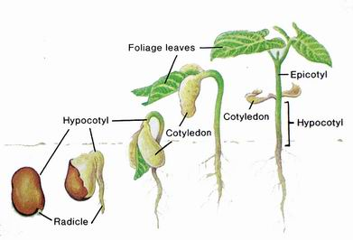

Modified Procedures and Connections:
- Set up a planting station or activity center. Have a different group plant five plants each day for five days.
- Assign jobs for each student in each group, every day, for five days. One student measures gravel, one student measures soil, one student places seeds and one student measures and pours water (based on skills and abilities).
- Have students replant the seedlings in larger containers or a school garden and continue to observe until fruit grows and harvest the seeds.
- Each day place one or two plants in a cardboard box and compare plants growing with “Sun” to plants growing with “No Sun” conditions.
- Each day, plant seeds with “No Water” and compare their growth to the plants “With Water” conditions.

http://www.enchantedlearning.com/subjects/plants/books/sproutingbean/
http://archive.fossweb.com/modulesK-2/NewPlants/frameset.php?page=teacher_videos.html

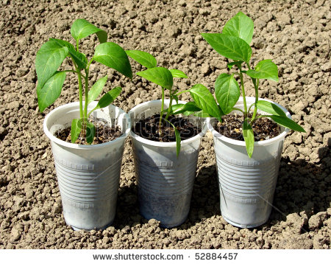

NGSS: Elementary School
PreK-LS1-1(MA). Compare, using descriptions and drawings, the external body parts of animals (including humans) and plants and explain functions of some of the observable body parts.
PreK-LS1-2(MA). Recognize that all plants and animals grow and change over time.
PreK-LS2-1(MA). Use evidence from animals and plants to define several characteristics of living things that distinguish them from non-living things.
K-LS1-1. Observe and communicate that animals (including humans) and plants need food, water, and air to survive. Animals get food from plants or other animals. Plants make their own food and need light to live and grow.
K-LS1-2(MA). Recognize that all plants and animals have a life cycle: a. most plants begin as seeds, develop and grow, make more seeds, and die; and b. animals are born, develop and grow, produce young, and die.
1-LS1-1. Use evidence to explain that: a. different animals use their body parts and senses in different ways to see, hear, grasp objects, protect themselves, move from place to place, and seek, find, and take in food, water and air; and b. plants have roots, stems, leaves, flowers and fruits that are used to take in nutrients, water and air, produce food (sugar), and make new plants.
1-LS3-1. Use information from observations (first-hand and from media) to identify similarities and differences among individual plants or animals of the same kind.
3-LS3-1. Provide evidence, including through the analysis of data, that plants and animals have traits inherited from parents and that variation of these traits exist in a group of similar organisms.
3-LS3-2. Distinguish between inherited characteristics and those characteristics that result from a direct interaction with the environment. Give examples of characteristics of living organisms that are influenced by both inheritance and the environment.
4-LS1-1. Construct an argument that animals and plants have internal and external structures that support their survival, growth, behavior, and reproduction.
5-LS1-1. Support an argument with evidence that plants get the materials they need for growth and reproduction chiefly through a process in which they use air, water, and energy from the sun to produce sugars and plant materials .

