How can I earn CEU credit?

Two credits may be awarded for the successful Paths to Technology post submission. You will need to be logged in as a registered user. We encourage you to submit technology ideas that you have developed, teaching strategies, student activities, how you use an app/device with accessibility features, how you uniquely use an app to teach a concept for a student who is visually impaired/ blind, information about software/app updates, and digital resource materials that you have created. Let us know if you have questions or need help.

Image: Example of a post with the title, first sentence description of post and image associated with the post.
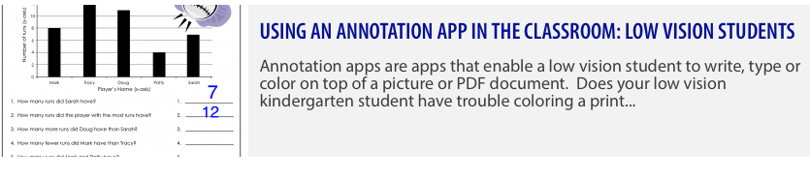

What should be included in each strategy or activity?

Each activity should include a title, description, one-sentence blurb that summarizes the post, procedure, adaptations, and a photo. If appropriate, include the device used, software/apps used, version of software, if the software/app is accessible with a screen reader, the accessibility features used and specific commands used in each step of the procedure. All videos should verbalize the commands and what is happening in the video. Additional photos, links to video or a URL may also be included, but are not required. Photos from copyrighted protected sources should not be used. The post must be relevant to technology used by students who are visually impaired or blind, from birth to 22 years of age. It must be original, show original modifications for students with visual impairments or multiple disabilities or provide instruction on accessibility features. In order to receive credit, the following rubric explains the criteria that must be met:

Criteria | Unsatisfactory | Satisfactory | Exemplary
Demonstrates knowledge and understanding of content and applicability to professional practice | Post does not demonstrate knowledge and understanding of content and applicability to professional practice (e.g. not clearly related to technology and students with VIB) | Post demonstrates some evidence of knowledge and understanding of content and applicability to professional practice | Post demonstrates clear evidence of knowledge and understanding of content and applicability to professional practice
1. Demonstrates creative solutions/applications or ideas through original activities, materials, or comments; or, 2. Post clearly demonstrates the technology, device, software/app or accessibility features through step-by-step instructions. | 1. Does not demonstrate creative solutions/applications or ideas through original activities, materials, or comments; or, 2. Post does not clearly demonstrates the technology, device, software/app or accessibility features through step-by-step instructions (e.g. duplicates existing content; steps/ commands are missing or unclear; or post is using outdated software/updates) | 1. Demonstrates some creative solutions/applications or ideas through original activities, materials, or comments; or, 2. Post demonstrates some of the defined goals of the post | 1. Demonstrates creative solutions/applications or ideas through original activities, materials, or comments; or, 2. Post clearly demonstrates the technology, device, software/app or accessibility features through step-by-step instructions
Completes all fields of the template and successfully uploads to site | Not all fields are completed or uploaded | All fields are completed and uploaded | All fields are completed and uploaded with optional fields as well (URL, video and/or embedded images)

Do I need permission to use photos/videos of students?

Yes, for any photo showing a student, you need to have a release form signed by the student's family, then scanned and uploaded with the post or emailed back to us at technology@perkins.org.

Link to Perkins media release.

What kind of credit will I receive?

You will receive two (2) Continuing Education Credits in the form of a certificate from Perkins. These can be used in many states and districts as part of the total number of credits needed for recertification, but you should check with your supervisor to find out if these will be recognized where you work.

How can I upload my activity to post it?

See Learn How to Share Your Ideas for step-by-step directions on the posting processes. For additional information on posting, including how to have posts appear in specific categories, go to How to Post on Paths to Technology.

Questions?

Contact us at technology@perkins.org

The credit is offered without charge in exchange for your contribution. It is estimated that each credit will take approximately two hours, which should allow time to organize the idea, create the post, and upload to the website. Perkins staff will evaluate the material to determine if all criteria have been met. Successful participants will receive a certificate in electronic format that they can then print out. Those who do not meet the criteria will receive email notification to that effect.

Posted materials will become the property of www.perkinselearning.org

