Making Inferences Using Pictures 2 Accessible Version
www.HaveFunTeaching.com

Description: Cartoon camera with the number Two in the center of the lens.

Graphics@Scrappin Doodles
www.HaveFunTeaching.com

After looking at this picture, I can infer that . . . (list four things).

Description: Smiling cartoon boy and girl sitting side-by-side cross-legged and holding one open book.

After looking at this picture, I can infer that . . . (list four things).

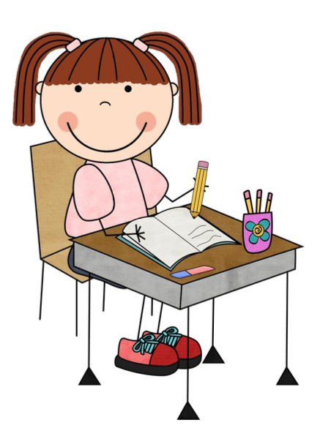
Description: Smiling cartoon girl in pigtails sitting at a desk with an open notebook, container filled with three pencils and eraser; the girl is holding a pencil and writing in the notebook.

- They are friends.
- They like to read.
- They are helping each other.
- They are happy.
- She is a student.
- She enjoys writing.
- She is prepared for class.
- She enjoys school.

www.HaveFunTeaching.com

