How to Post on Paths to Technology: Student

Register on Paths to Technology
- In order to share a comment or add a post, you must initially register on Paths to Technology. Your User Name will appear as the author of your post.
- Students should not use their last name.
- Your Paths to Technology registration is separate from Paths to Literacy – if you have already registered for Paths to Literacy, you will have to register again for Paths to Technology. You can choose to use the same User Name and password.
- To receive a once-a-week email notification about a new technology post, select Manage Your Notifications > Show Me My Options > select Paths to Technology.

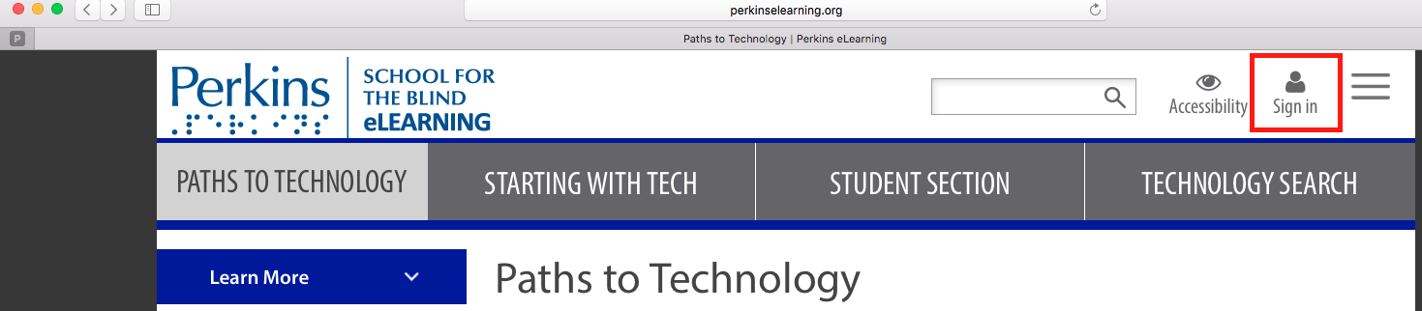

Sign in to Paths to Technology
You must be currently signed in on Paths to Technology in order to share a comment or add a post.

Add a Post - Student
If you are an adult, see How to Post on Paths to Technology: Adult.

Students: For written instructions on how to add a post, go to Learn How to Share your Ideas, located on the Paths to Technology Home page.

- Most student posts are added under Student Posts > Add Student Post; then, follow the directions under Learn How to Share Your Ideas.
- Select the appropriate boxes under Student Categories
- In order to appear on the Student page, all student posts should select the Student option under the Perspective category.
- If the post is about an app, select the appropriate boxes for iOS apps, Android apps and/or web-based apps.

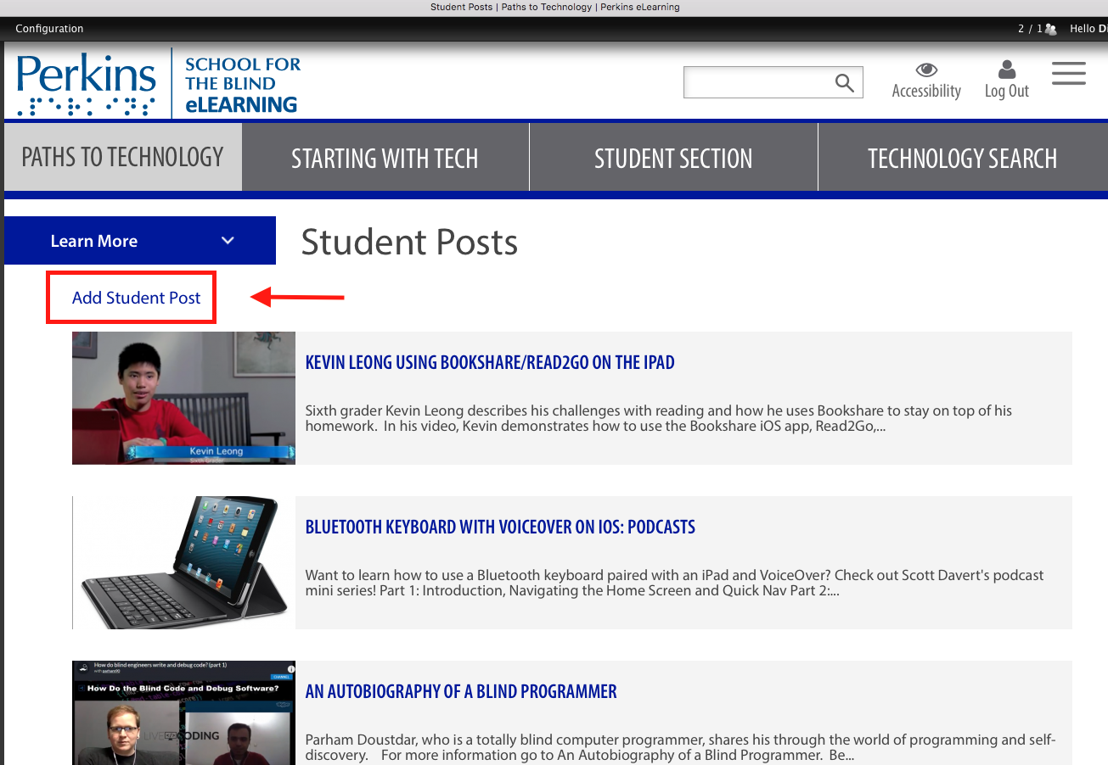

- Blog Posts appear in under Student Blog – these posts do NOT appear in the Student Posts block.
- If you are a confirmed student blogger, go to Student Blog > Add a Blog Post; then, follow the directions under Learn How to Share Your Ideas.To join a Student

Draft/Publish
While working on the post, you can save a draft version by scrolling to the bottom of the page and selecting Save As Draft. This will enable you to see what the post will look like before it is published on the website. Select the Edit tab to continue editing. When you have completed the post, select Publish.

Image
Each post should have an image associated with the post.

If using a picture or video of a student, you must upload the signed student media permission slip.

To add a Comment
Comments can be added to a specific post. You must be registered and currently signed-in to add a comment. Then, open the desired post and scroll to the bottom of the post. Type your comment in the Comment textbox and select Submit.

Q&A
You must first be registered and currently signed-in to add a question or an answer. Go to Q&A > Send Us Your Question!; then, follow the Learn How to Share Your Ideas instructions or simply type in the question and select Apply at the bottom of the screen.

To Answer a question, go to Q&A > select the desired question, type in your comment and select Submit.

Need help? Contact Technology@Perkins.org

