Creating an Accessible Table
Accessible Materials Workshop
By Diane Brauner
Posted on Paths to Technology

Steps to creating an accessible Table
- In the Ribbon, select Insert tab, then select Table.
- Select the number of rows and columns by highlighting the boxes on the grid.

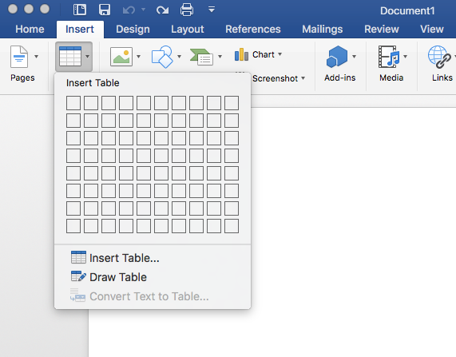

- Type in the table data.

- Title your table using the caption tool.
  - In the Ribbon, select References tab, then select Insert Caption.
  - In the popup window, type the title of the table in the Caption textbox.
  - In the Labe textbox, select Table. Then select OK.

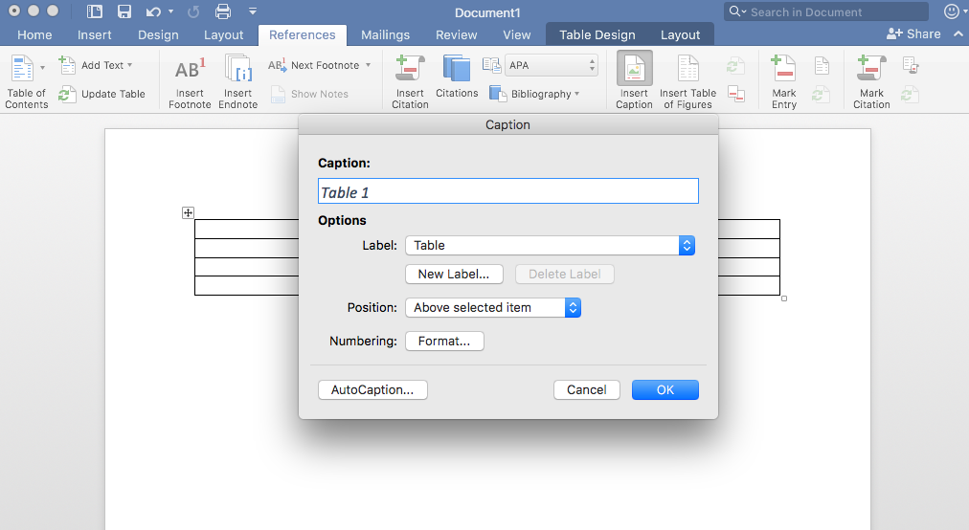

- Identify the Header Row
  - Select the top row of the table and right click.
  - Choose Table Properties.
  - In the popup window, select the Row Tab and check “Repeat as header row at the top of each page.” Then select OK.

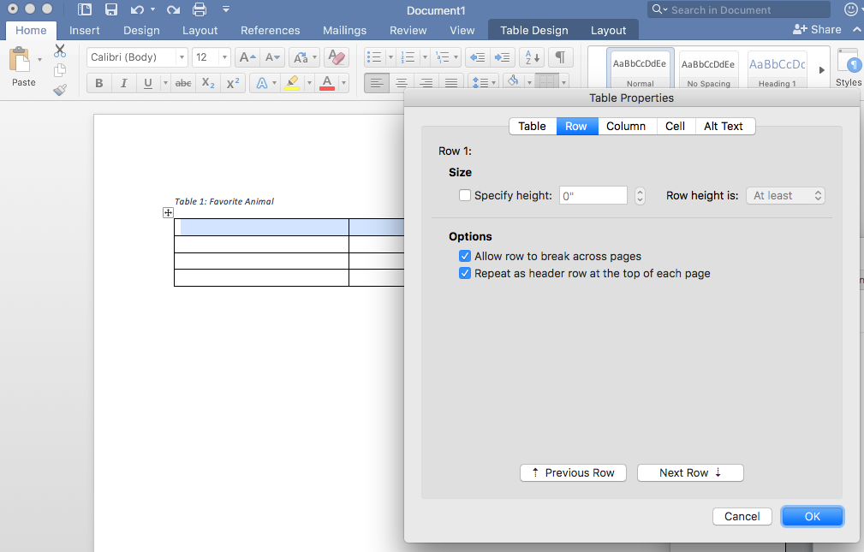

- Restrict the table to your page width.
  - Select the entire table and right click.
  - Choose Table Properties.
  - In the popup window, select the Row tab and uncheck “Allow rows to break across pages.”

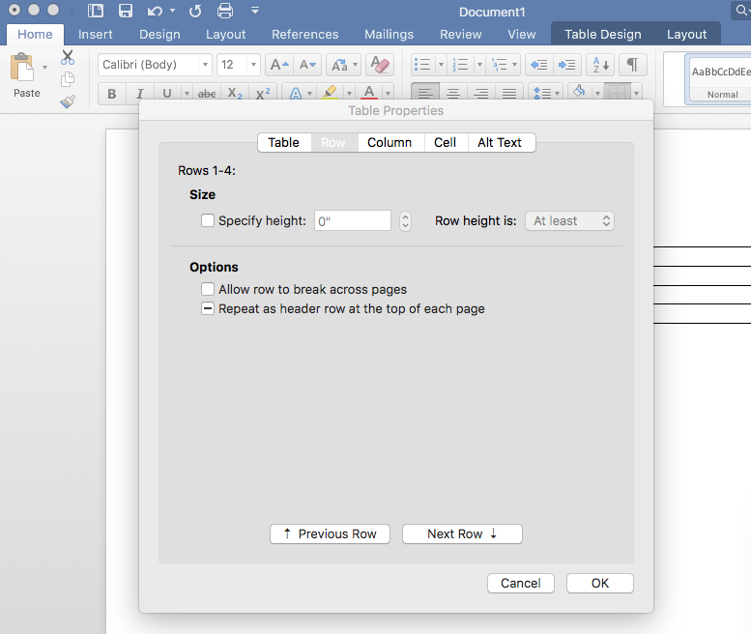

- Add Bookmark
  - Place cursor inside the first cell (A1).
  - In the ribbon, select the Insert tab, then select Bookmark.
  - In the Bookmark name textbox, type “Title” then the name of your table. Use underscores instead of spaces.

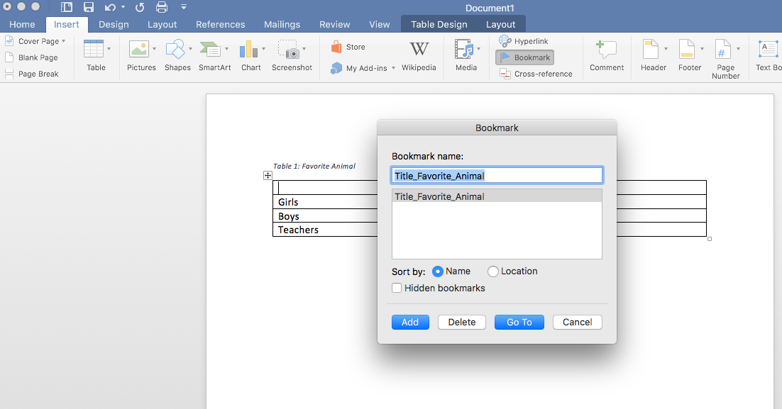

- Add Alt Tag description to Table
- Right click on the Table and select Table Properties.
- In the popup window, select Alt Text.
- Type in a description of your table

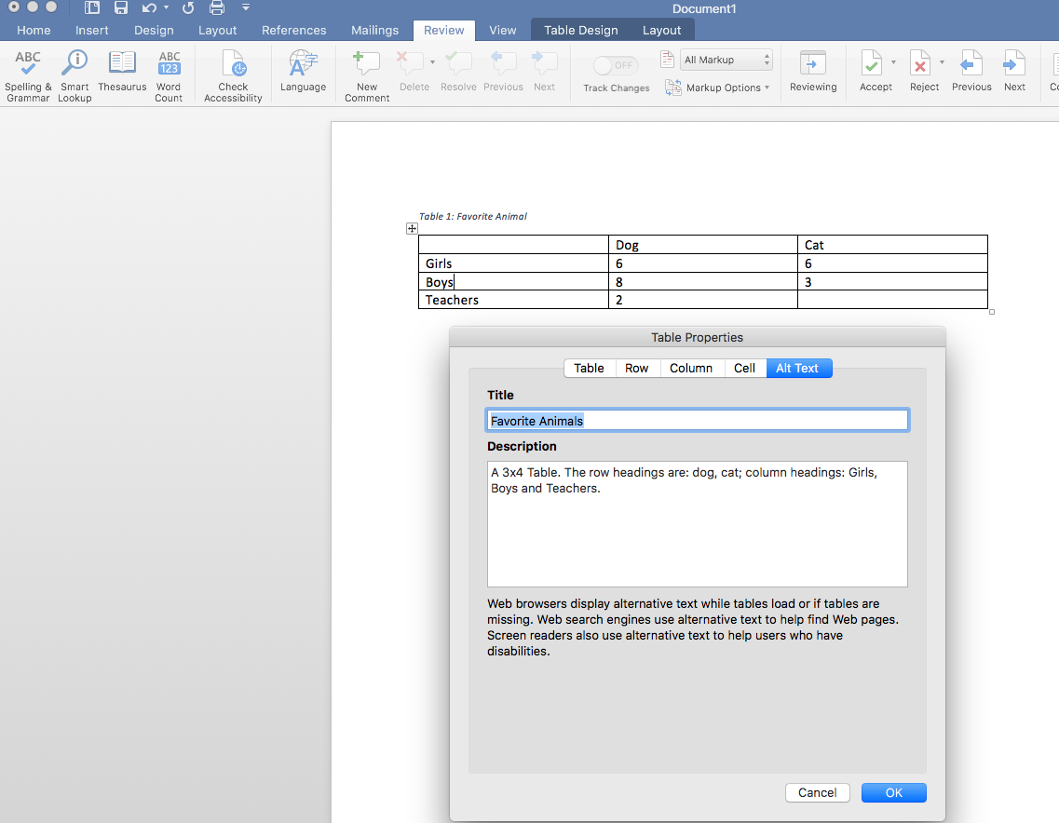

- Use the Word Accessibility Checker to check for accessibility.
  - In the Ribbon, select the Review Tab, then select Check Accessibility.
  - The Accessibility Checker will appear on the right side of the screen with the inspection results. If there are accessibility issues, the errors will be listed.

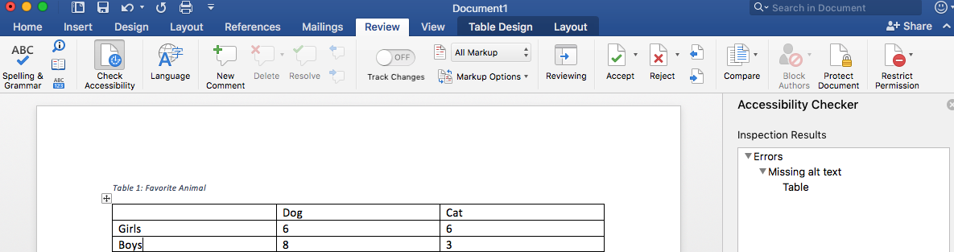

- Things you should NOT do:
  - Do not create your table using the Draw Table Tool.
  - Do not create page layouts with tables.
  - Do not merge or split cells.
  - Do not control spacing in your table with blink rows or columns. Adjust line spacing instead.

