Create Table with Stickers in Numbers

- Open a new Numbers spreadsheet (Blank page)
- Make your desired grid size (3x4 grid; NOTE: the first row and first column are table headers, so add one extra row and column. A 3x4 grid with headers requires 4x5.)
  - Hold and drag Column handle (circle with two lines located at the end of the column labels) to add or delete columns until desired size is reached.
  - Hold and drag Row handle (circle with two lines located at the bottom of the row numbers)
- Make grid squares larger (must be larger to accommodate stickers)
  - Select the entire table
  - Tap Format button (paintbrush symbol)
  - Tap Cell Button
  - Under Size, tap Plus Button multiple times until desired size is reached (90)

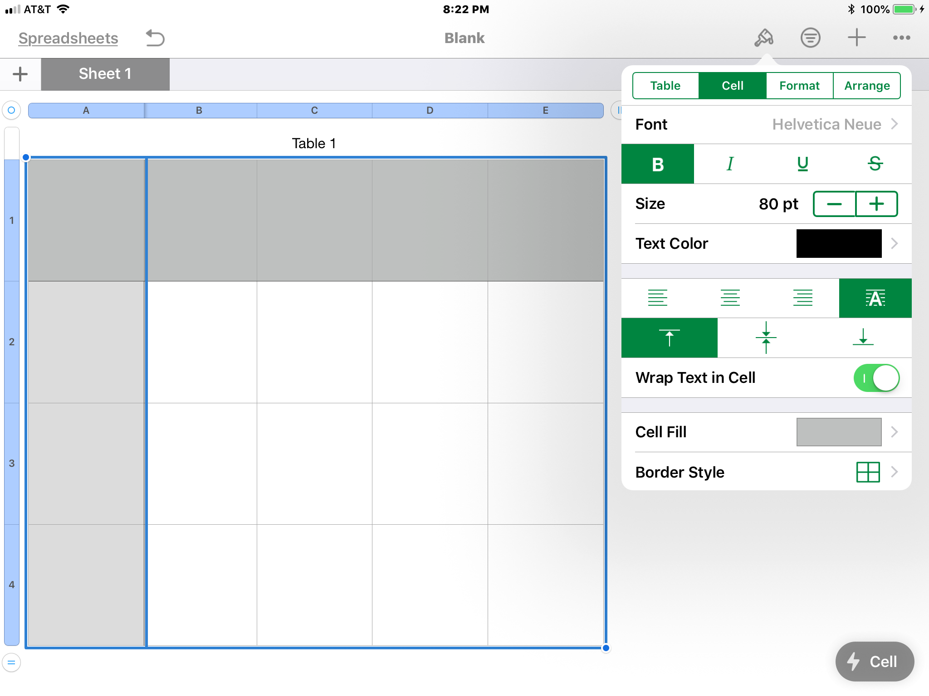

- Label Rows 1 -3
  - Touch shaded square in Row Header and type number.
  - Repeat until all Header Rows are numbered
- Label Columns A-D
  - Touch shaded area in Column Header and type letter.
- Add Sticker
  - Tap on Insert button (plus symbol)
  - Shapes button (square on top of circle symbol)
  - Select desired shape/sticker (horse)
    - Note: ‘Shapes’ are organized by these categories: Basic, Objects, Animals, Nature, Food, Symbols, Education, Arts, Science, People, Places, Activities, Transportation, and Work
    - There are 12 shapes under each category

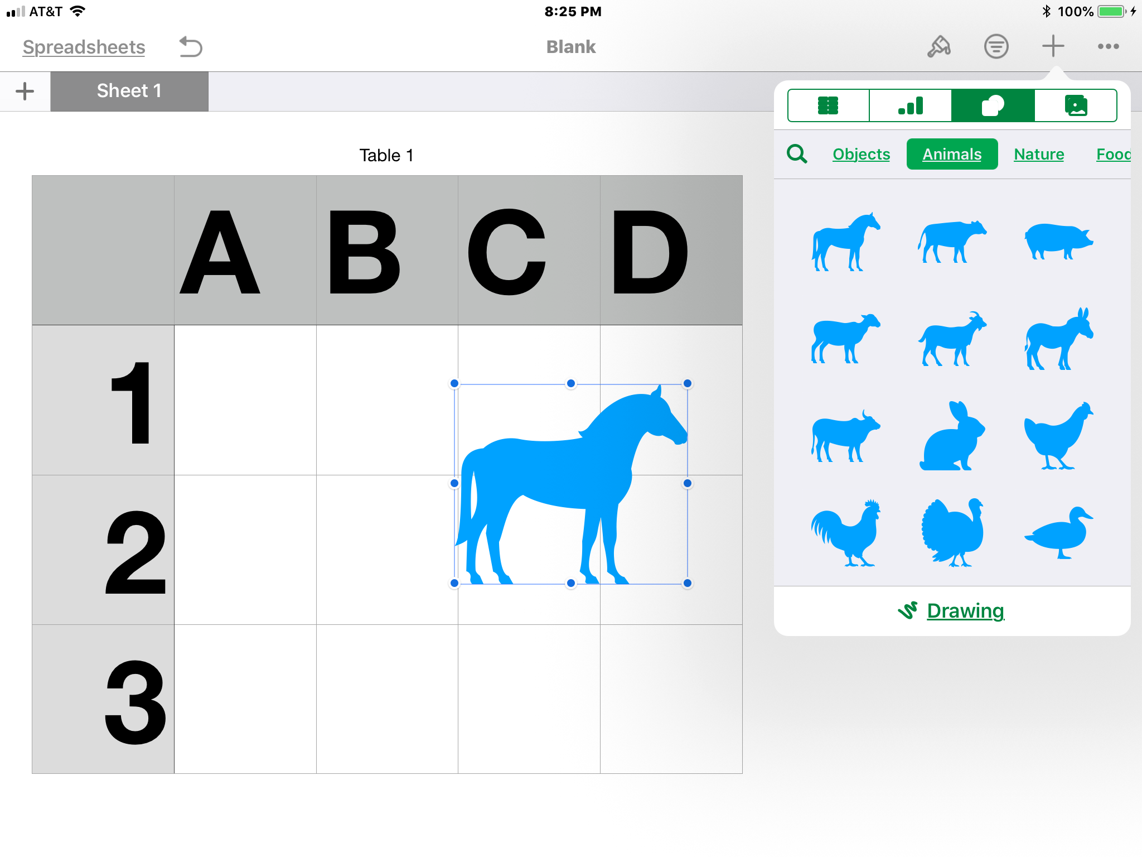

  - Change color of sticker
    - Tap on sticker
    - Tap on Format button (paintbrush symbol)
    - Tap on Style button
    - Select desired color
      - Options are blue, green, red, gold, pink or black
      - You can choose to add a border around the sticker, change the opacity, add shadow, etc.

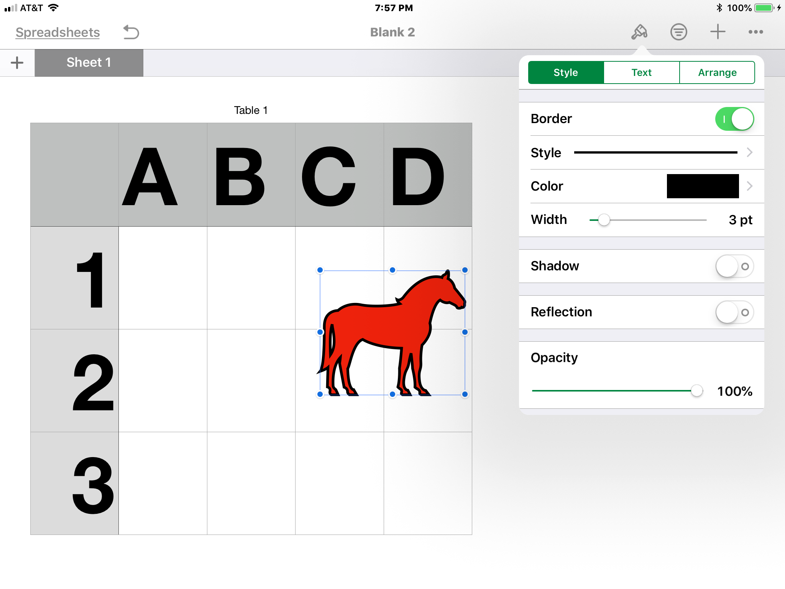

  - Decrease size of object so that the sticker will fit into the square.
    - Hold and drag the one of the handles in the corner of the of the sticker and decrease size
  - Move image to desired square
    - Tap on image to make handles appear
    - Drag image to desired square
    - Repeat to add additional stickers

  - Add a title or directions.
    - Tap ‘title’
    - Type in new title or directions
    - Increase font size of Title
      - Tap Format button (paintbrush symbol)
      - Under Size, tap Plus button multiple times until desired size is reached (31)

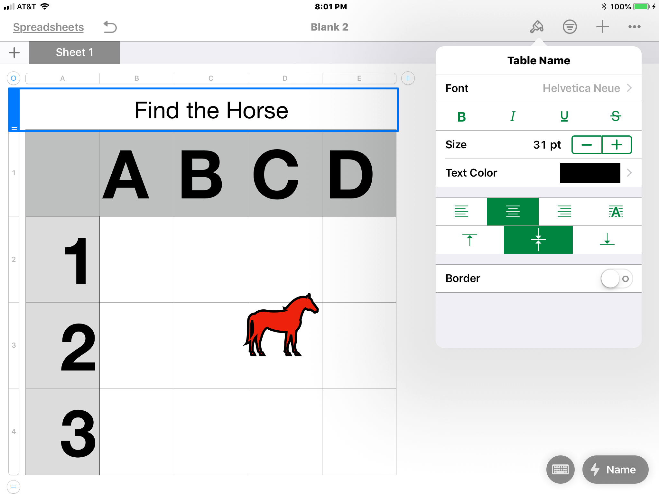

Note: Number Spreadsheet is accessible with VoiceOver; however, there are some VoiceOver hints that are important to know!
- VoiceOver will announce the name of the sticker, but ONLY if you drag your finger around the screen. If you swipe through the table, VoiceOver announces all the grid squares as ‘empty cell’. The stickers are announced after all the empty cells.
- VoiceOver does NOT announce the color of the sticker.
- Currently VoiceOver does not announce rows and column headers as you move through the table. Students must keep track of the row/column they are in. Or, once the student locates the horse, the student can drag in a straight line to the top to find the Column Header name (‘C’) or drag in a straight line to the left to find the Row Header (‘2’).
- Note: The stickers are NOT permanent. A student can accidently move the sticker to a new location!

