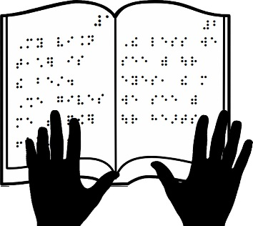

**Braille Lesson**

Braille is a code that presents written information. It is equivalent to print. The alphabet, numbers, music notation, and any other symbol that appears in print can be replicated in Braille by arranging combinations of the six dots of the Braille cell. Braille is read by touch. This is your name in Braille:

Braille dots are numbered as 1, 2, 3, 4, 5, and 6, as illustrated. Braille does not have a separate alphabet of capital letters as there is in print. Capital letters are indicated by placing a dot 6 in front of the letter to be capitalized.

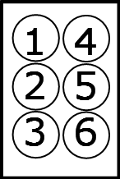 Dot 6 represents a capital letter.

The picture below shows you how the dots are arranged in the Braille cell for each letter of the alphabet.  
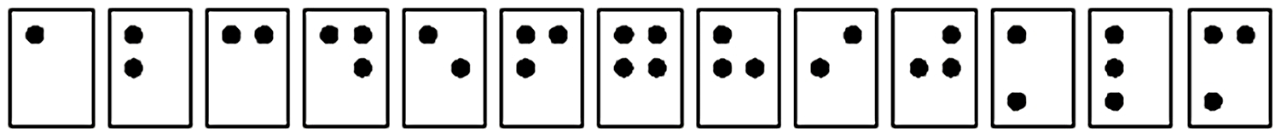

**a b c d e f g h i j k l m**

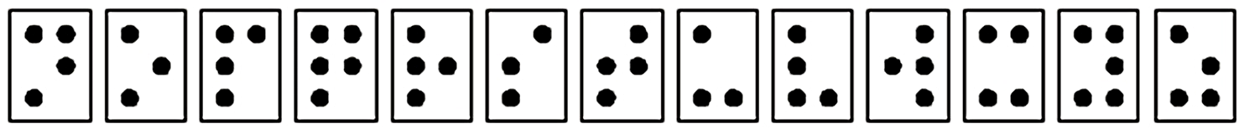

**n o p q r s t u v w x y z**

Practice by filling in the dots for your name below.

**YOUR FIRST NAME**



**YOUR LAST NAME**

