Assistive Technology Checklist for students with
Visual Impairments – Explained

Navigating this file
To navigate to a specific checklist number use [control+f], type in the number desired and press [enter].
If navigating this file using a screen reader, use the save as dialogue box and save the file as a "web page" or .htm or .html extension. When the file is selected use the [application key] to open the context menu, open the "open with" sub menu and choose "Internet Explorer" to open the new file.
Navigating by number with [control+f] will still work in Internet Explorer. Navigating by headings will also work with JAWS. Use [h] to navigate headings, or more specifically use [1] to navigate level 1 general category headings. The [2] key will navigate this heading as well as the below "Keyboard tasks." Use [3] to navigate level 3 headings, these are the checklist items. Use [4] to navigate level 4 headings, these are any subheadings under each item.

Keyboard tasks
Any keyboard reference or keyboard shortcuts referenced throughout this document are contained in brackets. A "+" between two keys indicates to hold down the first keystroke mentioned and then press the following key (e.g. [control+f] will open the find dialogue). If two keys are separated by a ',' this indicates to press the first key, let it go, and subsequently press the following key[s], (e.g. [alt, e, f] will open the find dialogue).

Windows Navigation

Use correct terminology for basic components of a computer system [e.g. monitor, keyboard, disk, printer, mouse], and develop understanding of their basic functions.
Computer
A general-purpose machine that processes data according to a set of instructions that are stored internally either temporarily or permanently.
Monitor
The monitor displays the video and graphics information generated by the computer through the video card. Monitors are very similar to televisions but display information at a much higher quality. Monitors come in two major types – Cathode-ray tube (CRT) and Liquid Crystal Display (LCD). CRT monitors look much like traditional televisions and are very deep in size. LCD monitors are much thinner while still offering equivalent, if not better, graphics quality. LCD monitors are beginning to make CRT monitors obsolete due to their smaller "footprint" on the desk and decreasing price. Most monitors range in size from 15" to 21" or more. This size is a diagonal measurement from one corner of the screen to the other.
Keyboard
Hardware device which allows you to input information into your computer. Standard keyboards are modeled after typewriters and are referred to as QWERTY keyboards, named by the order of the first six keys on the top row of letters. A keyboard consists of alphanumeric keys [letters and numbers], punctuation keys [comma, period, semicolon, etc.], and special keys [function keys, control keys, arrow keys, caps lock key, etc.].
Mouse
A device that controls the position of a pointer on the screen in response to its movements.
Storage Media
Any form of data storage device that allows for storing/recording of data/information. Such devices can include USB drives, CDs, DVDs, compact flash cards, SD cards, floppy disks, external hard drives, etc.
Printer
Hardware device that produces hard copy information of electronic text or graphics [information on screen], onto variety of printable formats [usually paper]
Embosser
A Braille embosser is an impact printer that renders text in raised dots representing braille code, using braille translation software.
Scanner
An electronic device (similar to a photo copier) that generates a digital representation of an image for data input to a computer.

Explore and develop keyboarding skills [It is to the discretion of the teacher to determine whether students will learn touch typing or simply become familiar with the keyboard functions].
If possible it is preferential that a student learns touch typing. This is a technique of using the keyboard without needing to look at the keys. The user memorizes what keys are allocated to each finger. The thumb to activate the space bar.
The ‘f’ and ‘j’ keys are marked so that a user can identify correct finger positioning by touch. If necessary, more prevalent locator dots could be used to identify these keys and possibly one or two other keys for beginning users [such as ‘F4’ and ‘enter’].
Braille or large-print labels on individual keys should be used as a last resort when a student has demonstrated an inability to memorize keys on multiple attempts with varying instruction.
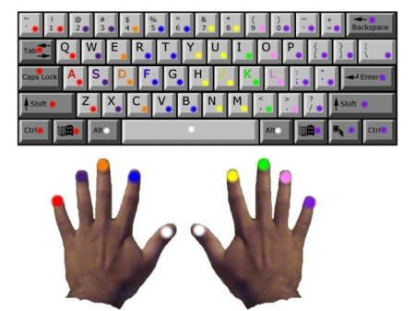
Prior to attempting alternative keyboards a one-handed user should attempt to access a standard keyboard using a two home-row method where they utilize their good hand on its regular side, and then slide their hand across to the other side, and utilize the corresponding keys in reverse. For example a right handed user would place their right index finger on the [j], right middle finger on the [k], right ring finger on the [l], and right pinky finger on the [;]. This user would access the left side of keyboard by sliding their hand over, and using their right index finger on the [a], right middle finger on the [s], right ring finger on the [d], and right pinky finger on the [f].

Identifies location of all letters on the alpha keyboard
Student is able to demonstrate knowledge of the placement of all letter keys on the alpha keyboard without using their vision. Usually letter keys are learned in an order similar to the following:
[a], [s], [d], [f], [j], [k], [l], [g], [h], [t], [y], [r], [u], [e], [I], [w], [o], [q], [p], [b], [v], [n], [c], [m], [x], [z].

Identifies location of all numbers on the alpha keyboard
Student is able to demonstrate knowledge of the placement of all number keys on the alpha keyboard without using their vision. Usually number keys are learned in sequence 1-0.

Identifies location of all punctuation keys on the alpha keyboard, including secondary keys [with shift key as modifier]
Student is able to demonstrate knowledge of the placement of all punctuation keys on the alpha keyboard without using their vision. Usually punctuation keys are learned as they become necessary. These keys include: ` - = [ ] \ ; ‘ , . /.

Identifies location of all navigation keys on the keyboard
Student is able to demonstrate knowledge of the placement of all navigation keys on the keyboard without using their vision. Navigation keys are learned in conjunction with learning to read documents. These keys include the [arrow keys], [home], [end], [page up], and [page down].

Identifies location of all editing keys on the keyboard
Student is able to demonstrate knowledge of the placement of all editing keys on the keyboard without using their vision. Editing keys are learned in conjunction with learning to word process. These keys include [space bar], [tab], [backspace], [enter], [insert], and [delete].

Identifies location of all lock keys on the keyboard
Student is able to demonstrate knowledge of the placement of all lock keys on the keyboard without using their vision. Usually punctuation keys are learned as they become necessary. These keys include [caps lock], [num lock], and [scroll lock].

Identifies location of all modifier keys on the alpha keyboard
Student is able to demonstrate knowledge of the placement of all modifier keys on the keyboard without using their vision. Usually modifier keys are learned as they become necessary in learning to navigate Windows without a mouse. These keys include [shift], [control], [Windows], [alt], and the [application key].

10. Identifies location of all numbers on the numeric keypad
Student is able to demonstrate knowledge of the placement of all number keys on the numeric keypad without using their vision. Usually number keys are learned beginning with the number 5 which has a locator dot on it.

Identifies location of all arithmetic keys on the numeric keypad
Student is able to demonstrate knowledge of the placement of all arithmetic keys on the numeric keypad without using their vision. Usually arithmetic keys are learned as a preference to utilizing similar keys on the alpha keyboard. These keys include [/], [*], [-], [+].

Identifies location of all function keys [f-keys]
Student is able to demonstrate knowledge of the placement of all function keys without using their vision. Function keys are learned as they become applicable in special programs or for keyboard shortcut use. Usually function keys are learned in sequence F1-F12.

Identifies location of escape-key, print screen, and pause
Student is able to demonstrate knowledge of the placement of the escape key, as well as the print screen and pause keys without using their vision. These keys are learned as they become applicable.
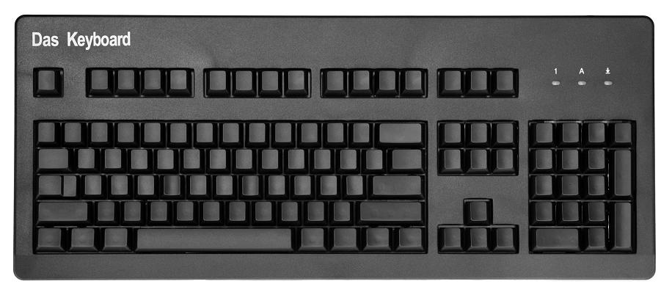
Function
Arithmetic
Lock
Editing
Modifier
Navigation
Punctuation
Number
Letter

14. Use application key [understand relation to point and click mouse users]
The Application key, sometimes referred to as the menu key or the right-click key, is a key found on Windows-oriented computer keyboards. It is usually located two keys to the right of the space bar, however laptop keyboards have a variety of locations for the application key.
The key is used to launch a context menu with the keyboard rather than with the usual right mouse button. The key's symbol is a small icon depicting a cursor hovering above a menu. In many Windows applications, a similar functionality can be invoked with the [shift+F10] keyboard shortcut.

Keyboard Shortcut
Open context menu = [application key]

15. Understanding of the [num lock] key
On a standard desktop keyboard the num lock key is located in the numeric keyboard, in the top left portion of this section. The key is a toggle key, similar to the CAPS lock and Scroll lock keys. An LED light built into the keyboard usually displays the status of the key, though a screen reader will announce when it is turned on and off.
The num lock key was created because earlier keyboards did not have arrow keys separate from the numeric keyboard, the num lock would choose between the two functions [numbers or arrows]. On many laptop keyboards, the num lock key can be activated using the [fn] key, and can convert part of the main keyboard to act as a numeric keypad rather than letters, without having to hold the [fn] key for each keystroke.
The below table displays the status of keys on the numeric keypad when the num lock key is toggled on or off.
Num lock On | Num lock Off
1 | End key
2 | Down Arrow Key
3 | Page Down
4 | Left Arrow Key
5 | Clear Key
6 | Right Arrow Key
7 | Home key
8 | Up Arrow Key
9 | Page Up
0 [zero]  [comma on some keyboard layouts] | Insert key
. [dot] | Delete key

16. Understanding the Desktop
The desktop can be accessed using the keyboard by holding the Windows key and pressing letter d-key [Window key+d]. The start button located in the bottom right corner of the keyboard can be accessed by opening the start menu [Window] key, then pressing [escape]. The task bar can then be accessed by pressing the [Tab] key and navigating with the arrow keys. The system tray can be accessed by holding the [Window] key and pressing the [b] key.
The desktop metaphor, is meant to help users easily interact with the computer. The idea is to treat the screen of a computer as if it were a user's desktop, upon which objects such as documents and folders of documents can be placed. The metaphor continues with the idea that documents represent a paper copy of the document placed on the desktop.
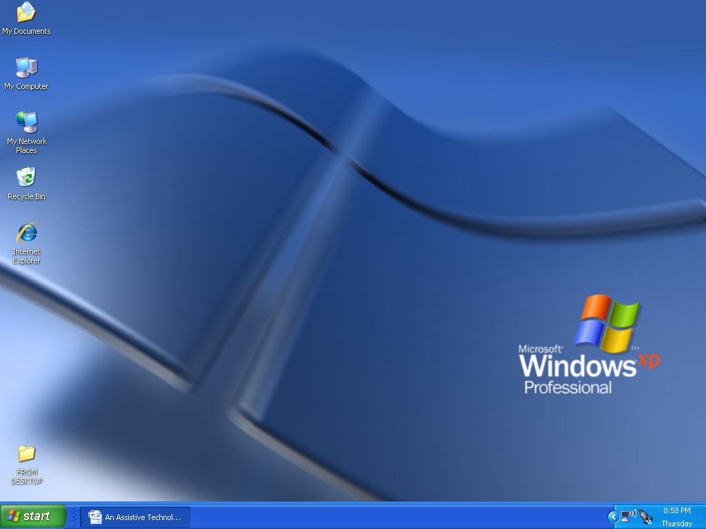

Keyboard Shortcuts
Route cursor to desktop = [Window key+d]
Open the start menu = [Window key]
Route cursor to start button = [Window key, escape]
Route cursor to system tray = [Window key+b]

17. Understanding the Start Menu
In operating systems prior to Windows Vista, the Start button, which opens the start menu, consists of the word "Start" and the Windows logo. In Windows Vista, the word "start" has been replaced by a blue Windows orb logo.
The start menu serves as the central launching point for applications and tasks in the Microsoft Windows operating system. Though not necessary as all applications can be opened through Windows Explorer [Windows key + e], the start menu provides simple and consolidated access to programs, Internet favorites, recently opened documents and the my documents folder, computer settings, search, Windows help and support, and the run… control. The start menu also has the controls for logging off and turning off the computer.
The top part of the start menu, above the programs sub menu, is customizable and can have items added to it. To add items using the keyboard and JAWS screen reader, select the item and then hold down [control] and [insert] and press the [/] on the numeric keypad. Press [Window] key to open the start menu, then [escape] to access the start button. Repeat the command to drop the selected icon into the start menu [control+insert+/]. Though it may be easier for a user to have a sighted user add the item to the start menu by dragging and dropping icons using the mouse.
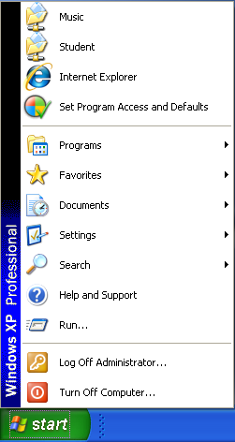

Keyboard Shortcuts
Open the start menu = [Window key]
Open Windows Explorer, my computer, dialogue = [Window key+e]
Route cursor to start button = [Window key, escape]
Drag and Drop = [control+insert+/] JAWS/SystemAccess

18. Find and launch programs/applications [Start menu]
The start menu can be accessed by pressing the [Window] key or by holding the [control] key and pressing [escape]. The programs sub folder can be selected using the up and down arrow keys and opened by using the right arrow, or it can be opened by using first letter navigation with the [p] key. Once open, programs and applications can be found using the up and down arrow keys or first letter navigation. The right arrow key opens sub menus, and the left arrow goes back one level.
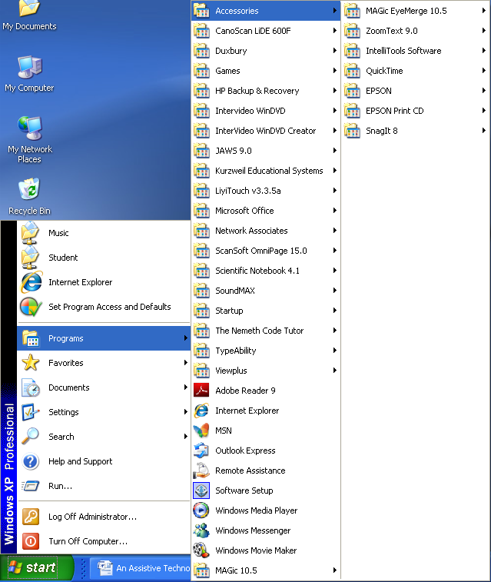
Keyboard Shortcuts
Open the start menu = [Window key] or [control+escape]
Navigate the start menu = [up/down arrow keys], or first letter navigation

19. Open Windows Explorer
Windows Explorer can be opened by holding down the [Window] key and pressing [e]. It can also be accessed by opening My Computer from the desktop. Another way to access Windows explorer is to right click on the start button, or use the [application] key, and select "Explore" from the context menu. The title bar when in Windows explorer is labeled "My Computer."
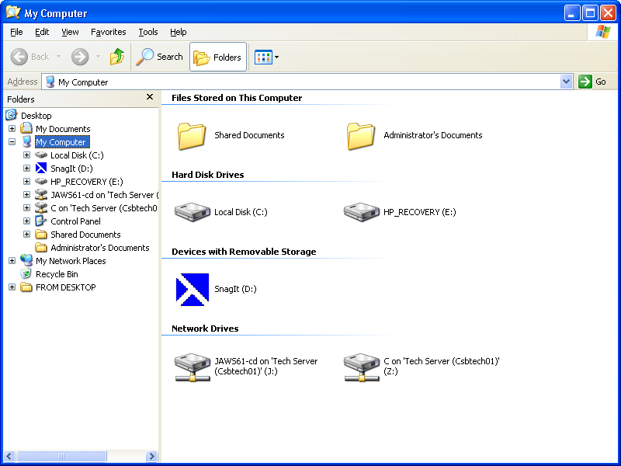

Keyboard Shortcuts
Open Windows Explorer / my computer dialogue = [Window key+e]

20. Find and launch programs/application [c drive] drive
The c drive can be found through Windows Explorer. To open programs, the user needs to open the Local Disk [C] drive. Within this drive, open the folder "Program files." At this point the user needs to have knowledge of the manufacturer name the program is created by. Users can first letter navigate to find this folder. As an example JAWS is made by Freedom Scientific, therefore the JAWS application is found in a folder named "Freedom Scientific." From here the user needs to find the file with an .exe extension.
To show extensions, go to the tools menu and select "folder options." Under the "view" tab, uncheck "hide extensions of known file types," by using the [space bar].
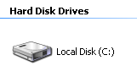

Keyboard Shortcuts
Check and uncheck checkboxes = [space bar]

21. Understand tree view and list view arrangement [Tab] and [Shift+Tab]
The tree view is an outline view that presents a hierarchical view of files and folders. Each item, or branch, within the tree view can have a number of subitems, or branches. Visually this is shown by indentations in the list. An item or branch can be expanded using the right arrow and collapsed using the left arrow key.
The list view displays folders and files inside of items selected in the list view. Visually the list view is the pane to the right of the tree view pane. The [tab] key will access the list view from the tree view. [shift + tab] will move the cursor back to the tree view.
The list view can be navigated using the up and down arrow keys. The [enter] key will open a folder and display the contents in the refreshed list view, the [backspace] key will display the previous level of folders and files in the list view. The [enter] key will open documents and applications from the list view, or a user can select a file and [tab] key to the desired selection, i.e. open or save.
The user can also use first letter navigation within the tree view and list view (see#25).
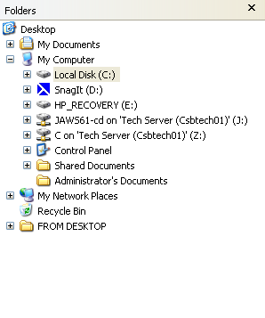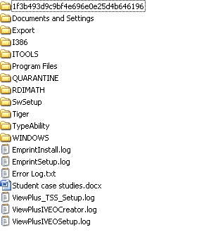

Keyboard Shortcuts
Move sequentially through options in a dialogue box = [tab]
Move backwards through options in a dialogue box = [shift+tab]
Open a folder in list view of dialogue box = [enter]
Go back to previous level in list view of dialogue box = [backspace]

22. Access menu bar
The menu bar can be accessed using the [alt] key. [right arrow] and [left arrow] can be used to select a menu. The [Down arrow] will open a menu, as will the [enter] key. Menus can be referred to as pull-down menus, hence making the down arrow more intuitive.
Shortcuts can be identified by the underlined letter in each menu word. Screen readers will announce this letter after reading the menu name. The letter short-cuts for the menus in Microsoft Word are [f] for "file," [e] for "edit," [v] for "view," [i] for "insert," [o] for "format," [t] for "tools," [a] for "table," [w] for "Windows," and [h] for "help."

Keyboard Shortcuts
Go to menu bar = [alt]
Navigate through menu's = [left/right arrow keys]
Open, or pull down, a selected menu [down arrow key]
The following shortcuts work in Microsoft Office 2003 and other programs with menus of the same name
File menu = [alt, f]
Edit menu = [alt, e]
View menu = [alt, v]
Insert menu = [alt, i]
Format menu = [alt, o]
Tools menu = [alt, t]
Table menu = [alt, a]
Windows menu [alt, w]
Help menu [alt, h]

23. Access system menu
The system menu can be accessed by holding down the [Window] key and pressing [b]. Arrow keys will navigate the items within the system menu.

Keyboard Shortcuts
Route cursor to system tray = [Window +b]

24. Use of Hot Keys and Keyboard Shortcuts
Hot keys are identifiable by the underlined letter of a word or phrase in a menu, screen readers announce this key after reading the menu selection. Hot keys activate the selection without needing to navigate using arrow keys and enter. Keyboard shortcuts are located to the right of an item if available. Keyboard shortcuts can access an item within a menu without needing to go to the menu bar. Screen readers will announce keyboard shortcuts after announcing the selected word or phrase and hot key.
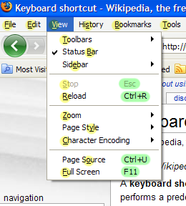

25. Use of first letter navigation
First-letter cursor navigation is a technique used to select items within a folder or drive, by entering the first character of a desired file or folder.

26. Create new files and folders
New files and folders can be created from an existing directory such as the desktop or Windows Explorer. A user can also create new files and folders when saving a file in the save as dialogue box.

New folder from Desktop
A new folder can be created on the desktop by routing the cursor to the desktop with [Window + d], then opening the context menu with the [application] key, and selecting folder from the new sub menu. Next, type the name of the folder that has been created.
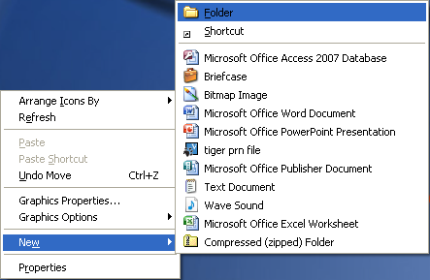

New file from Desktop
A new file can be created on the desktop in the same way as creating a new folder. Rather than select folder from the new sub menu, select the desired file, i.e. "Microsoft Office Word Document." The document will need to be named after the file type is selected.
Please consider that when creating a file from the desktop, the application the file is being created for is not actually opened. The student must understand the type of file they are creating and be conscious of its intended use.
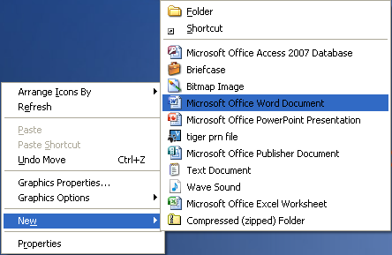

New folder from existing folder
A new folder can be created within a folder. The [alt] key will route the cursor to the menu bar. Within the file menu, navigate to the new sub menu and select folder [alt, f, w, f].

New folder from application
From within the save as dialogue box a new folder can be created by pressing the [tab] key one time past the save in combo box. From this point [tab] to "create new folder," option, press [enter] to select. A New folder dialogue box will pop-up and the user will need to type the name of the new folder and press [enter]. At this point the folder view/list view will be opened to the new folder and the new file can be saved to this new location.

Keyboard Shortcut
Open context menu = [application key]
Route cursor to desktop = [Windows +d]
Move sequentially through options in a dialogue box = [tab]
Move backwards through options in a dialogue box = [shift+tab]
Go to menu bar = [alt]
Navigate through menus = [left/right arrow keys]
Open, or pull down, a selected menu = [down arrow key]
File menu = [alt, f] Programs with menus of the same name
Create new folder from existing folder = [alt, f, w, f]

27. Rename files and folders
The primary method to rename files and folders is through the directory using the [application] key prior to opening the file or folder.
In order to rename a file or folder, route the cursor to the desired file or folder. Press the [application] key to open a context menu. Use the [down arrow] key to select "Rename" and press [enter], or use [m] as a hot key. The original file or folder name will be selected and will be replaced upon typing. Pressing [backspace] or [delete] is not necessary.

28. Select folders, files [select all, shift + space, control + space, space]
Generally the [shift] key is used to select information whether it is text, files or folders. There are several exceptions:
Select All: Hold down [control] and press [a]. This will select all information on the current Window, whether it is text in a document, or files and folders inside of a folder or drive.
Select non-consecutive files or folders: Hold down [control] and press the [space bar] on a file or folder to select. Continue holding down [control] and use [arrow keys] to find other files, press the [space bar] to select them. To unselect a file that has been selected, move the cursor to the file with the [arrow keys] and use the [space bar] to unselect.
Select consecutive files or folders: Hold down [shift] and use [arrow keys] to select multiple files or folders.
Use of the [space bar] to select first file or folder in list: When opening a new folder, the cursor will be on the first file or folder, however it will not be selected. In order to open, copy, or cut this folder, the user must press the [space bar] to select this object prior to subsequent commands.

Keyboard Shortcuts
Select all = [control+a]
Select consecutive files = [shift+arrow keys]
Select non-consecutive files = [control+space bar]
Select unselected file = [space bar]

29. Copy/paste files
Once a file has been selected it can be copied and subsequently pasted in a different location. Use navigation and selection commands to select files for copying. Press [alt] to go to the menu bar, use [arrow keys] or [e] to open the "Edit" menu. Select "copy" from the edit menu. The selected file can also be copied by holding [control] and pressing [c].
To paste the file, find the new desired location and select "paste" from the edit menu, hold down [control] and press [v] prior to routing to the menu bar.

Keyboard Shortcuts
Copy, file or content = [control+c]
Paste, file or content = [control+v]

30. Cut/paste files
Follow the same steps as copy/paste, however select "cut" or [z] from the "Edit" menu or hold [control ] and press [x].

Keyboard Shortcuts
Cut, file or content = [control+x]
Paste, file or content = [control+v]

31. Run multiple applications simultaneously, alternating among them [Task switching [cycle between open Windows with alt+tab and alt+shift+tab], and [alt+esc]]
Computers have the powerful ability to multitask [being able to work on more than one task at a time]. Users can access multiple Windows that are open concurrently, selecting and obtaining information from one or more Windows of focus.
Task switching is accessed by pressing and holding the [alt] key. While [alt] is down, [tab] may be pressed and released repeatedly, sometimes combined with [Shift] to move backward through the available Windows, to cycle the cursor through a list of open Windows. A special task selection Window appears the first time [tab] is pressed with [alt] held down. The release of the [alt] key closes the task selection Window and switches to the selected task.
File names are followed by the application they are running. Folders are labeled by name only.
[alt+esc] is used to minimize the current Window and bring to focus the next Window available [the order in which Windows are brought to focus is based on when they were opened].

Keyboard Shortcuts
Switch to alternate running program beginning with the most recently accessed = [alt+tab]
Switch to alternate running program beginning with the first accessed = [alt+shift+tab]
Minimize all Windows save for the last Window used = [alt+escape]
Hint: Tell your student that when they hold down the [alt] key their finger becomes glued to the keyboard and the only thing that dissolve the glue and release their finger is seeing or hearing the name of the application they are trying to open.
Techese: The order in which files are brought to focus when task switching [alt+tab] or using [alt+esc] is based on the z-order of overlapping two dimensional objects in a graphical user interface where Windows can overlap or completely cover one another. The z-order refers to the order of objects along the z-axis. In coordinate geometry, x typically refers to the horizontal axis [left to right], y to the vertical axis [up and down], and z refers to the axis perpendicular to the other two [forward or backward]. One can think of the Windows in a graphical user interface (GUI) as a series of planes parallel to the surface of the monitor. The Windows are therefore stacked along the z-axis, and the z-order information thus specifies the front-to-back ordering of the Windows on the screen.

32. Close Window/application [alt+F4]
The universal keyboard exit command is [alt + F4], this will close any open application Window. It functions the same as selected "Exit," [x], from the "File," [f], menu, [alt] to menu bar.
Sighted users can point and click on the [x] graphic at the top right of the title bar of an open application. Though this visual is not always in view.

Keyboard Shortcuts
Exit program / close Window = [alt+F4]

33. Close document[Ctrl+F4]
To close a document without closing the application that is running the document, hold down [control] and press [F4].
This can also be done by selecting "close" [c] from the "File" menu.

Keyboard Shortcuts
Close document = [control+F4]

34. Demonstrate understanding of the difference between closing a file/Window and quitting a program
A user must be able to complete task numbers 32 and 33, as well as express their understanding of the difference and use.
Hint: A great way to determine understanding of this skill, is when multiple tabs are open in Internet Explorer 7.0 or greater. Closing a document [control+F4] will keep Internet Explorer open, where as [alt+F4] will close all tabs and Internet Explorer.

35. Create new Window/document
A new Window or document can be opened through the "File" menu, then selecting [n]. A new Window or document can also be opened by holding down [control] and pressing [n].

Keyboard Shortcut
Create new document = [control+n]

36. Understand appropriate use of [enter] when in dialogue box, [enter] as preset default button.
When in a dialogue box the default button is highlighted, giving a subtle visual clue that the user has the option of clicking the button or simply pressing [enter]. Screen readers to not cue a user to what the default button for [enter] is, and therefore users should [tab] to the desired button and press the [space bar], unless they are sure of what the default enter key is for a particular dialogue box. Occasionally the default enter key will change depending on where the cursor is in a dialogue box.
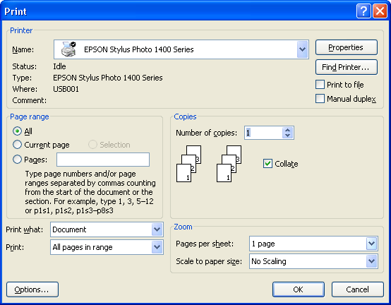
Hint: Encourage users who are using a screen reader to listen to the entire output when they navigate to a desired button, JAWS will speak "press space bar to activate button."

37. Check or un-check a check-box [space bar]
When a check box is selected using the [space bar] will check or uncheck the box, opposite of whatever is currently selected. Use [tab] to navigate fields in a form.
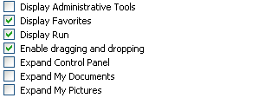

Keyboard Shortcuts
Check/un-check check boxes = [space bar]
Hint: When using JAWS in Internet Explorer, [x] will navigate through available checkboxes when forms mode is off.

38. Add items to the Start menu [knowledge of point and click method]
Adding items to the Start menu can be done using the keyboard or using the mouse. Users who cannot access the computer with sight, should be able to articulate the steps to help navigate a sighted user to add items to the start menu.
Begin by minimizing all programs [Window key + d], this will place the desktop in full view. Hover the mouse pointer over the icon of choice and click the [left mouse button]. Continue holding the [left mouse button] and drag the icon onto the Start button, then release the [left mouse button]. This icon [program, file, or folder] will be added to the Start menu.
Using the keyboard: To add items using the keyboard using JAWS screen reader, select the item and then hold down [control] and [insert] and press the [/] on the numeric keypad. Press the [Window] key to open the start menu, then [escape] to access the start button. Repeat the command to drop the selected icon into the start menu [control+insert+/].

Keyboard Shortcut
Minimize all Windows and route cursor to desktop = [Window key+d]
Drag and drop = [control+insert+/]

39. Show/hide extensions in folder view
Extensions are made up of three or four characters and are placed with a period preceding them after a file name. They allow a computer to understand what program to open a file with. Examples of extensions include: .doc for Microsoft Word files, .txt for text files, .brf for embosser ready files, and .html for websites.
To show extensions, go to the tools menu and select "folder options." Under the "view" tab, uncheck "hide extensions of known file types."
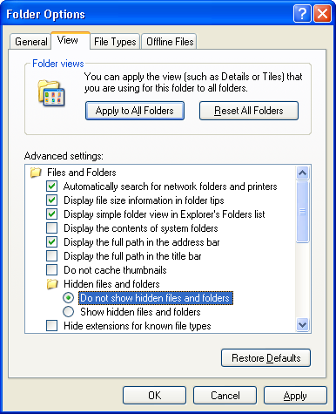

40. Adjust the volume on the computer
Adjusting the volume on a computer can be done through the system tray or accessed through the control panel.
The volume control is located in the system tray which can be accessed by holding down the [Window] key and pressing [b]. Using the [down arrow] will access items in the system tray. Pressing the [space bar] will open the master volume dialogue. The up/down slider can be adjusted using the [up/down arrows], holding the arrow keys down can facilitate quicker volume control. Pressing [tab] in the master volume dialogue will route the cursor to the mute check box, press the [space bar] to check the box and mute the volume.
Some keyboards have additional volume button controls. Occasionally these are additional buttons, and sometimes they require holding the [fn] key to adjust volume. When using these keyboards routinely, users can adjust volume directly from the keyboard.
The control panel can be accessed from the settings sub menu [s] in the Start menu [Window key]. Select and open "Sounds and Audio devices" in the Start menu. The cursor will be on the left/right volume slider in the sounds and audio devices properties dialogue box. Use the [left/right arrow keys] to adjust the volume.
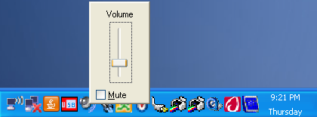
Hint: When purchasing headphones or external speakers be sure that they have an external volume control. This will allow a user to quickly adjust the volume without having to navigate to the volume control.

41. Search for files and folders
The search results dialogue box allows a user to search for files and folders on the computer using a variety of controls to speed the duration of the search. The search results dialogue box can be accessed in the start menu, using the [arrow keys] or the hot key [c] to open the sub menu. Select "For files and folders…" [f] to open the search results dialogue box. This dialogue box can also be opened by holding down the [Window] key and pressing [f].
Use the [up and down arrows] to determine what you want to search for and press the [space bar] to select. For most tasks, use "All files or folders." The pane will refresh and the cursor will be in the "All or part of the file name" edit box. Type the desired search and press [enter]. Use the [tab] key to enter the folder view/list view pane, any search results will show up here.
Files and folders can be opened directly from the search results dialogue box, they can also be copied. To determine where a file is saved, read or listen to the location of the book, a user will need to be familiar with the tree view and levels of the computer storage. The location of the file or folder can also be viewed in the address bar of the dialogue box [alt+d].
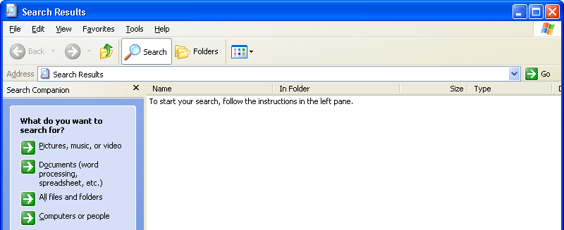

Keyboard Shortcuts
Select content and route cursor to address bar = [alt+d]
Open search results dialogue = [Window key+f]
Techese: Search for a file type by entering a file extension into the search edit box, i.e. .doc for Word documents, or .xls for Excel spreadsheets.
A search for content within a file can be conducted by pressing [tab] one time beyond the "All or part of the file name" edit box, however these searches will take considerably longer. Users conducting these searches can multitask in a different Window while waiting for their search to complete.

42. Use the recommended sequence below to troubleshoot freezing problems [check plug and cable connections, use stop command, force quit a program, restart if necessary]
- Restart access software. Active Windows can be restarted by using [alt+f4] when the Window is in focus. JAWS can be closed at any point by using [insert+f4]. Restart access software using standard method.
- Check volume knobs to be sure volume is turned on, and be sure that volume is not muted.
- Attempt to close the active Window by using [alt+f4] on Window that is freezing up.
- Attempt force quit of application using the Windows Task Manager [control + alt + delete]. Hold down [control] and press [tab] to open the "Applications" tab. [Tab] key to the "task" pane and use the [arrow keys] to find the misbehaving application. [Tab] key to the "End Task" button and press [space bar] to force quit program.
- Check plugs and cable connections [including keyboard, mouse, and power chords].
- Manually shut down the computer by holding down the power key for at least 10 seconds.

43. Open and delete files to/from local hard drive
When a file is selected at any point in a folder or drive the [enter] key will open the file in the predetermined program, the program is selected based on the file extension that was created when the file was created.
If a different program is desired to open the file, press the [application] key then select the "open with" submenu. Select a program out of the submenu using the [up/down arrow] keys. If the desired program is not on this list select "choose program…" the open with dialogue will open and a file can be selected using the [arrow keys].

44. Properly shut down computer
It is very important that you shut down your system properly. Simply turning the power off with the power switch can cause serious file system damage. While the system is on, files are in use even if you are not doing anything. Remember that there are many processes running in the background all the time. These processes are managing the system and keep a lot of files open. When the system's power is switched off, these files are not closed properly and may become corrupted.
"Turn off computer" can be accessed from the Start menu using the [up/down arrow keys] or [u] key. The "turn off computer" dialogue can also be accessed by using [alt+f4] any time an application Window is not in focus, i.e. focus is on desktop, task bar, system tray.
Users can choose to shut down [u], restart [r], or place the system at stand by [s] from this dialogue.
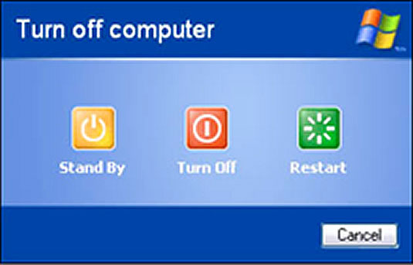

Keyboard Shortcuts
Restart computer = [Window key, u, r]
Shutdown computer = [Window key, u, u]

45. Demonstrate understanding of the difference between [backspace] and [delete]
The [backspace] key and [delete] key both erase a character. The [backspace] key erases the character to the left of the cursor. The [delete] key erases the current character. Visually, it appears that the [delete] key is erasing the character to the right of the cursor, this is a misnomer.
Techese: An entire word can be deleted by holding down [control] and pressing [backspace]

46. Read and resolve commonly occurring error messages [read in complete and “ok” out of them, or read and resolve]
Error messages often cause a dialogue box or program to close. It is important to be familiar with an error message when one pops-up. Review the content of the screen and [tab] to the "don't send" button or press [alt+f4] to close the Window.

Keyboard Shortcuts
Read dialogue box = [insert+b] JAWS/SystemAccess
Techese: If an error message is reoccurring it is helpful to make a copy of the message when asking for technical support. A copy of the error dialogue can be made by holding down the [alt] key and pressing the [print screen] key.

47. Use recommended sequence below to troubleshoot printing problems [stop sending print jobs, check plug and cable connections, check that the printer is on, cancel print jobs in the print dialogue monitor, check printer for paper or jams, turn printer off and then back on, get help]
- Check plug and cable connections between the printer and computer, as well as power.
- Check to be sure that the printer is on.
- Make sure there is paper loaded in the printer.
- If printer does not complete a print job, it is alright to attempt to complete operation again to be sure that no errors were made the first time print job was sent.
- Stop sending print jobs, as multiple items in queue will take longer to delete and solve.
- Cancel print jobs using the printer monitor dialogue. To determine if any print jobs are in queue, access "printers and faxes" from the "settings" submenu in the start menu. Select desired printer using [arrow keys] or first letter navigation, press [enter] to open printer dialogue.
- Documents can be stopped individually by accessing the context menu [application key] when a specific job is selected, or all jobs can be cancelled by selecting "Cancel all documents" [l] from the Printer menu [p].
- Check the printer for paper jams. If jam is found, remove, and press the paper feed button to clear potentially clear any other errors.
- Turn printer on and off, and/or unplug cable connection, to clear any jobs in the printer queue.
- Get help from sighted teacher or peer that can potentially identify unseen problem.
- Request help from information technology [IT] support staff.

Application Access

48. Acknowledge active program and read the title bar
The title bar contains the name of the file and the application in which it is open. When using JAWS [insert+t] will read the title bar.

Keyboard Shortcuts
Read title bar of active Window = [insert+t] JAWS/SystemAccess

49. Navigate save as dialogue box
To save a file for the first time, the user can access the ”save" option from the "file" menu, [alt, f, s] or use the keyboard shortcut [control+s]. To save a file with a different name or to a different location after it has already been saved a user can access the "save as…" option from the "file" menu, [alt, f, a]. In either case the save as dialogue is opened.
When opened the cursor begins in the "file name" combo box, the first line of text is used and is selected if the file is being saved for the first time. If the file is being saved with a new name or to a new location, the previously saved file name is selected in the "file name" combo box. Because this box automatically fills when navigating the folder view/list view, it is recommended that naming the file be one of the last steps in the process.
Use the [tab] key to find the "save in" combo box. Use the [up/down arrows] or first letter navigation to select the location to save in [i.e. my documents or removable disk], press [enter] to select the location. At this point the folder view/list view will populate with the similar files and folders already inside of the selected location. Use the [tab] key to access the folder view/list view, use the [arrow keys] or first letter navigation to select a folder to save into. Pressing [enter] on a folder within the folder view/list view will open that folder, pressing [backspace] will go back to the previous level of folders and files.
When the appropriate folder has been selected and opened, use the [tab] key to route the cursor to the "file name" combo box. Type the desired file name, then [tab] to the "save" button and press the [space bar], or press [enter]
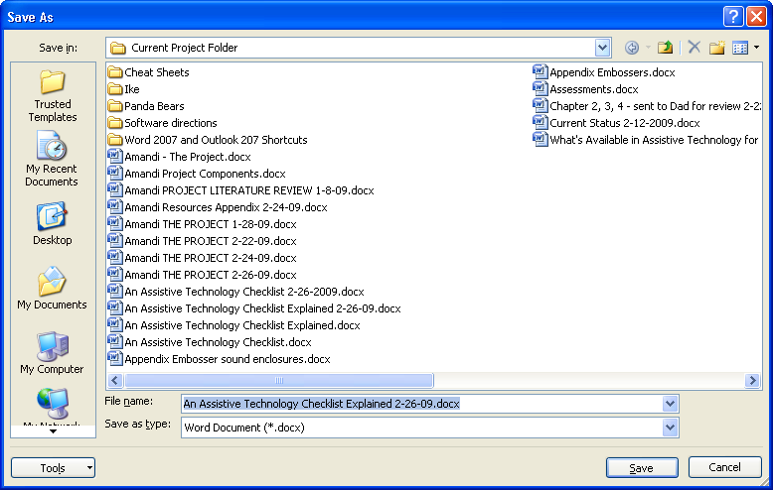

Keyboard Shortcuts
Save document = [control+s]
Hint: For advanced users who understand how to navigate from the Desktop, they can access the folder view/list view immediately after the save as dialogue opens by holding [shift] and pressing [tab]. By pressing the [backspace] key repeatedly, the folder view/list view will eventually populate with the items in the Desktop. This strategy may prove simple for individual students who are confused by the "save in" combo box.
Hint: Another strategy for saving is the use of the buttons on left side of the dialogue. These buttons can be navigated using the [up/down arrow] keys, [enter] will select them and route the cursor to the folder view/list view. These buttons can make for quick navigation for mouse users as well.

50. Understand and use the save as type file option
The "save as type" combo box in the save as dialogue offers users the opportunity to save a file with an extension different from the default file type for the application. Depending on what the intended use of the file is, it may be necessary to save the file with a different extension to ensure compatibility with note-takers or previous versions of a program. Often when new software versions are released, older versions are unable to read the newer system files. In this case saving a file in the older format will allow users of the older system to view the file.
The "save as type" combo box can be accessed in the save as dialogue using the [tab] key. To change the file type use the [up/down arrows] or first letter navigation. After making a selection the user can either press [enter] or simply [tab] to the next option, the "save" button.
Techese: Another reason to use the "save as type" combo box is to view files of that type in the selected location. Only the files with the same extension selected in the "save as type" combo box will appear in the folder view/list view.

51. Print from menu bar and/or combination keys
Opening the print dialogue can be done through the "File" menu [alt, f,p], or by using the keyboard short-cut [control+p]. In either case the cursor begins in the "Number of Copies" spin box, where a user can either type the number of desired copies or use the [up and down arrow keys] to select the number of copies. The default setting is one copy.
If the computer and corresponding printer have been set-up correctly, at this point, the user can press the [enter] key to send the print job.
If only a section of a document is desired, then the user can [shift+tab] to the "page range" pane where they can select the current page, or certain page numbers by entering in those numbers with a [-] between them. The default setting is for all pages in the selected application.
To print to a printer other than the default printer, [tab] to the "printer name" combo box. Use [arrow keys] or first letter navigation to select desired printer.
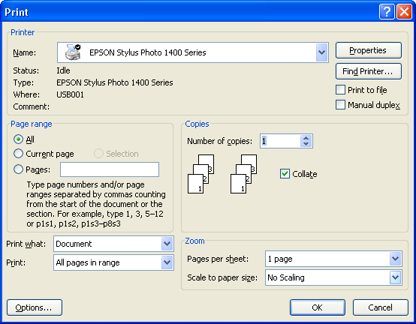

Keyboard Shortcut
Print = [control+p]
Techese: To set the default printer, access "printers and faxes" from the "settings" submenu in the Start menu. Select desired printer using [arrow keys] or first letter navigation, press [application key] to open a context menu, and select "set as default printer." This will cause the selected printer to be the default printer in the print dialogue from any application.

52. Confirm program version number and information
Program version numbers can be found in the "About…" dialogue from the "Help" menu, [alt, h, a].
It is important to know program information when calling technical support. Support personnel will need to know this information in order to understand issues specific to each version of the program.
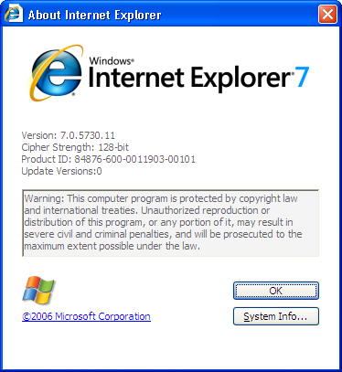

53. Play media file
Media files have a variety of extensions and play in a variety of media players. Generally media files are songs, stories, videos, and other audio and visual presentation types. The computer will recognize the file type and open the file in the appropriate program when selected. Windows based computers come with a version of Windows Media Player to play audio and visual programs.
Files can be navigated in Windows Media player using a variety of keyboard commands that can be found in the "play" menu, [alt, p]. To play/pause a file hold down [control] and press [p]. To stop a song hold down [control] and press [s]. Select the previous track by holding [control] and pressing [b], and the next track by holding [control] and pressing [f]. A user can rewind by holding [control] and [shift] and pressing [b], and fast forward by holding [control] and [shift] and pressing [f]. Tracks can be set to shuffle by holding [control] and pressing [h], and set to repeat by holding [control] and pressing [t].
If a user desires opening a media file using a program other than the default media player, press the [application] key when the desired file is selected. Open the "open with" submenu and choose the media player from the available programs in the submenu.

Keyboard Shortcuts
Play/Pause = [control+p]
Stop = [control+s]
Previous track = [control+b]
Next track = [control+f]
Rewind = [control+shift+b]
Fast forward = [control+shift+f]
Shuffle = [control+h]
Repeat = [control+t]
Hint: Media files can be a great way to introduce a user to file management and Windows navigation techniques. Students are often excited about listening to music or hearing stories. This motivation can be used to encourage them to upload files, listen to them, copy and paste them, rename them, and transfer them to alternate media players or storage hardware that they can further access them from in the future.

54. Program Specific Help
Questions about applications can sometimes be answered by searching through program specific help. Most programs have a menu labeled "help," [alt, h]. It depends on the program as to how to access help. Use the [down arrow] to open the menu and move through menu options.
Most help applications open a new dialogue box that is split into two panes. The left pane usually consists of several tabs that can be navigated by holding [control] and pressing [tab]. The tabs usually consist of a table of contents, an index, and a search option. The right pane of the help screen will have the information about the selected item in the left pane. Usually [tab] and [shift+tab] will route the cursor between the two panes, though this does not work in all program help dialogues.
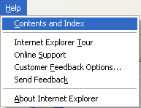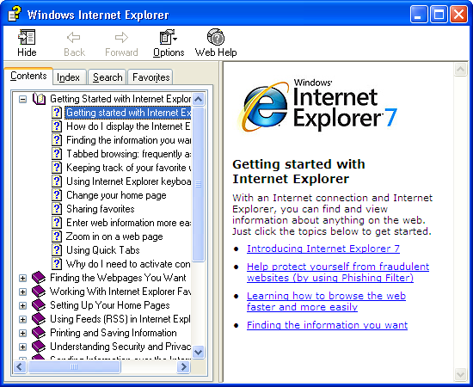

55. Understand "undo" in applicable programs
Undo is a command in many computer programs. It erases the last change done to the document reverting it to a previous state. In many programs undo can be used repeatedly to continue reverting back to the document's prior states. Undo can be accessed from the "edit" menu in most applications, [alt, e].

Keyboard Shortcuts
Undo = [control+z] or [alt+backspace]

56. Look for program updates
User's can usually look for possible upgrades to a software product by accessing the help menu [alt, h]. If an update feature is not available in the menu, a user will need to utilize the Internet to search for potential updates.
If a user knows the company that manufactured a product then searching the company website for updates or upgrades is a good source. A JAWS screen reader user can also search through headings [h] or links list [insert + f7]. A good strategy is to utilize the find dialogue [control + f], and search for "update", or "upgrade."
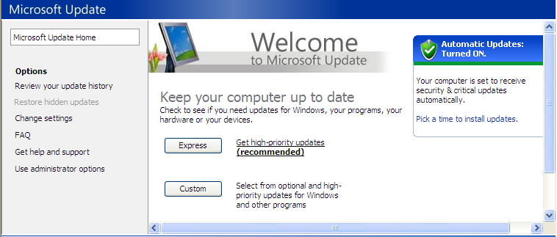

Keyboard Shortcuts
Open find dialogue = [control+f]
Navigate headings on Internet = [h] JAWS/SystemAccess
Open links list dialogue = [insert+f7] JAWS/SystemAccess

57. Install new software
Users need to experience installing new software. Some software is installed from online links, however most software is installed from CD. Most Install dialogue's can be navigated using a screen reader or screen magnifier. All content should be read on each screen, and buttons should be used to advance through the dialogue. The [tab] key advances through buttons. If using a screen reader and a dialogue box does not read completely, use [insert + b] to read content within the dialogue.

Keyboard Shortcuts
Read content within a dialogue = [insert+b]
Navigate buttons and options in a dialogue = [tab]
Navigate buttons and options in a dialogue in reverse order = [shift+tab]

58. Expand/Extract files
File compression is becoming more common as downloading content and files from Internet sites is becoming a common occurrence. Files are compressed so that they take up less space on a website computer server, and to speed download time. Zip files are probably the most common form of a compressed file. A zip file contains one or more files that have been compressed to reduce file size. In order to access the files in a zipped folder, they need to be extracted. This can be done using the Windows extraction wizard.
Select the zipped folder, then use the [application] key to open a context menu and select "Extract All…," [application key, a]. The dialogue opens and explains its purpose, using the [tab] key, a user can select the "Next" button with the [space bar]. The subsequent screen asks for a folder for the files to be extracted to. The default location and name is the same as the that of the zip file. If a different location is desired, [tab] to the "browse" button and press [space bar]. Select the desired location by using the [up/down arrows] or first letter navigation to find folders or drives, and the [right/left arrows] to expand and collapse sub levels. A new folder can be created in this screen by selecting the "make new folder" button. The "next " button will extract the files. The final screen has a check box for "Show extracted files," by default it is checked. If left checked when the "finish" button is selected the folder with the extracted files will open when the extraction wizard closes.
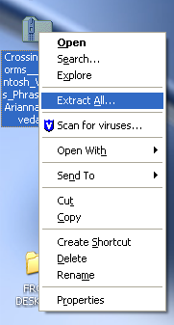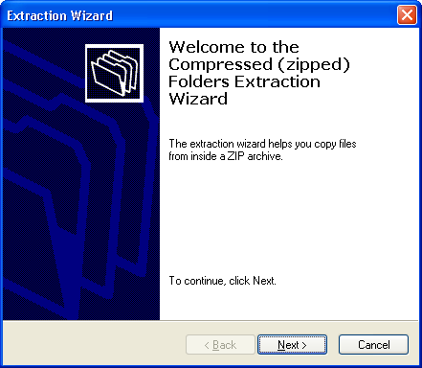

Storage Options / External Devices

59. Understanding storage options [physical devices]
There are a variety of storage media available. Students need to be comfortable handling and using a variety of forms of storage media so that they can handle files and applications presented from a variety of devices.

3 ½ inch floppy
A floppy disk is a data storage medium that is composed of a disk of thin, flexible, "floppy," magnetic storage medium encased in a rectangular plastic casing. Floppy disks are read and written by a floppy disk drive. In most situations floppy disks are no longer in use.

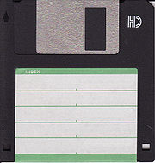

Techese: Floppy disks were invented by International Business Machines (IBM) in 1971 and were 8-inches [200 mm] in size. The 5¼-inch [133⅓ mm] floppy was introduced in 1976, and the newest and most common 3½-inch [90 mm] was introduced in 1982, and enjoyed many years as a popular and ubiquitous form of data storage and exchange through the late 1990s.

Compact Disc [CD]

A Compact Disc [also known as a CD] is an optical disc used to store digital data, originally developed for storing digital audio. The CD, available on the market since October 1982, remains the standard physical medium for sale of commercial audio recordings. CD's can also be used to store data of any kind from a computer. Files are written onto a CD differently depending on whether it is a data disk to be read on a computer or an audio disk to be read by a CD player.

Techese: The compact disc is a spin-off of the much less successful Laserdisc technology. Laser discs are now obsolete. Their defining characteristic was their size, measuring almost 12 inches in diameter.

Digital Video Disc [DVD]

DVD [also known as "Digital Versatile Disc" or "Digital Video Disc"] is a popular optical disc storage media format. Its main uses are video [movies] and data storage. Most DVDs have the same dimensions as compact discs [CDs] but store more than six times as much data.

Universal Serial Bus [USB] drives

USB refers to a type of connection that can connect computers and peripherals. It is the most common current form of connection. This connection is also used for miniature drives known as USB drives, also known as (flash drives, thumb drives, jump drives). USB drives offer potential advantages over other portable storage devices. They have a more compact shape, operate faster, hold much more data, have a more durable design, and operate more reliably due to their lack of moving parts. Additionally, it has become increasingly common for computers to be sold without floppy disk drives, and some without CD/DVD drives. USB ports, on the other hand, appear on almost every current mainstream PC and laptop.
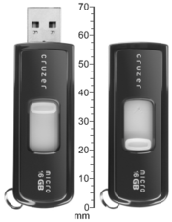

Compact Flash Cards [CF]

Compact Flash [CF] is a mass storage device format used in portable electronic devices. Compact Flash became a popular storage medium for digital cameras. In recent years it has been widely replaced by smaller cards. Braille Note-takers still use compact flash cards as a primary storage media however are transitioning to smaller cards as well. Compact flash cards have a ridge on one end that can help users without vision identify which way to insert them into devices.
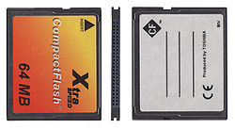

Secure Digital Cards [SD]

Secure Digital cards have replaced the compact flash card in the majority of mainstream products, such as digital cameras. The card is approximately the size of a postage stamp, and is quite thin as well. SD cards have a cut-off corner that allows users without vision to insert them into devices appropriately.
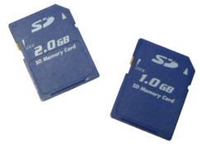

Portable Hard-drives

Portable hard-drives are also known as external hard disk drives. They can be connected to computers through a variety of connections, though are commonly connected to a computer via USB. External hard drives use similar technology as USB drives however are capable of holding much more information. At the time of this publication external hard drives can hold as much as four terabytes of information. This is more than sixty times more storage space than the largest capacity USB drive, or 7,000 times as much information as a floppy disk.
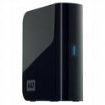

60. Understand and navigate pop-up box when removable disk is inserted
When an external source of data is attached to a Windows computer, a dialogue pops-up asking the user to determine what they wish to do with the media. This dialogue is titled according to the type of media inserted. Options according to the type of files on the device are presented to the user, they can be navigated by using the [up/down arrow] keys or first letter navigation. Available for all devices is an option "open folder to view files," selecting this option by pressing [enter] will open the content of the external media in a new Window.
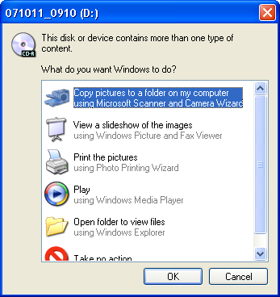

61. Use 3 ½ floppy, if necessary
The correct way to insert a floppy disk can be identified by the metal slider on one edge that is inserted into the drive. The round metal circle on the bottom side of the floppy disk should be directed downward upon insertion.
To access data on a 3 ½ floppy, the user will open Windows Explorer [Windows key + e]. Use [down arrows] to access 3 ½ floppy, or use first letter navigation, in this case [number 3]. Floppy disks are recognized by the Windows system as the a-drive [a:]. Use [tab] to navigate to the folder view/list view to access content. Floppy disks must not be active (being read or written to) when being removed from the drive however do not need to be safely removed using the safely remove hardware utility.

Keyboard Shortcuts
Open Windows explorer, my computer, dialogue = [Window key+e]

Techese:
By typing "a:" then the name of the file in the "file name" combo box, the file will be saved to the floppy disk with the file name given after "a:."

62. Use CD/DVD
CDs and DVDs can have two usable sides, it is important that users keep track of the correct side in storage as the sides are difficult to differentiate. Most CDs and DVDs have only one visible side. Try viewing the burned area of a disk by viewing the bottom side of the disk at an angle. The recorded playable side of a CD or DVD is inserted face down in a drive. The labeled side is placed face up.
To access data or music on a CD, the user will open Windows Explorer [Windows key + e]. Use the [down arrows] to access the CD drive, or use first letter navigation. Depending on how the CD/DVD was created, the title of the disk appearing in the tree view may be different according to each individual disk. [Tab] to the folder view/list view to access content. CDs do not need to be safely removed using the safely remove hardware utility.

Keyboard Shortcuts
Open Windows explorer, my computer, dialogue = [Window key+e]

63. Use USB
The proper way to insert a USB drive can be identified by the position of a plastic bar inside the metal casing that fits into the computer. However as this is often difficult to differentiate it may be beneficial to mark the top side of a USB drive so that users can easily insert them right side up. Locator-dots (known as loc-dots) provide a thin but very noticeable marker.
When inserted, the dialogue asking what the user wishes to do with the device will pop-up with content according to the types of files on the device. Content can also be explored using Windows Explorer, (window key+e).
USB drives have a file system on them just like a hard drive and therefore need to be safely removed using the safely remove hardware utility.

Keyboard Shortcuts
Open Windows Explorer, my computer, dialogue = [Window key+e]
Route cursor to system tray = [Windows key+b]
Open system tray dialogue = [insert+f11]

Hint:
Checklist #68 Safely Remove Hardware describes how to optimize a device for quick removal, so that the safely remove hardware utility is no longer necessary.

64. Use Compact Flash Card
The proper way to insert a compact flash card can be identified by the position of a plastic ridge on the bottom side of the outside edge when it fits into the computer. However, as this is often difficult to identify, it may be beneficial to mark the top side of a compact flash card so that users can easily insert them right side up. Locator dots (known as loc-dots) provide a thin but very noticeable marker.
When inserted the dialogue asking what the user wishes to do with the device will pop-up with content according to the types of files on the device. Content can also be explored using Windows Explorer, (Window key+e).
Compact flash cards have a file system on them just like a hard drive and therefore need to be safely removed using the safely remove hardware utility.

Keyboard Shortcuts
Open Windows Explorer, my computer, dialogue = [Window key+e]
Route cursor to system tray = [Windows key+b]
Open system tray dialogue = [insert+f11]

65. Use SD card
The proper way to insert a secure digital card can be identified by the position of several grooves on the bottom leading edge and a cut-off corner on the top right edge to be fitted into the computer.
When inserted the dialogue asking what the user wishes to do with the device will pop-up with content according to the types of files on the device. Content can also be explored using Windows Explorer (Window key+e).
Secure digital cards have a file system on them just like a hard drive and therefore need to be safely removed using the safely remove hardware utility.

Keyboard Shortcuts
Open Windows Explorer/my computer, dialogue = [Window key+e]
Route cursor to system tray = [Windows key+b]
Open system tray dialogue = [insert+f11]

66. Use card reader when necessary
Though compact flash card drives and secure digital drives are commonplace on braille-notetakers and recently manufactured personal computers, older computers do not have these types of drives built into them. A USB card reader may be used to access folders and files on external storage media. The safely remove hardware utility needs to be used when the user is finished using a card.

Keyboard Shortcuts
Open system tray dialogue = [insert+f11]

67. Use external hard drive
External hard drives are usually connected to a computer via a USB cable. The proper way to insert a USB cable can be identified by the position of a plastic bar inside the metal casing that fits into the computer, however as this is often difficult to tell, it may be beneficial to mark the top side of a USB connection so that users can easily insert them right side up. There is an arrow on one side of the USB plug to help with orientating it to the USB socket.
When inserted the dialogue asking what the user wishes to do with the device will pop-up with content according to the types of files on the device. Content can also be explored using Windows explorer.
External hard drives have a file system on them just like your hard drive and therefore need to be safely removed using the safely remove hardware utility.

Keyboard Shortcuts
Open Windows Explorer, my computer, dialogue = [Window key+e]
Route cursor to system tray = [Windows key+b]
Open system tray dialogue = [insert+f11]

68. Safely Remove Hardware
External devices need to be safely removed using the safely remove hardware utility when unplugged from the computer. This ensures that background processes that the user is unaware are occurring do not get interrupted when the device is removed and result in corrupted or inaccessible files.
Devices can be safely removed using the utility in the system tray, using the safely remove hardware button. The system tray can be accessed by holding down the [Windows] key and pressing [b]. Use the [down arrow] to navigate to the "safely remove hardware" button and press [enter]. Within the safely remove hardware dialogue, the user will use the [up/down arrows] to choose what hardware they wish to eject, then [tab] to the "stop" button, and press [enter]. It is also possible to hold down [alt] and press [s], rather than [tab] to the "Stop" button. On the next screen, the user confirms the device to be ejected using the [up/down arrows] then presses [enter] or [tabs] to the "ok" button and presses the [space bar]. Wait for a chime, and a bubble above the system tray to announce that it is now safe to remove hardware.
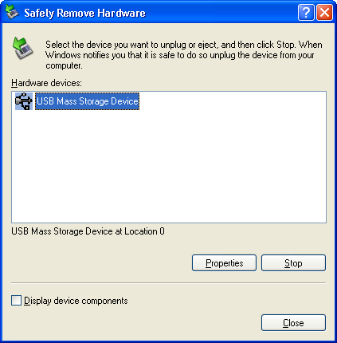

Keyboard Shortcuts
Route cursor to system tray = [Windows key+b]
Open system tray dialogue = [insert+f11]

Techese: There is a setting for USB drives that tells the operating system how to optimize their usage. Either it is optimized for "Quick Removal" or for "Performance." The setting for quick removal disables write caching on the disk so that you can disconnect the drive without using the safely remove hardware icon. The setting for performance enables the write caching on the disk so as to improve disk performance. To disconnect the drive when set-up for performance, you should use the safely remove hardware icon so as not to hurt your USB drive.
To optimize the device for quick removal, open Windows Explorer [Window key + e]. Use the [Tab] key to navigate to the folder view/list view, and use the [up/down arrow] keys or first letter navigation to find the external device. Select the device and press the [application key], use [down arrow] and [enter] or [r] to select "properties." Hold down [control] and press [tab] to get to the "hardware" page. Use [up/down arrows] to select device to optimize then [tab] to "properties" and press [enter], or press [alt+r]. In the "policies" page [up arrow] to "Optimize for quick removal" and [tab] to the "ok" button and press the [space bar]. The default setting for devices is "optimize for performance."
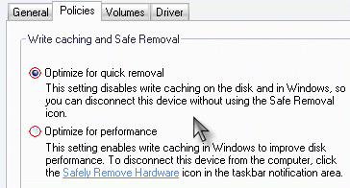

69. Duplicate CD
Because of the vast array of CD duplicating and burning software available for computers, both free with the purchase of a computer and purchased additionally from a third party, this section will not cover a how to on duplicating a CD.
Many programs have a separate Window for CD duplication, from which there are only a few buttons to choose, and the program makes a duplicate of an inserted CD. This is different then choosing data from the computer to burn to a CD. Remember, [tab] key will go through the options available in a dialogue, the [space bar] will select buttons, and [enter] will select the default enter button.
Sometimes the CD creation software opens to different programs depending on what you want to do with the software. This is true of Roxio CD creation software that comes with many Windows based computers. In this case please check the program submenu in the programs folder of the Start menu to determine if you are starting the most sensible application [i.e. CD Copier to make a duplicate CD].
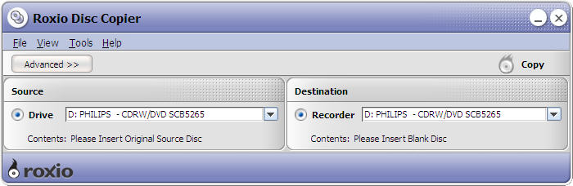

70. Burn a music CD
As in the case of duplicating a CD, this section will not cover exact steps in burning a music CD because of the wide selection of available CD creation software.
Some CD creation programs have an application that allows you to burn music CDs by copying music directly onto the blank CD in Windows Explorer. If this is the case, the user will need to read the user's manual of the CD creation software to determine how to appropriately set-up this application. When set-up successfully, sometimes with the assistance of a sighted aide if this part of the program is not accessible, then the user will be able to copy and paste files into the blank drive using Windows Explorer and then follow the necessary steps, such as eject the disc, at which the files will be burned prior to ejecting, such is the case with ROXIO drag-to-disc application in Easy CD Creator 7.0.
Other things to look for in CD creation software is whether adding songs to the to be burned folder can be done with "copy" and "paste" through Windows Explorer, or if it is necessary to navigate through the system using the proprietary software. Be aware of selecting multiple files using [shift + arrow keys], [control + space bar], and [control + a].
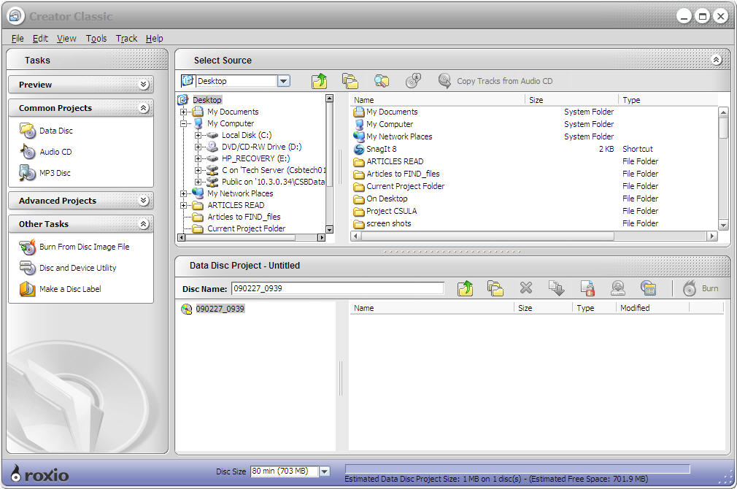

71. Burn a data CD
Please review the hints given in #70 Burn a music CD.
Hint: Stores sell Data discs and Audio discs. Usually the audio discs are more expensive. There is actually no difference between the CDs and therefore audio or data can be burned on either CD purchased.

72. Label CD appropriately
Whether printing directly onto a printable CD, printing a full CD size sticker label to attach to a CD, printing a smaller label, or affixing a Braille label to a CD, CD labeling should be done with caution. Organizing CDs is an appropriate skill in CD usage. CDs should be labeled so they can be accessed quickly and easily without having to test many on a computer or a CD player prior to finding the correct one. Due to the way a CD is ready [using a laser to read grooves on the CD when spinning], a slight off-balance created by a sticker or label can create difficulty for CD players to read music or data, though usually data is less touchy they audio.
If affixing a full-size CD label, be sure that it is centered exactly without bubbles or creases, it is beneficial to use a tool for completing this task. These are simple plastic devices that allow a user to place the sticker under the CD and press down evenly while ensuring the sticker is centered. It is important to smooth out any bubbles that might remain by smoothing from the inside out on the label. Some CD players are unable to read CDs with full-size labels, often because the CD itself becomes too thick.
If affixing smaller labels, it is important that labels are thin and not too big as they could create an off-balance issue with the reader. If the user is organized they may not need to label the CD itself and could label the CD case. If they remember to insert the CD back into the case each time, this could ensure good storage and organization as well as ensure that the device will read the CD.
If the user has vision, using a permanent marker is a fine and simple way to label a CD without the worry of skewing the balance.

73. Experience computer peripherals [digital camera / camcorder]
Digital cameras and camcorders can be connected to a computer, images and video can be copied to the hard drive, burned to CDs and DVDs, uploaded to websites and blogs, e-mailed to friends and family, and otherwise enjoyed. Users with low vision and without vision can enjoy this access as they become familiar with the file saving system of their digital camera or camcorder.
Users should learn how to turn on and off the peripheral device, take a picture, record a video, lecture, or discussion.
Hint: Users without vision who have a note-taker can keep track of the pictures they take on a camera in a document or database file on their note-taker. When the images are uploaded to the computer they will be listed in the order they were taken. The user can reference their shot list and rename the files with appropriate descriptions, [application key, m] to rename when the file has been selected.

74. Use .mp3 player
Mp3 players come in all shapes and sizes. If a student has low vision, determine their visual access to an mp3 player – can they access digital menus, does a video magnifier enable access? If a user can access menus with a video magnifier, can they still access other content without a magnifier?
Users without vision and users with low vision often find smaller mp3 players without screens to be the most accessible, as the use is the same for sighted peers. These devices often have few buttons to memorize and are easy to upload content on through the computer.
Hint: The iPod Nano has synthesized speech that the user can use to navigate menu's and song titles.

75. Use of transfer programs when necessary [such as BookPort transfer]
The BookPort is currently not in production. New programs and devices do not require copying information through a transfer program. Hardware components are capable of recognizing more file types than in years past. If transferring files is necessary, pay attention to the type of file extensions supported by the hardware. Be sure that existing folders are used for appropriate file types, and new folders are only created if supported by the hardware.

76. Use a variety of printer types [including parallel, serial, infra-red, USB, and blue tooth]
There are numerous kinds of printers. It is important for the user to be familiar with a variety of connection types. Parallel and serial cables are being phased out, as are infra-red printers. However note-taker users still use these connections frequently either through direct connection with an embosser or through a modified port on a printer.
Users need to be familiar with printer set-up on their note-taker and how to delineate the type of printer they will be printing too. Users also need to be able to handle a variety of different connection types.
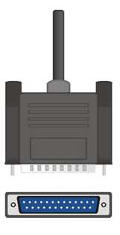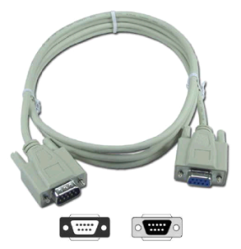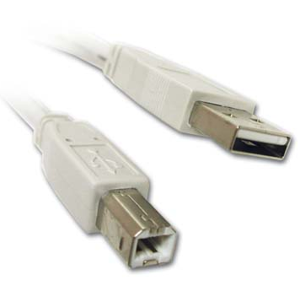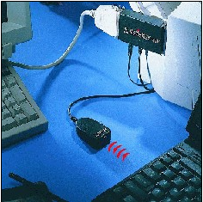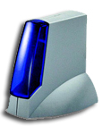
Parallel, Serial, USB, Infra-red, Bluetooth

77. Scan pictures
When a scanner is purchased, a picture scanning application comes with the scanner. Most of these applications are not accessible to screen readers, however modifications can be made for simple scanning access. Most scanners have buttons on the scanner itself, these buttons will either have pre-set functions or they can be set to the user's specifications. If the program is accessible the user can set these button functions, if not they can guide a user with visual access to setting the buttons. A user can experiment with the button functions by testing them, of course a sighted peer will be necessary in relaying information presented on the screen and its correspondence with the information scanned.
Microsoft word presents an accessible way to scan pictures. Using Microsoft Office Word 2003 or later, a user can scan pictures using the "from scanner or camera…" option in the "picture" submenu, from the "insert" menu, [alt, I, p, s]. An Insert picture from scanner or camera dialogue box will open, the cursor opens to the "device" combo box, the user can select the attached scanner by using the [up/down arrow] keys or first letter navigation. Resolution is can be changed one [tab] past the "device" combo box, use [right/left arrows] to choose "web quality" or "print quality." Print quality has more resolution. To scan and insert the picture [tab] to the "insert" button and press the [space bar].
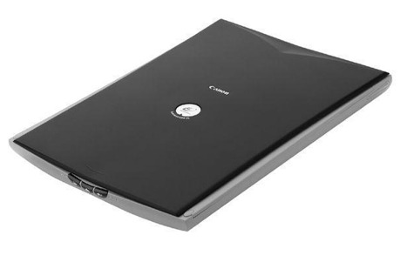

78. Scan to optical character recognition (OCR) program
Optical character recognition [OCR] is a program's ability to make sense out of printed information scanned onto the computer. A lexicon of characters is sorted by the OCR program in identifying printed information on a scanned document, the text is then presented as electronic text which can be read and manipulated by the user with or without vision.
Whether an OCR program is designed for users without vision or users with low vision there are usually keyboard short-cuts available to scan, read, and navigate the text. Standard Windows navigation commands will work, however if synthesized speech is available, often specific keyboard commands exist for each program. Options can be accessed without keyboard commands using the menu bar. The menu bar in any application can be accessed using the [alt] key. Subsequently [right/left arrow] will read the available menus, [down arrow] or [enter] key will open a menu, and [up/down arrow] will go through options within a menu. Use the [enter] key to select menu items.

79. Explore the use of tactile graphic readers [e.g. Intellitools, Talking Tactile Tablet, Iveo, etc.]
Tactile graphics are an essential component of reading and obtaining information for people without vision. Exploring available information as well as experimenting with self-authoring tactile graphics using a touch tablet can increase a user's knowledge of and ability to read tactile graphics. Tactile graphics standards should be referenced when creating tactile graphics for users with visual impairments. The Braille Authority of North America [BANA] guidelines for tactile graphics can be viewed at www.tactilegraphics.org. The International Council on English Braille [ICEB], Tactile Graphics Project can be viewed at http://www.iceb.org/icetac.html.
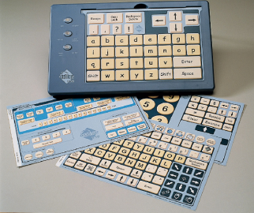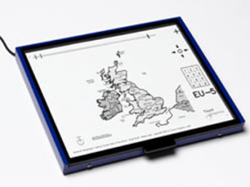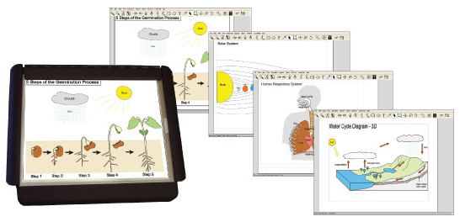
Intellitools, Talking Tactile Tablet (TTT), IVEO

80. Connect PDA and access files in either direction
Students with note-takers should be familiar with connecting their note-taker [PDA] to the computer to create back-up files and to open and transfer files. Though most file transferring is done using card media such as SD, USB, or compact flash cards, sometimes connecting to a computer is necessary to troubleshoot information or determine what files are on a note-taker. Connecting to a computer also allows a user without vision to display to a user with vision, who is unfamiliar with the device without a screen, what is on the system and saved in memory.

Network

81. Open and delete files to/from a network server
To view files on a computer other that the user is using, the My network places dialogue needs to be opened. This dialogue can be opened from the desktop by pressing and holding [Window key] and pressing [d]. Use the [tab] key to route the cursor to "network tasks" then use the [down arrow] to select "entire network." The cursor will route to the folder view/list view, select and press [enter] on "Microsoft Windows Network." Continue by using [arrow keys] and [enter] to select the desired drive and then [arrow keys] or first letter navigation and [enter] to select the desired computer. When the shared computer is opened all available shared files will be available to navigate and open. To open a file, select it an press [enter]. To delete a file, select it and press [delete], then [y] to confirm delete.
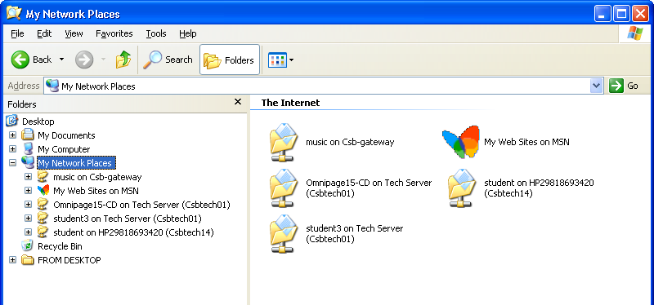

82. Share a folder over a network
When a folder is selected, press the [application] key then select "sharing and security…" and press [enter]. The default selection is "do not share this folder," use the [down arrow] to select "share this folder" then [tab] to the "apply" button and press [enter].
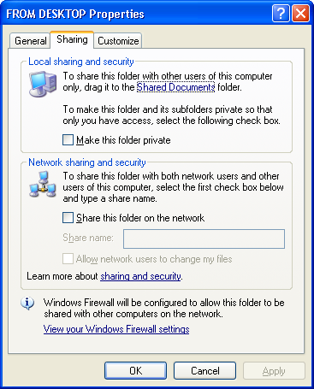
Techese: Users have control to make shared files so that they are read only and cannot be deleted. When a folder is selected, press the [application] key then select "sharing and security…" and press [enter]. [Tab] to the "permissions" button and press [space bar], a permissions for on desktop dialogue. [Tab] to the "allow" and "deny" checkboxes and select whether to allow or deny "change" or "read" options. Press [space bar] to select these options.
Another format for this depending on the version of Windows being used will open to the folder name dialogue "sharing" tab. Use the [tab] key to the "share this folder on the network" check box. Press [space bar] to select and share the folder. Use the [tab] key to "allow network users to change my files," if left unchecked users can read and view the file, but cannot modify it.

83. Share a printer over a network
To share a printer over a network so that other computers can access an attached computer, open "printers and faxes" from the "settings" submenu on the "Start" menu, [Window key, s, p]. The dialogue opens with the cursor in the folder view/list view, use the [arrow keys] or first letter navigation to get to the desired printer. Use the [application] key and select "sharing…" from the context menu. Use the [down arrow] to "share this printer" and type in the "share name" for the printer. Press [enter] or [tab] to the "apply" button and press the [space bar].

84. Access a shared folder over a network
Review steps in #81

85. Access a shared printer over a network
Review steps in #81 to find and select the desired printer. Copy the printer icon by using the "edit" menu or [control+c]. To add the network printer open "printers and faxes" from the "settings" submenu on the "start" menu, [Window key, s, p]. In the printers and faxes dialogue [tab] to the folder view/list view and paste the copied folder from the "edit" menu or by pressing [control+v]. The printer will now be available in the print dialogue from any program that has a print function.

Keyboard Shortcuts
Copy, file or content = [control+c]
Paste, file or content = [control+v]

86. Map a network drive
Mapping a network drive is configuring a file folder on another computer to share files and folders with and have available through my computer. From the my computer dialogue [Windows+e], go to the "tools" menu and select "Map Network Drive…"
When the map network drive dialogue opens a selected drive letter will be chosen based on what letters are available. To change the drive letter click [shift+tab] and use [up/down arrow keys] or letter navigation to select a new drive letter. Then [tab] to the "browse…" button and press the [space bar] to open the browse for folder dialogue. [Tab] to the list view and use the [up/down arrows] to select folder, and [left/right arrows] to expand and collapse folders, when desired folder is selected [tab] to the "ok" button and press the [space bar].
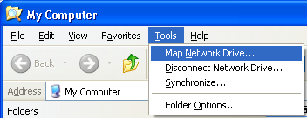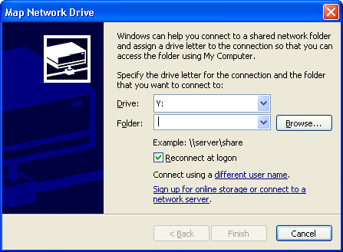

Word Processing

87. Navigate a document using arrow keys
The arrow keys are essential in navigating a document. They provide simple and effective navigating reading and cursor insertion. The [right/left arrows] move the cursor character by character. Holding down [control] and using the [right/left arrows] will move the cursor one word or punctuation at a time. The [up/down arrows] will move the cursor up/down a line of text. Please notice that the cursor is in the same position left to right as it was on the line it moved from. Holding down [control] and using the [up/down arrows] will move the cursor to the beginning of the paragraph, above or below where the command is given. Holding down [alt] and pressing the [up or down arrow] will navigate a user to the top of the current page.

Keyboard Shortcuts
Navigate character by character = [left/right arrow keys]
Navigate word by word = [control+left/right arrow keys]
Navigate line by line = [up/down arrow keys]
Navigate by style changes [i.e. heading vs. paragraph, etc.] =
[control+up/down arrow keys]

88. Navigate to the beginning or end of a line
The [home] and [end] keys are located in the six-pack of keys. When in a document, the [home] key will route the cursor to the beginning of a line, the [end ] key will route the cursor to the end of line.

Keyboard Shortcuts
Navigate to beginning of line = [home]
Navigate to end of line = [end]
Hint: Routing the cursor to the beginning or end of a line is especially important when inserting answers to questions. A screen reader will read a current line when the [up/down arrows] are used regardless of the cursor location. The user needs to press the [end] key to be sure they are answering a question after the question mark.

89. Navigate to the beginning or end of a document [control + home/end]
When the [control] key is held down, the function of the [home] and [end] keys change. [control + home] routes the cursor to the top of the document, whereas [control+end] routes the cursor to the end of a document.

Keyboard Shortcuts
Navigate to beginning of document/Window = [control+home]
Navigate to end of document/Window = [control+end]

90. Select Text
Adding the [shift] key to any navigation command will select the text. This will enable the user to copy or cut the text and paste it to another location.
To select all information within the application or document screen, use the select all command. From the "edit" menu, select "select all," [alt, e, a], or use the keyboard shortcut [control+a].

Keyboard Shortcuts
Select All = [control+a]

91. Copy/paste characters/words/paragraphs from documents
Information within a document needs to be selected prior to being copied. Holding down the [shift] key in combination with any navigation keys [see #'s 87-89] will select that group of text. After the text is selected, from the "edit" menu, select "copy," [alt, e, c], or use the keyboard shortcut [control+c]. A copy of text is a duplicate of the original, the original remains in its original place, the copied text is stored in the clipboard [a background application that is not visible to the user] until a paste command is given. Once copied to the clipboard, the user needs to route the cursor to the desired location to paste the information. From the "edit" menu, select "paste," [alt, e, p] or use the keyboard shortcut [control+v]. Information can be copied and pasted within the same document, to different documents, and even to separate applications.

Hint
Every time something is copied or cut to the clipboard, the clipboard content is replaced with the new content unless one appends to the clipboard. This feature is available in some screen readers.

Keyboard Shortcuts
Select characters/words/lines, etc. = [shift+navigation command]
Copy, file or content = [control+c]
Paste, file or content = [control+v]
Append to Clipboard = [windows key+c] JAWS

92. Cut/paste characters/words/paragraphs from documents
Information within a document needs to be selected prior to being cut. Holding down the [shift] key in combination with any navigation keys [see #'s 87-89] will select that group of text. After the text is selected, from the "edit" menu, select "cut," [alt, e, x], or use the keyboard shortcut [control+x]. Cutting text removes the selected text from where it was cut, the cut text is stored in the clipboard until a paste command is given. Once cut to the clipboard, the user needs to route the cursor to the desired location to paste the information. From the "edit" menu, select "paste," [alt, e, p] or use the keyboard shortcut [control+v]. Information can be cut and pasted within the same document, to different documents, and even to separate applications.

Keyboard Shortcuts
Select characters/words/lines, etc. = [shift+navigation command]
Cut, file or content = [control+x]
Paste, file or content = [control+v]

93. Change alignment
Standard text is usually aligned to the left of the page, the keyboard command to align left is [control+l]. The keyboard commands to center text is [control+e], to align right is [control+r], and to justify is [control+j]. Text does not need to be selected in order to set the alignment, the command given when the cursor is within a line will align the entire line accordingly.
Visually the alignment can be selected by clicking on one of the four buttons:

Keyboard Shortcuts
Center text = [control+e]
Align text to the left = [control+l]
Align text to the right = [control+r]
Justify text = [control+j]

94. Change font
The type of font can be adjusted by using the font dialogue. The font dialogue is located in the "format" menu [alt, o, f]. Once the font dialogue is open press the [tab] key twice to move to the "size" edit box. When the font dialogue opens the cursor is in the "font" edit box, and the user can type the desired font name, use [up/down arrow] keys to choose a desired font, or use first letter navigation to select a font by name. When desired font is selected press [enter] to confirm, or [tab] to the "ok" button and press the [space bar].
The font dialogue can also be opened by pressing the [application] key at any point in the document, then pressing [f], or using the [up/down arrows] to "Font…"
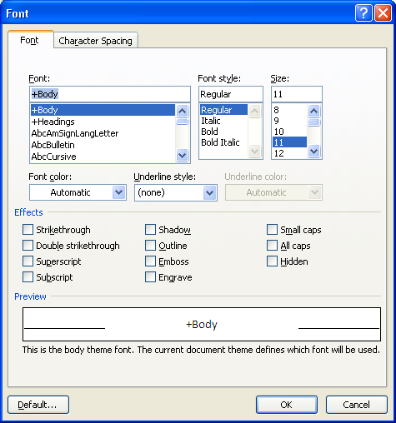
Hint: For students who have enough vision to view the screen, the "preview" pane at the bottom of the font dialogue shows the name of the selected font with any adjustments selected in the current font dialogue screen.
Hint: Font changes in documents can express a lot. Even users without vision need to have an understanding of different fonts. Try using a Micro capsule thermo imaging device or another tactile graphic production tool to demonstrate to a student the differences between several font types.

95. Change font style
The primary font style changes are bold, italic, and underline. The point of font styles is to draw attention to a word or phrase in a document. This is a visual print formatting technique and something that students with any level of vision should master regardless of their ability to see their changes. The lines that compose text are thicker when bold is on. The lines that compose text are slanted to the right when italic is on, this is a cursive style. Underlined text has a line underneath it.
The easiest way to make these changes is using keyboard shortcuts. Select the text to change the font style of [see #90-92]. Hold down [control] and press [b] to change the font style to bold face. Hold down [control] and press [i] to change the font style to italicize text. Hold down [control] and press [u] to change the font style to underline text. To return to standard text, use the same command to toggle off the font style [i.e. [control+b] will turn bold font back off].
Font styles can also be adjusted in the font dialogue. The font dialogue is located in the "format" menu [alt, o, f]. Once the font dialogue is open press the [tab] key once to the "font style" edit box. Use [up/down arrow] keys to choose a desired font style. When the desired font style is selected press [enter] to confirm, or [tab] to the "ok" button and press the [space bar].

Keyboard Shortcuts
Turn bold on/off = [control+b]
Turn italic on/off = [control+i]
Turn underline on/off = [control+u]

96. Change font size
Holding down the [control] key and pressing [[] [left bracket] will decrease the size of the font by one point. Holding down the [control] key and pressing []] [right bracket] will increase the size of the font by one point.
This adjustment can be made prior to typing in the new font size or to change text that has already been typed. To change the font size of text, select the text prior to adjusting the font size [see #90-92].
Remember to un-select your text after you change the size, pressing any navigation key will do this. If you forget to un-select the text, it will be replaced with the next input key. If this happens, lost text can be recovered by using the undo command [control+z].
Font size can also be adjusted by using the font dialogue. The font dialogue is located in the "format" menu [alt, o, f]. Once the font dialogue is open press the [tab] key twice to the "size" edit box. Type the desired font size or use [up/down arrows] to select the font size. Press [enter] to confirm, or [tab] to the "ok" button and press the [space bar].
The font dialogue can also be opened by pressing the [application] key at any point in the document, then pressing [f], or using the [up/down arrows] to "Font…"

Keyboard Shortcut
Increase font size = [control+[]
Decrease font size = [control+]]
Undo = [control+z]

97. Change font color
Within the font dialogue, [tab] to the "font color" combo box. Use the [down arrow] key to open the combo box, and then use the [up/down arrow] keys to select the color of choice. Press [enter] to select the desired color. If more colors are desired [tab] to the "more colors…" button and press [enter]. Within the colors dialogue [tab] once, then use the [left arrow] to access all colors.
Remember to select the text you wish to change the color of prior to selecting a new color. If a font color is selected prior to entering text, remember to change the font color back to black to return to normal. Because of this requirement, it may be easier to type text, then select it and change color.
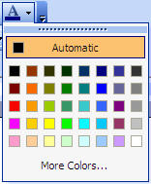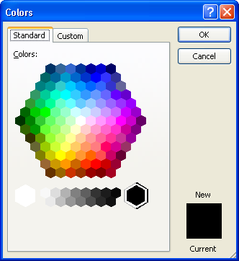

98. Change font effects
Within the font dialogue, [tab] to the "effects" pane. This section is composed of check boxes of the following items: strikethrough, double strikethrough, superscript, subscript, shadow, outline, emboss, engrave, small caps, all caps, hidden. Use the [up/down arrows] or [right/left arrows] to navigate through the selections, use the [space bar] to select a font effect. When all desired font effects are selected press [enter] to confirm, or [tab] to the "ok" button and press the [space bar]. Only certain font effects can be combined.
99. Undo and Redo
The undo command can be found from the "edit" menu; select ”undo," [alt, e, u], or use the keyboard shortcut [control+z]. In some applications undo can be used repeatedly. Redo is only visible in the "edit" menu after an undo command has been applied. The keyboard shortcut for redo is [control+y], or through the menu it is [alt, e, r].

Keyboard Shortcuts
Undo = [control+z]
Redo = [control+y]

100. Use outline format [numbering or bullets]
Bullets and numbering can be an effective way to create a list of ideas, or outline format for organizing ideas. The bullets and numbering dialogue can be accessed through the "format" menu, then selecting "bullets and numbering…," [alt, o, n].
The bullets and numbering dialogue can also be opened by pressing the [application] key at any point in the document, then pressing [n], or using the [up/down arrows] to "Bullets and Numbering…"
The bullets and numbering dialogue opens in the "bulleted" tab, different styles of bullets can be chosen using the [right/left arrow] keys. When desired bullet set is selected, press [enter] or [tab] to the "ok" button. To select different numbering styles, hold [control] and press [tab], to move to the "numbered" tab, then follow the same steps to selecting a bulleted item.

101. Spell Check
Most word processors have a spell check application of some kind. Most work by finding words whose spelling does not match with the words in the program lexicon, checking from the cursor point to the end of the document, then from the beginning of the document to the point of cursor. Because Microsoft Word is the most common word processor in education the spell check dialogue in Word will be reviewed here.
From the "tools" menu, "spelling and grammar…" can be selected to begin the spelling and grammar check, or the keyboard shortcut [F7] can be used.
When the Spelling and Grammar Error: English [U.S.]is opened, the cursor begins in the not in dictionary pane. The primary suggestion is highlighted and read by screen readers, pressing the [enter] key will select the "change" button to switch the misspelled word with the suggestion or correct the grammar error, or select the "ignore once" button if no suggestions are available. If the primary suggestion is not desired, the [tab] key will move the cursor to the suggestions pane, within this pane the [up/down arrow] can be used to access other suggestions. When a selection is desired, the [enter] key will select the "change" button.
The "change all" and "ignore all" buttons affect all errors of the same kind throughout the rest of the document. This is commonly used for proper names of persons and products.
Spelling errors are made visible by many applications by a red squiggly line underneath the misspelled word. A green squiggly line indicates a grammar error. When the cursor is on an error, the [application] key will pull up a context menu of suggestions.
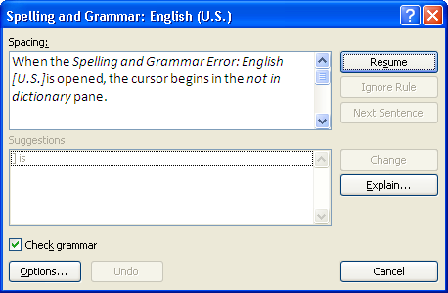

Keyboard Shortcuts
Open spelling and grammar dialogue = [f7] Microsoft Office
Open spelling errors dialogue = [insert+f7] JAWS
Hint: When using JAWS screen reader, the key combination [alt+shift+l] will open a spelling errors dialogue. The user can use [up/down arrows] to select a misspelled word and [enter] to route the cursor to the word in the document, then use the [application] key to bring up a spelling suggestions context menu, use [up/down arrows] to find the correct word. JAWS users can press [insert+5,5] on the numeric keypad to hear the word spelled, and [enter] to replace the misspelled word with the selected word.

102. Use thesaurus
In Microsoft Office 2003 the thesaurus can be opened from the "tools" menu, under the "language" submenu, [alt, t, l, t] or [shift+f7]. If the cursor is on a word, then the thesaurus will automatically search for synonyms for the current word. If the cursor is not on a word then the thesaurus will be empty. Use [f6] to switch panes to the "research" task pane, and the "search for" edit box of the thesaurus. Type the desired word and press [enter]. Use the [tab] key to the list view and use the [up/down arrow keys] select a word. To insert a word into the document, press the [application] key and press [enter] on "insert.”
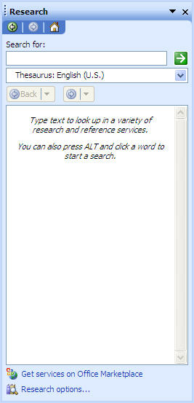

Keyboard Shortcuts
Open thesaurus = [shift+f7] Microsoft Office

103. Manipulate line spacing
Often it is necessary or helpful to manipulate line spacing, such as double space a document for print formatting or for review. Line spacing can be determined prior to typing or after text has been selected. From the "format" menu, select "paragraph…" [alt, o, p]. The paragraph dialogue will open in the "indents and spacing" tab, use the [tab] key to the "line spacing" combo box. Use the [down arrow] to select the line spacing desired. When the desired line spacing is selected [tab] to the "ok" button and press the [space bar].
Visually line spacing can be selected by clicking the following button from the formatting toolbar:

104. Format columns
Columns can be used from the "format" menu, select "columns…," [alt, o, c]. Within the columns dialogue, the cursor is routed to the "number of columns" combo box. The setting is defaulted to "1" column, the [up arrow] can increase the number of columns on the page. More than three columns on a page may create difficulty in reading depending on the orientation of the paper and font size. Setting a thin column along the left or right side of the paper can be done by using [shift+tab] to move the cursor to the "presets" pane and use the [left/right arrow] to "left" or "right" preset for columns. When the preset is selected [tab] to the "ok" button and press the [space bar], or press [enter].
Visually up to four columns can be selected by clicking the following button from the standard toolbar.

105. Insert image
A variety of images can be inserted into a document. Files downloaded from the Internet or collected using computer peripheries such as a digital camera can be saved onto the computer and inserted into a document. Clip art can also be used within a document. Clip art is a collection of graphics available for use in production. Most clip art images are simple computer generated line drawings with or without fill colors, though some photographs are collected as clip art. See #77 Scan images about scanning pictures directly into the word processor.
In Microsoft Word 2003 to insert an image, use the "insert" menu and navigate to the "picture" submenu, [alt, i, p]. To insert a clip art file, select "clip art…" [alt, i, p, c]. To insert an image from a file select "from file…" [alt, i, p, f].
When inserting from clip art, a task pane to the right of the screen is opened. This task pane can be hidden by holding [control] and pressing [f1], the same keyboard shortcut will reveal it again. In the clip art task pane, the cursor begins in the "search for" edit box. The user will type in their desired search. To determine what clip art collections to search through [tab] to the "search in" combo box and press [down arrow] to open it. Use [space bar] to select and un-select items, having "web collections" checked will cause the search to take longer however will provide more results, as long as an Internet connection is available. To collapse the "search in" combo box press [escape]. Use the [tab] key to the "results should be" combo box, follow the steps for the "search in" combo box to select: all media types, clip art, photographs, movies, or sounds. Use [shift+tab] to select the "go" button and press the [space bar]. The search will begin. [Tab] to the list box. The default setting has two rows of clip art displayed. This can be changed by using the mouse to change the width of the task pane. With the two rows [up/down arrows] will navigate each row, the [right/left arrows] will switch between the rows. When a desired image is selected, use the [application] key and select "insert" from the context menu, [application, i].
To insert an image from a file, open the insert picture dialogue from the "insert" menu, [alt, i, p, f]. The insert picture dialogue is similar to the open and save as dialogues. Use the [tab] key to the "look in" combo box, using the [up/down arrows] to select the drive or folder where the image is located. Navigate using the [tab] key to the folder view/list view. Use the [arrow keys] or first letter navigation to select a file, [tab] key to the "insert" button and press [enter].
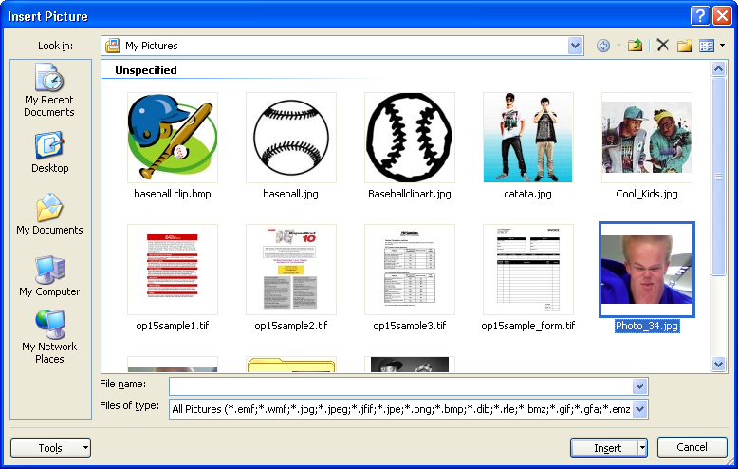
Hint: The default view for the folder view/list view is set to thumbnails. To change this to list view, use the [tab] key to the toolbar, then use the [right/left arrow] keys to view sub menu, use [up/down arrow] keys to select "list" and press [enter].

106. Use word wrap with images
In Microsoft Word 2003, wrapping text can allow the pictures in a document to fit in line with the text. Wrapping text will make the picture in the document fit and its edges serve as an anchor point on the page for the text, so that there is not a surplus of white space as there normally is without text wrapping.
Choose the point in the text and insert the image [see #105 and #77 on inserting images]. Select the image and press the [application] key, from the context menu press [enter] on "format picture…" This will open the format picture dialogue. This dialogue can also be opened from the "format" menu, select "picture," [alt, o, i]. Hold down [control] and press [tab] to the "layout" tab. Use the [tab] key to the "wrapping text" pane and use [right/left arrow] keys to select "tight" wrapping style. To select the horizontal alignment within the page [tab] key to the "horizontal alignment" pane and use [right/left arrow] keys to select: left, center, right, or other. When selections are made [tab] to the "ok" button and press the [space bar], or [enter].
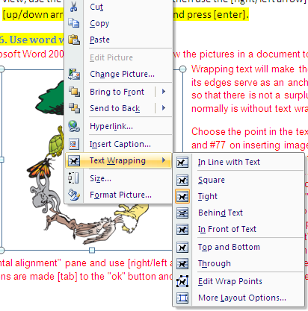

107. Utilize header and footer

A header or footer is text or graphics that is usually printed at the top or bottom of every page in a document. A header is printed in the top margin; a footer is printed in the bottom margin.
Headers and footers can be as simple as the document title and a page number, but you can create headers and footers that contain graphics, multiple paragraphs, and fields. You can specify a different header or footer for odd and even pages or use a different header or footer for the first page of a section or document. If you divide a document into sections, you can use different headers and footers in each section. For example, you might want the header for each section to reflect the title of that section.
To access the header and footer, open the "view" menu and select "header and footer," [alt, v, h]. This will route the cursor into the header, which text and graphics can be inputted into as if it were a standard document. To access the footer use the [down arrow] past the final line in the header and the cursor will relocate to the footer. To go back to the header use the [up arrow] past the uppermost line in the footer.
The default setting for the header and footer is for the information to repeat on every page of the document. To return to the rest of the document, either press the [space bar] or the "close" button in the header and footer tool bar, see below, or hold [alt] and press [c].
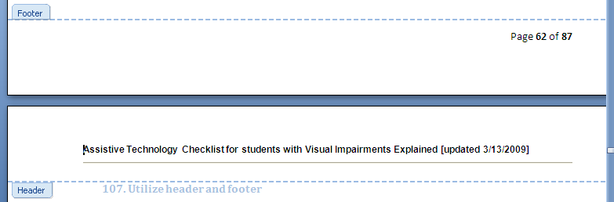
Hint: The header and footer dialogue is not accessible to screen readers. However, it can be added as a toolbar alongside the standard and formatting toolbars, and can then be accessed by holding the [control] key and pressing [tab], then using the [left/right arrows] and [enter] to navigate and open options. To move the dialogue into the toolbar, have a mouse user click and drag from the title bar of the dialogue into the toolbar region. From this point on, the header and footer dialogue should now function as a toolbar.

108. Insert footnotes
To insert a footnote, open the "reference" sub menu from the "insert" menu, and select "footnote…," [alt, i, n, n]. This will open a footnote and endnote dialogue, where the default setting is for footnotes at the bottom of the page numbered sequentially starting with 1. If this format is desired [tab] key to the "insert" button and press [space bar], or press [enter].
To choose between footnotes and endnotes use the [up/down arrows] on the radio buttons in the "location" pane. To choose the location [tab] to the combo boxes for either "footnotes" or "endnotes" and use the [up/down arrows] to make a selection. If a different number format is desired, [tab] key to the combo boxes in the "format" pane and use [up/down arrows] to select options. When desired settings are selected [tab] to the "insert" button and press the [space bar], or press [enter].
Techese: If the user presses the "apply" button instead of the "insert" button, the changes made in the footnote and endnote dialogue will be saved for further uses.

109. Sort
The default setting for sorting Microsoft Word 2003 is to sort in ascending alphabetical order of paragraphs. Text can be sorted in descending order and can be sorted by columns or fields in a table as well. From the "table" menu, select "sort…," [alt, a, s]. This will open the sort text dialogue. The cursor starts in the "sort by" combo box, the [up/down arrow) keys will manipulate this box, as well as the next combo box, the "type" combo box one [tab] away. To alphabetize paragraphs of text, no changes need to be made in the sort text dialogue. The dialogue needs to be opened [alt, a, s], then [tab] to the "ok" button and press [space bar], or press [enter].
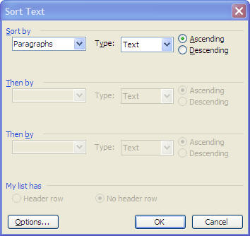

110. Conduct word count
A word count can be effective in determining the specific number of words of a document. From the "tools" menu, select "word count…," [alt, t, w]. The word count dialogue that opens displays the number of pages, words, characters [no spaces], characters [with spaces], paragraphs, and lines within the document. A checkbox to include any footnotes and endnotes is also available. To select this, [tab] to the checkbox and press [space bar] to select it.
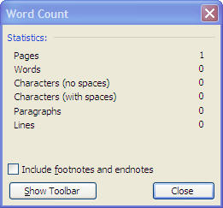
Hint: There is not a beginning point within the word count dialogue to start reading or to [tab] to. In order to read the information in the dialogue press and hold [insert] and press [b] when using JAWS.
Hint: The word count dialogue can be added to the toolbar in the same way the header and footer dialogue can be (see #107).

111. Determine number of pages
Visually the page number and total number of pages are displayed in the status bar.
In JAWS screen reader, hold down the [insert] key and press [3], this will read the information on the status bar.

Keyboard Shortcuts
Read the information on the status bar = [insert+3] on the numeric keypad JAWS/SystemAccess

112. Manipulate margins
In Microsoft Word 2003 the page margins can be adjusted in the page setup dialogue. Open the "file" menu, use the [up/down arrows] to select "page setup…" and press [enter], or [alt, f, u]. In the page setup dialogue the cursor begins in the "top" margin spin box. Use the [up/down arrows] to increase or decrease the size of the margins, use [tab] and [shift+tab] to access the other margins; bottom, left, and right. When margins have been set to their desired specification, [tab] to the "ok" button and press the [space bar], or press [enter].
Most printers are set to print only with margins greater than or equal to half an inch [0.5"].
Techese: If you have determined that a changed setting is the standard setting desired for a particular computer, [tab] to the "default…" button in the page setup dialogue and press [space bar]. When activated a Microsoft Office Word dialogue will open asking to confirm that change in default settings. To continue with the changes [tab] to the "Yes" button and press [space bar], or use [y].

113. Add page breaks to a document [bibliography]
Page breaks can be inserted into a document so that information beyond the page break begins on the next page. This can be helpful in creating chapters or sections of a document.
To add a page break select "break…" from the "insert" menu, [alt, i, b]. This will open a break dialogue, where "page break" is already the selected radio button, [tab] to the "ok" button and press the [space bar], or press [enter]. A hard page break can be deleted by using the [backspace] or [delete] keys near the page break.
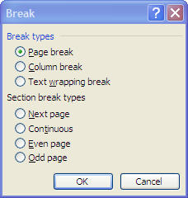

Keyboard Shortcuts
Create page break = [control+enter]
Techese: A soft page break occurs when the software automatically creates a new page when a page has been filled. Putting a page break into a document is called a hard page break or forced page break.

114. Add page numbers to a document
Page numbers can be inserted into a document from the header and footer dialogue. Select the "page number" button from the dialogue, this will insert the page number into the header or footer, depending on where the cursor was when the dialogue was opened. To insert the number of pages in the document, select the "insert number of pages" button. Place holder for the page number and number of pages are placed in the header and footer and will change as the amount of information in the document changes.
When inserting both the page number and the total number of pages it is a good idea to put something in between such as the word "of" or a hyphen [-] to explain the numbers.
Hint: Please reference the hint in #107 to move the header and footer dialogue to the toolbar to create accessibility for screen readers.

115. Select page orientation [portrait or landscape]
Page orientation is the way in which a rectangular page is oriented for normal viewing. The two most common types of orientation are portrait and landscape. Portrait orientation is where the height of the page is greater than the width, and is more common for the pages of books. Landscape orientation, where the width of the page is greater than the height, is often used for images and diagrams that need to be wider than a portrait page.
Page orientation can be adjusted in the page setup dialogue, that can be accessed through the "file" menu [alt, f, u]. Use the [tab] key to the orientation pane, then use the [left/right arrows] to select either "portrait" or "landscape." When page orientation has been set, [tab] to the "ok" button and press [space bar], or press [enter].
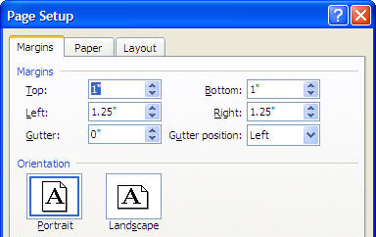
Techese: Some LCD monitors can be turned on their side, and the screen can be viewed in a portrait or landscape mode. This can be beneficial for users with low vision when performing certain tasks. If the screen is able to turn on its side, hold down [control] and use the [arrow] keys to set the screen to the new right way up. The keyboard shortcut [control+arrow keys] will adjust the direction of the screen only on computers that have a video card that can support this function.

116. Print in accessible format [e.g. print, large print, Braille, Braille and print]
It is an essential skill that a student can print information both in a presentable format to give to a reader with normal vision and to print so they have access to the document themselves. In Microsoft Office 2003 there is not a control within the print dialogue that allows the user to choose a font size to print to. Therefore the user will need to select text in the document, change the font size, then send the document to print.
Please reference #96 Change Font Size, #'s 87-89 and #90 about selecting text.
Here is a quick how to for embossing braille using the Duxbury braille translator software:
Steps to Emboss a Document
- Open Duxbury Application. To do this press the [Window key] to open the Start Menu, then [d] for Duxbury (this step assumes that Duxbury is present on the Start Menu if it is not, then select the "Duxbury" folder from the "Programs" submenu in the Start Menu.
- In Duxbury go to the "file" menu [alt], then press [o] for "open". This could also be done by pressing [control+o].
- Within the "Select Document File" dialogue, to confirm this press [insert+t].
- [Tab] until you find "Look In" combo box, or press [alt+i].
- Use the [up/down arrows] to find 3 1/2 Floppy.
- [Tab] to the folder view/list view.
- Use [up/down arrow keys] to select file you wish to emboss
- Press [enter] key, or [tab] to the "open button."
- Duxbury will load the document, it can be navigated as a document in Microsoft Word document can.
- Press [control+t] to translate the file to braille.
- Press [control+e] to emboss the file.
- In the File: Emboss dialogue, press [enter].
- The file will emboss, go get it!

Keyboard Shortcuts
Select all = [control+a]
Translate file = [control+t] Duxbury
Emboss file = [control+e] Duxbury

117. Select number of copies in print dialogue
The print dialogue can be accessed through the "file" menu [alt, f, p], or by using the keyboard shortcut [control+p]. Inside the dialogue, the cursor beings in the "number of copies" spin box, use the [up/down arrows] to change the number of copies, or type in the desired number of copies.
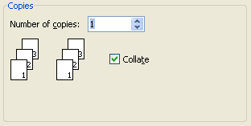

118. Select page range in print dialogue
The print dialogue can be accessed through the "file" menu [alt, f, p], or by using the keyboard shortcut [control+p]. Inside the dialogue, [tab] to the "page range" pane and use [up/down arrows] to select "all," the "current page," or specific pages "pages" [this option will require typing in the desired pages with a [-] in between].
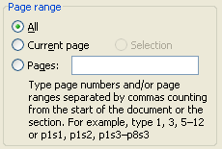

119. Select printer in print dialogue
The print dialogue can be accessed through the "file" menu [alt, f, p], or by using the keyboard shortcut [control+p]. Inside the dialogue, [tab] to the "printer name" combo box. Navigate to the desired printer using the [up/down arrows] or first letter navigation. When the desired printer is found press [enter] or [tab] to select the printer.
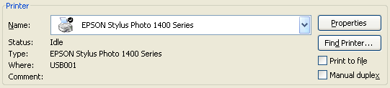

120. Select media and paper source in print dialogue
The print dialogue can be accessed through the "file" menu [alt, f, p], or by using the keyboard shortcut [control+p]. Inside the dialogue, [tab] to the "properties" button and press the [space bar], this will open the 'printer name' properties dialogue. Use [tab] to the "paper source" combo box to tell the printer what tray the paper is in, use the [up/down arrow keys] to select the paper source available. Use the [tab] key to the "type" combo box to set the type of paper being used, use the [up/down arrow keys] to select the paper type. Once preferences are selected [tab] to the "ok" button and press the [space bar], or press [enter]. The properties dialogue will close and the cursor will be in the print dialogue.
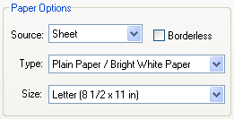
Hint: Depending on the printer being used, its properties dialogue may be different. Use the [tab] key to go through available options and use [up/down arrow] keys to make selections.

121. Print to PDF
The portable document format or PDF, is a document that maintains the format and features of a document, including pictures and text. Not all computers come with a PDF printer already in place. In Microsoft Office 2003, the "Microsoft Document Image Writer" printer option is made available when Microsoft Office is updated, please reference #56 Look for program updates.
Use [tab] to the "printer name" combo box. Navigate to the desired printer using the [up/down arrows] or first letter navigation, PDF print options other than "Microsoft Document Image Writer" are available and some are installed when certain programs are installed onto the computer. When the desired printer is found press [enter] or [tab] to select the printer. When the "ok" button is pressed to send the document to print, rather than printing the save as dialogue will open. Please reference #49 Navigate the save as dialogue.
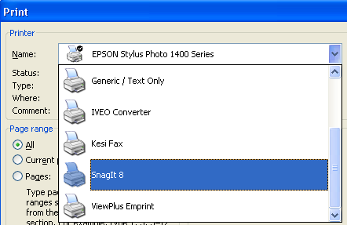
Hint: PDF's can be used to ensure desired formatting when a printer is not available. They can also be used to make documents accessible to any user regardless of their ownership of the document's creation software on their computer. Adobe reader is a free software program available from www.adobe.com that can open and read PDF documents.

Internet

122. Open desired URL
A URL is an address for a webpage on the World Wide Web. By entering a specific URL, a specific webpage will be opened. Usually URL's begin with "www." and end with a three letter extension depending on the type of website [i.e. ".com", ".org", ".edu"].
There are three ways to open a desired webpage. Two possibilities require the Internet browser to be open. From the "file" menu, select "open…" [alt, f, o] this opens an open dialogue with an edit box to type in the desired URL. After typing in the web address [tab] to the "ok" button and press [space bar], or press [enter]. This will open the webpage and the cursor will be placed at the top of the webpage. The open dialogue can also be opened by the keyboard shortcut [control+o].
Another method within the Internet browser is to use the address bar. The address bar is the input box at the top of the browser Window that shows the URL [Internet location] of the currently displayed web page. It is also used to type the domain address you wish to visit. To access the address bar hold down [alt] and press [d]. The current address will be selected, a new address can be typed over the existing address.
The third method to open a desired URL is to use the run dialogue from the start menu. Open the start menu with [Windows] key and open "run…" by using [up/down arrows] or [r]. The run dialogue will open, and the user can type in the desired URL and [tab] to the "ok" button and press the [space bar], or press [enter].
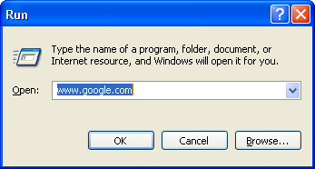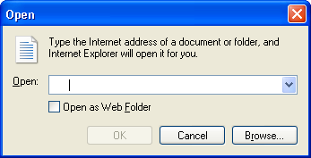

Keyboard Shortcuts
Route cursor to address bar = [alt+d]
Open new URL dialogue = [control+o]
Open run dialogue= [Window key, r]
Hint: Accessing the address bar is important when the user wishes to share the location of a webpage they found. After [alt+d] to address the URL, the user can copy the text with [control+c], and paste [control+v] the URL into another application [i.e. word processor, e-mail, etc.].
Techese: URL is an abbreviation for Uniform Resource Locator

123. Use navigation features of browser [e.g. “back,” “forward”]
When in Internet Explorer, the navigation features of the browser are available through the "view" menu. Access the "view" menu by going to the menu bar [alt] then pressing [v], use [up/down arrows] to make selections in the view menu.
From the "go to" sub menu, an option for "forward" and "back" can be selected if applicable to the current location and previously viewed pages. The "forward" option [alt, v, g, f] or [alt+right arrow] opens the page accessed previously that is one link deeper than the page that is currently being viewed. The "back" option [alt, v, g, b] or [alt+left arrow] opens the previous page viewed. It is also possible to navigate to the home page using the menu bar [alt, v, g, h] or the keyboard shortcut [alt+home].
If a webpage is taking a long time to open, sometimes it is beneficial to stop the loading of the page. The keyboard shortcut to stop loading is the [escape] key, through the menu it is in the "view" menu, select "stop" [alt, v, p].
Another option to get a webpage to load correctly, or if a webpage has continuously updating content is to refresh the screen. In the view menu, select "refresh" [alt, v, r] or use the keyboard shortcut [f5].

Keyboard Shortcuts
Go to previous page = [backspace] or [alt+left arrow]
Go to page prior to accessing previous page = [alt+right arrow]

124. Conduct basic search for websites
For the purpose of this guide, the Google website will be used for conducting basic searches. To access the Google webpage, open www.google.com [see #122]. When the Google page opens the cursor begins in the edit box. If the user navigates out of the edit box, they can navigate back to the edit box by clicking within it, using the [tab] key to find it, or if using JAWS they can press [e]. Type in the desired search terms and [tab] to the "Google search" button and press the [space bar], or press [enter]. Many screen readers require that forms mode be turned on in order to type into an Internet page. This is because letter keys are used to navigate elements of the page, forms mode indicates that letters will be used for typing. Forms mode can be turned on using the [enter] key. With some screen readers forms mode is automatically turned on when the cursor is placed into the text entry field.
After typing in the search words and activating the search button, Google will search the Internet and display a new page with the results of its search. The new page will present each item found with a linked heading [that can be accessed using [h] with JAWS]. Below the linked heading is a short description of the webpage. The user should be able to determine if the webpage is worth a further look from the heading and description. Below the description is the URL of the webpage.
To access the webpage found through the Google search, the linked heading will need to be activated. This can be done by clicking on it or pressing [enter] when the linked heading is selected.
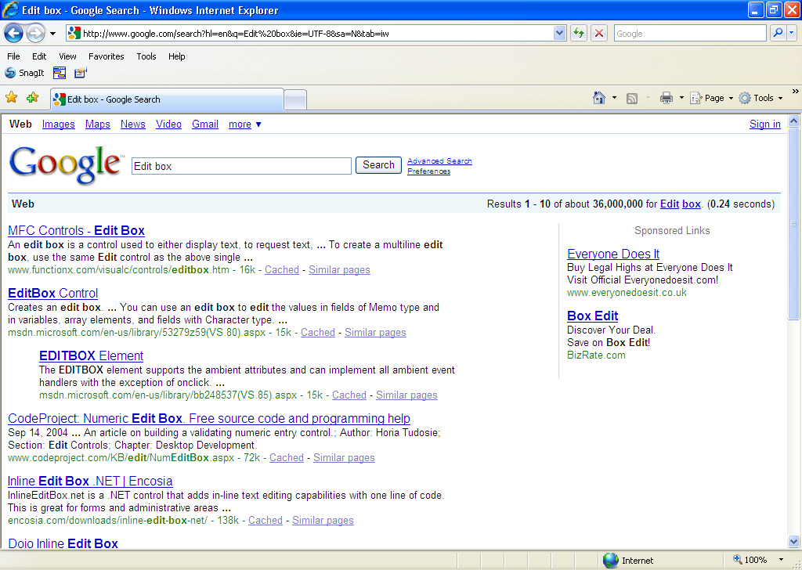

Keyboard Shortcuts
Turn forms mode on = [enter] JAWS/SystemAccess
Navigate headings on Internet = [h] JAWS/SystemAccess
Hint: A lesson about keywords can be beneficial to using the search engines. Users should determine the keywords of the idea they are searching for, this will shorten the list of web-pages found and sort for more relevant pages. Google can also interpret searches written in question form in the search edit field!
Hint: When using JAWS of System Access, find the linked heading by using the [h] key. When a heading sounds appropriate to the search, use the [down arrow] key to read the description. If the current selection is desired, use the [up arrow] back to the linked heading and press [enter]. If the user wishes to skip the current selection and find the next search result, use [h].

125. Conduct basic search for images
An image search through Google can be done before or after a standard Google search of the web has been conducted. If the user is beginning their search they can open the address www.google.com/images, or images.google.com. The same steps as #124 will be used to conduct the search. If a search has already been conducted and the user wishes to search for images rather than the web, a user with vision can click the "images" link at the top of the screen. Using JAWS the user can open the links list by holding down [insert] and pressing [f7]. The links list dialogue will open and the links will be listed as they appear on the webpage, the cursor will begin at the point the links lists was opened from on the webpage. Use [up/down arrows] or first letter navigation to select a link, in this case use [i] to find images, and press [enter].
When using the pointer, clicking on the image will open it to a new page that shows the content of the page is a large pane, and displays a thumbnail of the picture in the top pane, the cursor begins in the top pane. The trouble with using the keyboard and a screen reader to find images is that images are labeled differently depending on how they were posted to the web. Most pictures are not posted with good alt tags [written descriptions of images that can be read using a screen reader]. Using the [arrow keys] the user can navigate the pictures in the Google search. The user should listen for the word "link" prior to the label of a picture. This will cue them that the cursor is on a picture, pressing [enter] will open the subsequent two pane screen that has a thumbnail of the image.
On the subsequent page, activate the "see full size image” link. If a screen reader is being used, this can be done using the links list dialogue [insert+f7]. From here a new page opens that only displays the image. Use the right-click on the mouse or [application] key to open a context menu for the image and select "save picture as…" [application, s]. This will open a save picture dialogue that is the same as the save as dialogue (see #49).
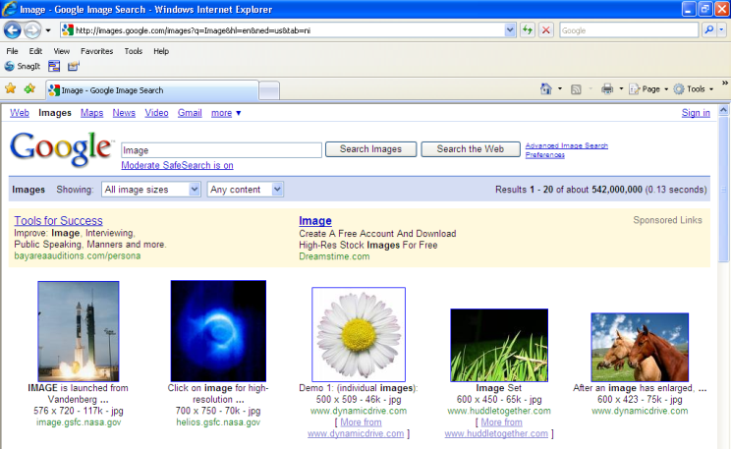

Keyboard Shortcuts
Turn forms mode on = [enter] JAWS/SystemAccess
Navigate headings on Internet = [h] JAWS/SystemAccess
Open links list dialogue = [insert+f7] JAWS/SystemAccess

126. Conduct basic search for news
A news search through Google can be done before or after a standard Google search of the web has been conducted. If the user is beginning their search they can open the address www.google.com/news, or news.google.com. The same steps as #124 will be used to conduct the search. If a search has already been conducted and the user wishes to search for images rather than the web, a user with vision can click the "news" link at the top of the screen. The JAWS or System Access user can open the links list by holding down [insert] and pressing [f7].
The page that loads has three main columns. The left most column has search links that can further consolidate a search. The center column has the search results for news. The right column has a list of sponsored links. The cursor will read the entire left column, then center, then right. To access the webpage of the news result, press [enter] on the title/heading of the article.
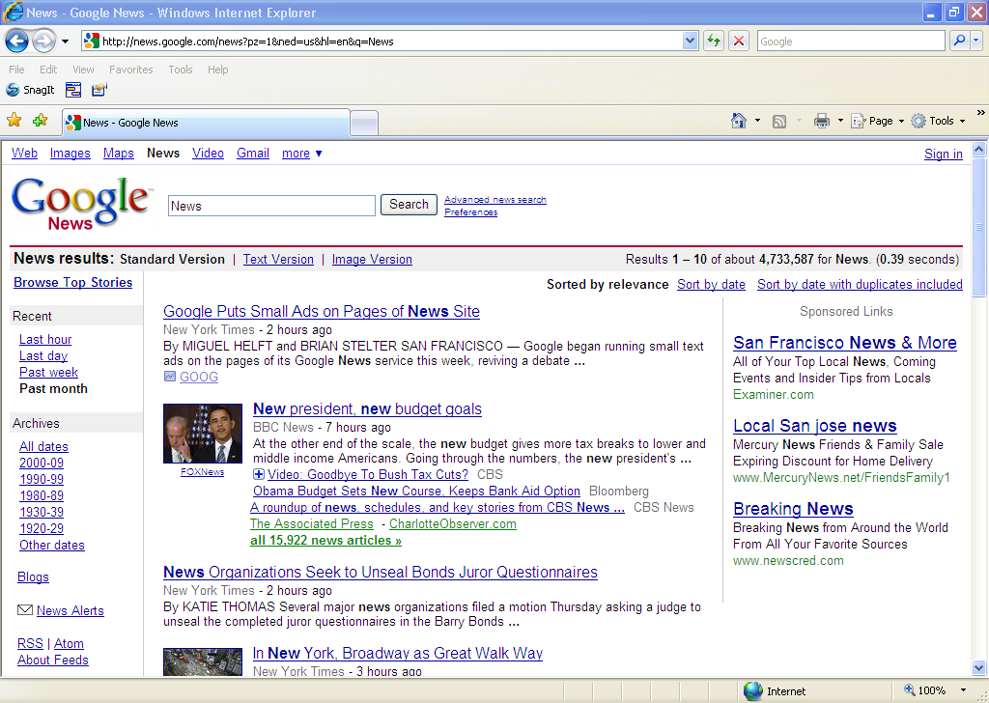

Keyboard Shortcuts
Turn forms mode on = [enter] JAWS/SystemAccess
Navigate headings on Internet = [h] JAWS/SystemAccess
Open links list dialogue = [insert+f7] JAWS/SystemAccess
Hint: If using the JAWS screen reader, the user can press [n] to find non-linked text. This will route them to the byline of the desired articles. From here the [up/down arrows] can be used to access the title/link for the article and short descriptions of the article.

127. Copy/paste characters/words/paragraphs/full articles
To copy and paste characters, words, and paragraphs from a webpage the same techniques will be used as are used in a document [see #28-29]. Full articles can be copied using the "select all" command [control+a] or by saving the webpage using the "save as" option from the "file" menu. If the page is saved using the save as dialogue it will be saved in a format that requires a web browser to open.

Keyboard Shortcuts
Select characters/words/lines, etc. = [shift+navigation command]
Copy, file or content = [control+c]
Paste, file or content = [control+v]

128. Download images from Internet
Please follow the steps outlined in #125 Conduct basic search for images.

129. Set desired homepage
The homepage [often written as home page] is the URL or local file that automatically loads when a web browser starts and when the browser's "home" button is pressed. The keyboard shortcut to go to the homepage is [alt+home]. A specific URL can be set as the homepage or a blank page can be used.
To change the homepage in Internet Explorer, access "Internet Options" from the "Tools" menu [alt, t, o]. The Internet options dialogue opens in the "general" tab with the cursor highlighting the current homepage. To set the homepage to a desired URL, type the URL [e.g. www.laurasmurals.com]. If the page that is loaded when the Internet option dialogue was opened is desired as the home page, [tab] to the "use current" button and press the [space bar]. If no homepage is desired [tab] to the "use blank" button and press the [space bar]. When the homepage is set, [tab] to the "apply" button and press the [space bar].
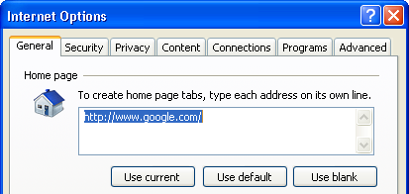

130. Add to favorites
In Internet Explorer, the "Favorites" menu can be used to remember websites [alt, a]. The user can organize the menu and label website links by name, and can organize the menu with categorized folders as well. This can be an effective way to resource webpages that are difficult to remember.
Webpage's can be added to the favorites menu by selecting "Add to Favorites…" from the "favorites" menu, [alt, a, a]. The Add a Favorite dialogue will open with the cursor selecting the default name of the current page, in the "name" edit box. The user can type over this name to name the webpage themselves or accept the given name. To determine whether to have the link to the page be in the general "favorites" menu or within a folder in menu, [tab] to the "create in" combo box. Use the [up/down arrow keys] to select from the pre-existing folders, press [enter] to select a folder. If a new folder is desired, [tab] to the "new folder" button and press the [space bar]. The Create a Folder dialogue will open, type the new folder name into the "folder name" edit box and specify its location in the "create in" combo box, then [tab] to the "create" button and press the [space bar].
Items in the "favorites" menu can be accessed using [up/down arrows] in the menu, along with [right arrow] to expand submenus and [left arrow] to collapse submenus. First letter navigation can also be used to navigate the "favorites" menu.
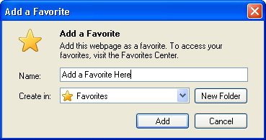

131. Organize favorites
To organize the "favorites" menu, select "Organize Favorites…" from the "favorites" menu, [alt, a, o]. This will open the Organize Favorites dialogue. This dialogue is composed of a folder view/list view containing the webpage links and folders contained in the menu as well as four button options to organize the menu: new folder, move…, rename, and delete….
To select an item to organize, [tab] to the folder view/list view and use [up/down arrows] or first letter navigation to select the desired item. Use the [tab] key to select the appropriate button.
When the "new folder" button is activated, a new folder is created and the user can type the name of the new folder and press [enter], the cursor remains in the folder view/list view with the new folder selected.
When the "move…" button is activated, a browse for folder dialogue is opened, use the [up/down arrow keys] or first letter navigation to select the desired folder to move the item to, or select the "make new folder" button to make a new folder in which to place the item.
When the "rename" button is activated the current item or folder name is selected, and the user can type the new name in and press [enter] to finalize.
When the "delete…" button is activated a confirm folder or file delete dialogue opens, [tab] to the "yes" or "no" buttons, or press [y] or [n].
When finished organizing [tab] to the "close" button and press the [space bar], the cursor will move back into the current webpage.
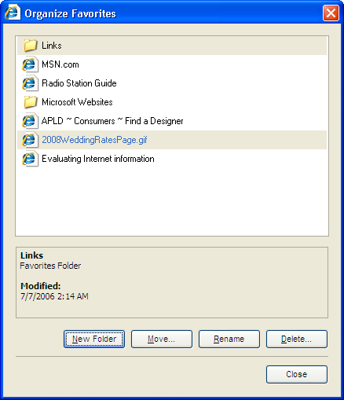

132. Use of multiple tabs [tabbed browsing]
Tabbed browsing refers to use of Internet browsers which allow multiple tabs [sub-Windows] to be opened within the Window the browser is open in, each tab displaying a web-page.
A new tab can be created by selecting "new tab" from the "file" menu or by using the keyboard shortcut [control+t]. When a new tab is created, the cursor begins in the new Window. Treat the new tab as if it were a routine browser Window.

Keyboard Shortcuts
Close a tab = [control+w]
Open result in a new tab from the address bar or search edit box = [alt+enter]
Open a new tab in the foreground = [control+t]
Opens quick tabs, a thumbnail view that can be navigated with [arrow keys] = [control+q]
Switch forward through tabs = [control+tab]
Switch backward through tabs = [control+shift+tab]
Switch to a specific tab number = [control+n] where n can be 1-8
Switch to the last tab viewed = [control+9]
Close other tabs = [control+alt+f4]
Opens the link in a background tab = [click the middle mouse button on a link]
Closes a tab = [click the middle mouse button on a tab]
Opens a new tab = [double-click the empty space to the right side of the last tab]

133. Use online thesaurus
There are many online thesauruses; however for the purpose of this guide www.thesaurus.com will be used because of its known accessibility. In Internet Explorer use the address bar [alt+d], or the open dialogue [control+d], or from the Start menu use the run dialogue [Window key, r], to type the URL www.thesaurus.com.
The webpage will open with the cursor in the search edit box. Type the desired word into the edit box and press [enter]. Remember if you are using a screen reader and it requires forms mode to be turned on this needs to occur prior to typing the desired word.
The search entry will appear as a visual heading on the page, with the number of thesaurus results alongside it. This is not an HTML heading and therefore screen readers will not find it using a headings search, such as [h] in JAWS. Instead search for non-linked text, [n] in JAWS, and listen for the search word followed by a number of "thesaurus results." Using the [n] again, will route the cursor to the first result, and then again for subsequent results. Use the [arrow keys] to read the content including: part of speech, definition, synonyms, and antonyms.
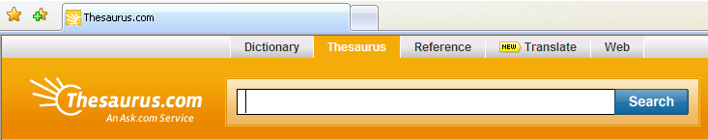

Keyboard Shortcuts
Route cursor to address bar = [alt+d]
Open new URL dialogue = [control+o]
Open run dialogue= [Window key, r]
Navigate to edit boxes on Internet = [e] JAWS/SystemAccess
Turn forms mode on = [enter] JAWS/SystemAccess
Navigate headings on Internet = [h] JAWS/SystemAccess
Navigate non-linked text on Internet = [n] JAWS/SystemAccess
Open links list dialogue = [insert+f7] JAWS/SystemAccess
Hint: www.thesaurus.com, www.dictionary.com, and www.reference.com are all run by the same corporation, therefore they can all be accessed from one another. To access the alternative resource click on the desired link, with a screen reader use the links list dialogue [insert+f7] with JAWS.

134. Use online dictionary
There are many online dictionaries; however for the purpose of this guide www.dictionary.com will be used because of its known accessibility. In Internet Explorer use the address bar [alt+d], or the open dialogue [control+d], or from the Start menu use the run dialogue [Window key, r], to type the URL www.dictionary.com .
The webpage will open with the cursor in the search edit box. Type the desired word into the edit box and press [enter]. Remember, if you are using a screen reader and it requires forms mode to be turned on this needs to occur prior to typing the desired word.
The search entry will appear as a visual heading on the page, with the number of thesaurus results alongside it. This is not an HTML heading and therefore screen readers will not find it using a headings search, such as [h] in JAWS. Instead, search for non-linked text, [n] in JAWS, and listen for the search word followed by a number of "dictionary results."
Using a screen reader, the user can also navigate by headings, [h] in JAWS. This will route the cursor to the beginning of each search result, use the [up/down arrows] to read content.

Keyboard Shortcuts
Route cursor to address bar = [alt+d]
Open new URL dialogue = [control+o]
Open run dialogue= [Window key, r]
Navigate to edit boxes on Internet = [e] JAWS/SystemAccess
Turn forms mode on = [enter] JAWS/SystemAccess
Navigate headings on Internet = [h] JAWS/SystemAccess
Navigate non-linked text on Internet = [n] JAWS/SystemAccess
Open links list dialogue = [insert+f7] JAWS/SystemAccess
Hint: www.thesaurus.com, www.dictionary.com, and www.reference.com are all run by the same corporation, therefore they can all be accessed from one another. To access the alternative resource click on the desired link, with a screen reader use the links list dialogue [insert+f7] with JAWS.
Techese: After the word in each result, there is a "hear" button with a picture of a speaker and sound waves. Clicking on this will play a voice recording of the word. If a screen reader is being used, press [h] to find the first entry, [down arrow] to the "Ø button" and press [enter].

135. Use online encyclopedia
There are many online encyclopedias; however for the purpose of this guide www.reference.com will be used because of its known accessibility. In Internet Explorer use the address bar [alt+d], or the open dialogue [control+d], or from the Start menu use the run dialogue [Window key, r], to type the URL, www.reference.com.
The webpage will open with the cursor in the search edit box. Type the desired word into the edit box and press [enter]. Remember if you are using a screen reader and it requires forms mode to be turned on this needs to occur prior to typing the desired word.
The search entry will appear as a visual heading on the page, with the number of refernce results alongside it. This is not an HTML heading and therefore screen readers will not find it using a headings search, such as [h] in JAWS. Instead search for non-linked text, [n] in JAWS, and listen for the search word followed by a number of "reference results." To access the results, use the [down] arrow to be sure to read from the beginning, by pressing [n] again will start about one sentence into the first result. Any subheadings on the page are marked as appropriate headings and can therefore be accessed in JAWS by using the [h] key or by the heading list dialogue [insert+f6].

Keyboard Shortcuts
Route cursor to address bar = [alt+d]
Open new URL dialogue = [control+o]
Open run dialogue= [Window key, r]
Navigate to edit boxes on Internet = [e] JAWS/SystemAccess
Turn forms mode on = [enter] JAWS/SystemAccess
Navigate headings on Internet = [h] JAWS/SystemAccess
Navigate non-linked text on Internet = [n] JAWS/SystemAccess
Open links list dialogue = [insert+f7] JAWS/SystemAccess
Hint: www.thesaurus.com, www.dictionary.com, and www.reference.com are all run by the same corporation, therefore they can all be accessed from one another. To access the alternative resource click on the desired link, with a screen reader use the links list dialogue [insert+f7] with JAWS.

136. Use multiple search tools to find information on the Internet
Different search engines use different indexes and therefore can provide different results for the same search. Search engines have different features that might be preferential to an individual user, it is recommended that a user experiment with three or four search engines to establish a prefence. Recommended search engines include www.google.com, www.yahoo.com, www.aol.com, www.msn.com. There are many more, go in search of them!

Keyboard Shortcuts
Navigate to edit boxes on Internet = [e] JAWS/SystemAccess
Turn forms mode on = [enter] JAWS/SystemAccess
Navigate headings on Internet = [h] JAWS/SystemAccess
Navigate non-linked text on Internet = [n] JAWS/SystemAccess
Open links list dialogue = [insert+f7] JAWS/SystemAccess

Hint: If the user accesses white text on a black background, try www.blackle.com.
Techese: Search engines use automated software programs known as spiders or bots to survey the Web and build their databases. Web documents are retrieved by these programs and analyzed. Data collected from each web page are then added to the search engine index. When you enter a query at a search engine site, your input is checked against the search engine's index of all the web pages it has analyzed. The most relevant URLs are then returned to you as hits, ranked in order with the most relevant results at the top

137. Use keyword and phrase searching and apply “+” and “-“ limiters
A keyword is a word that has been determined by the search engine to be significant to the page it is found on. Search engines are software programs, and each is designed differently as to how it recognizes keywords. The title of a page, for example, usually gives useful information about the subject of the page, and is usually indexed as a keyword. Words that are mentioned towards the beginning of a document are given more weight by most search engines. Words that are repeated several times throughout the document are also given more weight. Some search engines index every word on every page. Others index only part of the document.
Depending on the search engine, operators such as [+] and [-] can be used to refine a search. Using the [+] key between keywords will search for pages that have the first word in the search and include the secondary word as well. Using the [-] key between keywords will search for pages that have the first word but then exclude pages that contain the secondary word. Other operators including "AND", "OR", and "NOT" can also be used.

Keyboard Shortcuts
Navigate to edit boxes on Internet = [e] JAWS/SystemAccess
Turn forms mode on = [enter] JAWS/SystemAccess
Techese: The operators "AND", "OR", and "NOT" are Boolean operators named after George Boole, who first defined an algebraic system of logic in the mid 19th century. This system finds commonality or individuality between two things being compared. Think of the Venn diagram.
Techese: Web designers can set the keywords for each particular page in their website on their own by attributing Meta tags or Meta elements to their page. Search engines will find these tags and use them as the indexed keyword[s].

138. Cite sources, acquire exact URL
In order to cite sources from the Internet, the exact URL is necessary to reference. To obtain the exact URL of the current page access the address bar using [alt+d]. Copy the selection/URL in the address bar using [control+c]. The URL can now be pasted, using [control+v], in a document to be cited.

Keyboard Shortcuts
Route cursor to address bar = [alt+d]
Copy, file or content = [control+c]
Paste, file or content = [control+v]

139. Download files appropriately
Files are often posted online that require being downloaded in order to view. When a link is selected to download a file, a file download dialogue opens, asking whether to open or save the file. If the "save" button is selected, the save as dialogue will open [see #49 Navigate save as dialogue]. When the file has been successfully saved, a download complete dialogue will open, the user can choose to "open" the file, "open the folder" the file is in, or "close" the dialogue. The three options in the download complete dialogue can be accessed using the [tab] key and the [space bar] to activate the button.
Opening a file from the file download dialogue involves saving the file to a temporary Internet folder, and opening the file in the appropriate program. When the file is open it will function as any document or file in that program, giving the user the opportunity to save the file if desired. When the program is closed the file is automatically erased from the temporary Internet folder.
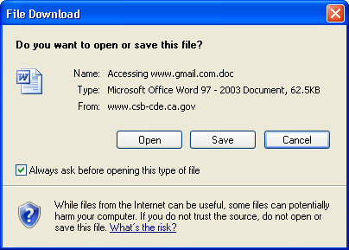

E-mail

140. Compose e-mail
For the purposes of this guide, Google's gmail will be used because of its known accessibility. When using gmail with a screen reader turn on "basic html," this can be done by opening the links list dialogue [Insert+F7], then pressing [b] to find "basic html."
- Find “Compose Mail” link. To do this, open links list dialogue [Insert+F7]
  - Within the “Links List” Dialogue Box
    - Find “compose mail,” using first letter navigation ‘c.’
    - Press [enter], or [tab] to the “Activate Link” button then press [enter]
- Let student get familiar with this page by navigating entire page with arrow keys.
- You are ready to compose an e-mail
  - Find “To:” edit field, screen reader will read this as “To:edit”
    - This can be done by pressing ‘e’ to advance edit fields until “To:” is found, or by pressing ‘f’ to advance form fields until “To:” is found.
    - Note: If user has difficulty remembering both of these commands, teach ‘f’ as form fields include edit fields.
  - Turn forms mode on, press [enter]
  - Type in desired e-mail account to whom you wish to send message.
  - (Tab) to subject line, screen reader will read as “Subject:edit.” Type in subject [name of e-mail].
  - (Tab) to the edit area, screen reader will read as “edit.”
    - Press [enter] to turn on forms mode. Type message in edit field [body of e-mail].
  - When you have finished typing your e-mail, [tab] to the “send button” and press the [space bar] or [enter].
    - Jaws will cue the user to activate by pressing the [space bar], users should use the [space bar] to activate buttons unless they are confident of the default button and then may use [enter].
  - Your message has been sent, gmail returns to the inbox
Note: Depending on the settings of your screen reader, the page may begin reading from top to bottom whenever the page is refreshed. In this case pressing [control] to pause the screen reader prior to navigating the page with command keys will help. If the user has let the screen reader go through most of the page prior to pressing [control] they may want to go to the top of the page [control + home] prior to navigating the page.

Keyboard Shortcuts
Open links list dialogue = [insert+f7] JAWS/SystemAccess
Navigate to edit boxes on Internet = [e] JAWS/SystemAccess
Turn forms mode on = [enter] JAWS/SystemAccess
Navigate headings on Internet = [h] JAWS/SystemAccess
Navigate non-linked text on Internet = [n] JAWS/SystemAccess
Navigate buttons on Internet = [b] JAWS/SystemAccess

141. Read received e-mail
For the purposes of this guide, Google's gmail will be used because of its known accessibility.
Gmail’s pre-set inbox has four columns with each conversation thread appearing in each row. If the conversation thread is expanded then individual e-mails represent each row. The column’s are: From, Subject, Attachment, and Date.
- Student can find messages using [down arrow key], to find the individual e-mails. Student will learn to recognize preceding links that are always on screen prior to the messages they want to read.
- Using the [f] key, the user can jump through links and buttons until they find ‘checkbox not checked.’ At this point the user can use the [down arrow key] to find the e-mail subject line which will refresh the screen with the desired e-mail.
  - At this point it is desirable to navigate the inbox with [arrow keys] so that user screen reader will acknowledge attachments.
- To open an e-mail press [enter] or [space bar] on the subject line link of desired e-mail.
  - If student knows the name of the e-mail they are searching for they could access it through the links list dialogue [insert + F7]
- The new e-mail opens in a refreshed screen, student can use page navigating functions to get to the content of the e-mail.
  - [n] can be used to find blocks of text. This can be the quickest way to get to the beginning of the text in the e-mail field.
- Returning to inbox
User can go to the links list dialogue [insert + F7] and find ‘inbox,’ or they can [tab] past the e-mail message to the ‘Back to inbox,’ link.

Keyboard Shortcuts
Navigate forms fields on Internet = [f] JAWS/SystemAccess
Open links list dialogue = [insert+f7] JAWS/SystemAccess
Navigate non-linked text on Internet = [n] JAWS/SystemAccess

142. Open an attached file
Attached files in e-mail programs are usually linked before the body of the text and after the sender, date, etc. information. An attachment can be navigated to using the [arrow keys] and be downloaded or opened using the [enter] keys. A save as dialogue will be opened that allows a user to download or open the file through the dialogue.

143. Send an attachment
For the purposes of this guide, Google's gmail will be used because of its known accessibility.
- After typing recipients into the ‘to’ field, and the title into the ‘subject’ field, user will hear ‘file upload edit’ with the next press of the [tab] key after ‘subject.’
  - The next tab will put the cursor on the ‘Browse’ button.
  - Jaws does not read this button, however if it is passed to the ‘Attach more files’ button and then a [shift+tab] is used to go back, the ‘Browse’ button will read ‘file upload edit’ by the screen reader.
  - This can be confusing. User will know they are on the button and not the edit field once they press the [space bar] to activate.
    - Pressing the [space bar] in the edit bar will simply say ‘space,’ if pressed correctly on the ‘Browse’ button a ‘choose file’ dialogue box will pop-up.
- Choose file dialogue box
  - This dialogue looks similar to the ‘Open’ dialogue box found in Microsoft and other applications, the cursor begins in ‘File Name: edit’ field.
  - [Tab] to ‘Look in:,’ screen reader will read as ‘Look in: combo box.’
  - Find desired location from tree view
    - Examples: Desktop, my documents, 3 ½ floppy, etc.
  - [Tab] to ‘folder view/list view’
  - Find desired file, press [enter]
    - Note: If student does not understand the idea of default buttons, they should [tab] to the ‘open’ button and press the [space bar].
  - Attach more files
    - The easiest way to navigate this screen is to use letter key [e] to move through edit boxes. Each attachment option will be labeled 1-10.
      - A single [tab] from the edit box will put the user on the ‘Browse’ button for that attachment.
      - When viewing ‘Attach more files’ page, user needs to [tab] to the ‘done’ button to return to message screen.
  - Oops, wrong attachment
    - If you inserted the wrong file, find it in the message screen and uncheck the box alongside it before you send your e-mail.

Keyboard Shortcuts
Navigate to edit boxes on Internet = [e] JAWS/SystemAccess
Navigate buttons on Internet = [b] JAWS/SystemAccess

144. Delete an e-mail
For the purposes of this guide, Google's gmail will be used because of its known accessibility.
- Find the message you wish to delete
- In the ‘from’ column the screen reader will read a check box along with the sender name [i.e. "Jerry check box not checked"].
- Check the box by press the [space bar]
- [Tab] or [shift+tab] [depending on whether you are closer to the beginning or end of your inbox: the buttons above and below the messages are the same] to the ‘combo box More Actions…’
  - Press [space bar] to select this combo box
  - Use arrow keys to find ‘Move to trash’
  - Select ‘move to trash’ by pressing [enter]
  - [Tab] to ‘go’ button, press the [space bar]
- Delete Forever
  - Find the ‘trash’ link on the gmail page [insert+F7] will go to the links list dialogue, ‘t’ for trash]
  - Check the messages you wish to delete
  - [Tab] or [shift+tab] to ‘Delete Forever’ button, press the [space bar]
- You can also delete messages after reading them
  - Find the ‘move to trash’ link in the screen in which you read the e-mail, press the [space bar].

Keyboard Shortcuts
Navigate checkboxes on Internet = [x] JAWS/SystemAccess
Navigate buttons on Internet = [b] JAWS/SystemAccess

145. Add contacts
For the purposes of this guide, Google's gmail will be used because of its known accessibility.
Gmail establishes all received and sent e-mail addresses in your contacts folder. In basic html format it is not possible to add a contact to the contact list independently.
- Open ‘contacts’ from the links list [insert+F7] or find the ‘contacts’ link
- Initially only ‘frequently mailed’ contacts are listed, if the contact you are looking for does not appear on this list, you will need to find the ‘all contacts’ link and press the [space bar] or activated it through the links list.
- Check each contact you wish to send e-mail to, when all desired contacts are checked, [tab] or [shift tab] to the ‘compose’ button.
- Screen will refresh with desired contacts inserted into the ‘To:’ field
- Contacts are searchable
  - Name or e-mail information can be entered in the second edit field on the page.
    - After entering information [tab] to ‘search contacts’ to view results.

Keyboard Shortcuts
Open links list dialogue = [insert+f7] JAWS/SystemAccess

Considerations

146. Exhibit legal and ethical behaviors when using technology, and understand consequences of misuse
Here are some ideas for guidelines on the topic:
- Understand and agree to the home school districts computer and Internet use policy and ethics.
- Work cooperatively and collaboratively with peers and others when using technology.
- Demonstrate positive, social and ethical behaviors when using technology.
- Discuss common uses of technology in daily life [provide advantages and disadvantages of those uses].
- Discuss basic issues related to responsible use of technology and information and describe personal consequences of inappropriate use.
- Identify capabilities and limitations of contemporary and emerging technology resources and assess the potential of these systems and services to address personal, life long learning and workplace needs.
- Research and evaluate the accuracy, relevance, appropriateness, comprehensiveness, and bias of electronic information sources concerning real-world problems.
- Practice responsible use of technology systems, software, and the Internet. Discuss consequences of misuse.
- Make informed choices among technology systems, resources, and services.

147. Understand implications of institution's acceptable use policy and consequences for misuse of technology
This standard will depend on the individual institution's acceptable use policy and associated consequences with its violation. Students should be clear on the consequences of misuse and the appropriate recommended use of technology. They should understand the procedure for voicing disagreements with the policy.

148. Express individual technology needs
Self-advocacy is an essential component of every person's life. The ability for a person with a visual impairment to identify their assistive technology needs will ensure their ability to search for resources and utilize assistive technology to facilitate independence and access to job and school endeavors.
In expressing their technology needs, a student should be familiar with all of aspects of their own assistive technology tools including hardware and software. They should be able to identify the purpose of their assistive technology, and specify how they use it to access information.

149. Identify technology resources
Students should identify sources of available adaptive technology, where to learn to use products, and how to problem solve and troubleshoot problems.
Product manuals and help menus/dialogues are often the best place to start when troubleshooting a problem. Online web forums and discussion groups are a good resource as well. Conversations will come up through searches, and can be read to identify similar problems. Posting a problem to a relevant discussion group can yield answers as well.
Websites, blogs, discussion groups, and e-mail list serves that are associated with a student's disability and relevant assistive technology are good sources for social interaction and opportunities to expand one's technology knowledge.
Assistive technology vendors and manufacturers are good resources for product questions. In the field of visual impairments, state special schools often have resources that provide information about relevant assistive technology, and some have specialists that can be contacted to answer questions. Teachers of students with visual impairments and Information Technology specialists can also be great resources for training and product information. Attending disability specific conferences or just the exhibit hall of these conferences can provide hands-on exposure to a variety of products.
A user should feel confident in their ability to learn about new technology and gain help to troubleshoot existing technology.

150. Use technology research and publishing tools to address real-world problems
Use technology resources [e.g., puzzles, logical thinking programs, writing tools, digital cameras, drawing tools] for problem solving, communication, and illustration of thoughts, ideas, and stories.
Use technology resources [e.g., calculators, data collection probes, videos, educational software] for problem solving, self-directed learning, and extended learning activities.
Determine which technology is useful and select the appropriate tool[s] and technology resources to address a variety of tasks and problems.
Design, develop, publish, and present products [e.g., documents, handouts, presentations] using technology resources that demonstrate and communicate curriculum concepts to audiences inside and outside the classroom.
Demonstrate an understanding of concepts underlying hardware, software, and connectivity and of practical applications to learning and problem solving.
Apply productivity/multimedia tools and peripherals to support personal productivity, group collaboration, and learning throughout the curriculum.
Collaborate with peers, experts, and others to contribute to a content-related knowledge base by using technology to compile, synthesize, produce, and disseminate information, models, and other creative works.

151. Evaluate information from the Internet for bias
The World Wide Web offers information and data from all over the world. Because so much information is available, and because that information can appear to be fairly “anonymous”, it is necessary to develop skills to evaluate what you find. When you use a research or academic library, the books, journals and other resources have already been evaluated by scholars, publishers and librarians. Every resource you find has been evaluated in one way or another before you ever see it. When you are using the World Wide Web, none of this applies as there are no filters. Because anyone can write a Webpage, documents of a wide range of quality, written by authors of the widest range of authority, are available on an even playing field.
When evaluating information, the following items should be considered:
- Authorship: Is the author well known in their field of study. If the author is not recognized, does the site provide biographical information about the author, contact information about the author can lead the reader to learning more about the authors accreditations. Was the author linked to, or recommended by another trusted author?
- The publishing body: Is the organization that published the work relevant to the information presented. Does the page where information is being gathered from, link from the organization's home page.
- Point of view or bias: Information is rarely neutral. When evaluating information found on the Internet, it is important to examine who is providing the "information" you are viewing, and what might be their point of view or bias.
- Referral to and/or knowledge of the literature: Does the author/site provide knowledge of theories and techniques? If so, are these referenced in a bibliography? If the information being presented is controversial, does the author/site acknowledge this?
- Accuracy or verifiability of details: Can facts and background information be verified in full or in part by other websites or information sources?
- Currency: When was the information published online, is the website and its content current?

152. Explore issues of ergonomics and safety in using computers
The below listed issues are referenced from www.hp.com/ergo

Work area setup and organization
- Seat height: you should be able to plant your feet firmly on the floor.
- Seat height: elbow height should be near your keyboard's home row.
- Footrest, if you need one.
- Chair back angles and lower back support: your back should be well supported.
- Keyboard height: home row should be near your elbow height.
- Keyboard slope: wrists should be in a comfortable, neutral position.
- Pointing device: should be placed to the immediate left or right of your keyboard.
- Optional forearm support: shoulders should be relaxed and forearms evenly supported.
- Distance from monitor, height, and angle: should allow your head to be balanced comfortably over your shoulders.
- Document holder, phone, and reference materials: frequently used items should be within easy reach.

Safety Checklist:

Seated position
- Have you found a range of seated postures that are most comfortable for you?
- Are you changing postures within your "comfort zone" throughout the day, especially in the afternoon after several hours of work?
- Are your feet firmly planted?
- Are the undersides of your thighs near your knees free of pressure?
- Are the backs of your lower legs free of pressure?
- Is there sufficient space under your work surface for your knees and legs?
- Is your lower back supported?

Shoulders, arms, wrists, and hands
- Are your shoulders relaxed?
- Are your hands, wrists, and forearms in their neutral comfort zone?
- If you use arm supports, are they adjusted so that your shoulders are relaxed and your wrists are in a comfortable, neutral position?
- Are your elbows in a zone that is near the height of your keyboard's home row?
- Do you avoid resting your hands and wrists while typing or using the mouse?
- Do you avoid resting your hands and wrists on sharp edges?
- Do you avoid cradling the phone between your ear and shoulder?
- Are items you use frequently, such as your phone and reference materials, easy to reach?

Eyes
- Do you rest your eyes frequently by focusing on a distant point?
- Do you get your eyes examined regularly by a vision care specialist?
- Do you blink enough?
- If you wear bifocals, trifocals, or progressive addition lenses, do you avoid tilting your head back to see the monitor?
- Have you considered having glasses prescribed that are specially suited for working with a computer monitor to avoid awkward postures?

Typing style
- Are you training yourself to lighten up when you find you are pounding on the keys?
- If you are not a touch typist, have you been taking typing lessons?
- Are you training your fingers to relax when you find them tense, including those not touching the keys and pointing device, as well as those actively typing and pointing?
- Do you use your whole arm to reach for keys not located near the home row?

Keyboard and pointing device
- Is your keyboard positioned directly in front of you?
- Are your keyboard height and slope adjusted so that your wrists are in a comfortable, neutral position and your shoulders relaxed?
- If you are typing with the keyboard on your lap, are your shoulders relaxed and your wrists in a comfortable, neutral position?
- If you are using a mouse or detached trackball, is it placed to the immediate right, left, or directly in front of your keyboard?
- If you are using a pointing device, are you holding it loosely, with a relaxed hand?
- Do you let go of your pointing device when you are not using it?
- Are you using a light touch when you click the buttons on your pointing device, trackball, touchpad, or pointing stick?
- Are you cleaning your mouse or trackball frequently?

Monitor
- Is your monitor positioned in front of you and at a comfortable viewing distance, about arm's length? Or if you look at a paper document more than your monitor, is your document holder in front of you with your monitor to one side?
- Have you eliminated glare and bright reflections on your monitor, without compromising your posture?
- Is your monitor's entire viewing area located just below your eye height?
- Is your monitor tilted so your face and the monitor are parallel?
- Have you adjusted the brightness and contrast controls to improve the quality of text and graphics?
- Is your document holder positioned near the monitor, at the same distance, height, and angle as the monitor?

Notebook Computer
Note: To reduce the possibility of heat-related injuries or of overheating the computer, do not place the computer directly on your lap or obstruct the computer air vents. Use the computer only on a hard, flat surface. Do not allow another hard surface, such as an adjoining optional printer, or a soft surface, such as pillows or rugs or clothing, to block airflow. Also, do not allow the AC adapter to contact the skin or a soft surface, such as pillows or rugs or clothing, during operation. The computer and the AC adapter comply with the user-accessible surface temperature limits defined by the International Standard for Safety of Information Technology Equipment [IEC 60950].
- Do you change postures frequently, seeking a balance between relaxed shoulders and a comfortable neck posture?
- Do you avoid resting your wrists on your thighs while typing?
- When using a keyboard on a couch or bed, do you avoid reclining too far to avoid neck fatigue?
- When computing for long periods, have you tried lifting your notebook computer with a block or book and using an external keyboard and pointing device?

General prevention
- Do you take breaks and walk around briefly, at least once per hour?
- Do you exercise regularly?
- Periodically, do you take inventory of the stress in your life and change what is within your control to change?
- If you experience any symptoms that you think may relate to your using a computer, either at work or other times, have you consulted a doctor and, if available, your company's health and safety department?

153. Identify ways in which technology is used in the workplace and in society
Technology is fast becoming an essential component to many jobs. In this regard, the use of technology whether it be high-tech or low-tech solutions, is particular to the job at hand. In researching career options for students, discover the types of technology used in those particular professions. The checklist can be a good resource to determine how far a student is from obtaining those skills. Remember that on the job training may cover many skills to, and sometimes the technology within a field is not always necessary.
Society is also becoming ever more technology dependent. Using computers and peripheries for communication and leisure are commonplace. Identifying social networking websites, and gaining access to telephones to talk and text are important contributions to a person's socialization and overall mental and emotional health.

BrailleNote Conversions

154. Convert Keysoft files to MS Word
Users who take advantage of the BrailleNote as a braille note-taker need to convert files in order to have access to them on a computer. This is a necessary step to ensure formatting, file transfer, and the ability to turn in assignments over the Internet.
The following process can be followed in order to complete file conversion to Microsoft Word format:
- From the BrailleNote "main menu" [1+2+3+4+5+6+space], open the "file manager" menu [f] then the "translation" menu [t].
- To export a document, press [e+space], the original document will remain unchanged.
- When prompted, select the drive/folder where the file to export is stored
- Select the file name
- Select the drive to which you wish to export the file
- KeySoft will prompt to export from file, or export from the serial port, select file [f]
- At this point KeySoft will prompt for what type of file is desired, use [space+3+4] to navigate options

155. Transfer files between BrailleNote and PC
The easiest way to transfer files between a note-taker and a computer is to use an external device, whether this is a compact flash card, secure digital card, or USB device. Another way to establish a connection between the BrailleNote and the computer is to use a serial cable and use the software program Active Sync. This program will open a connection between the devices that will allow a user to access files from the note-taker on the computer. Though most note-taker files are not compatible to run on a computer, the files can be identified, sorted, and backed-up using a computer.

156. Use BrailleNote as electronic Braille display with PC
The BrailleNote can function as an electronic braille display supported by a screen reader. To connect the BrailleNote to the computer, use the serial communication cable. This cable was provided at the time of the purchase of the BrailleNote.
To access the braille terminal from the BrailleNote, go to the main menu and press [t], or press [backspace + enter + t].
In addition to setting up the note-taker, the screen reader needs to be set to recognize the BrailleNote as a braille display. In the JAWS screen reader application, from the "options" menu, select the "Braille…" menu, and [tab] to the "Add braille display" button. A dialogue will open where a checkbox for the BrailleNote should be checked prior to selecting the "ok" button.

That's All Folks! At least for now

