To Infer or Not Infer – Accessible Version
Original worksheet from www.HaveFunTeaching.com

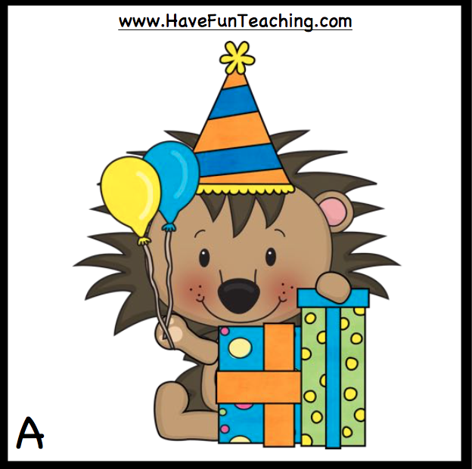

Description: A smiling cartoon lion sitting by wrapped boxes, holding two balloons wearing a pointed party hat.

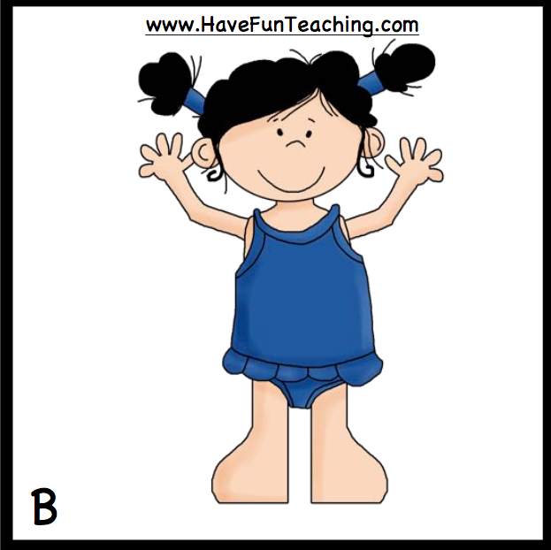

Description: Smiling girl in pigtails wearing a blue swimsuit with waving hands raised in the air.
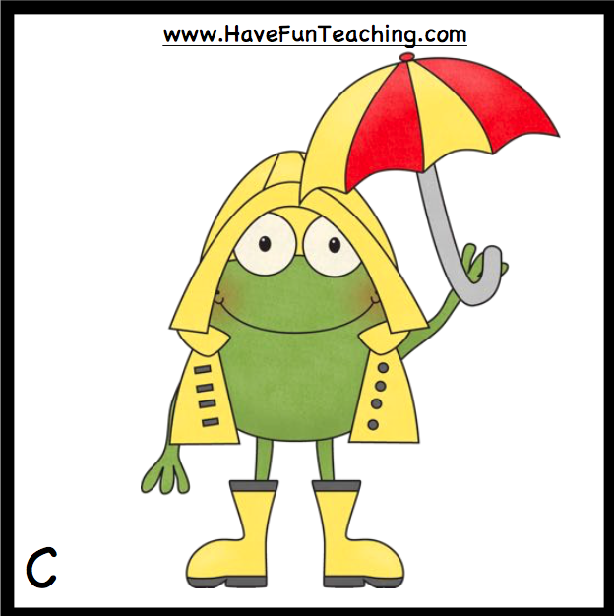

Description: Smiling cartoon frog is wearing yellow coat, yellow rubber boots, and holding a striped umbrella.
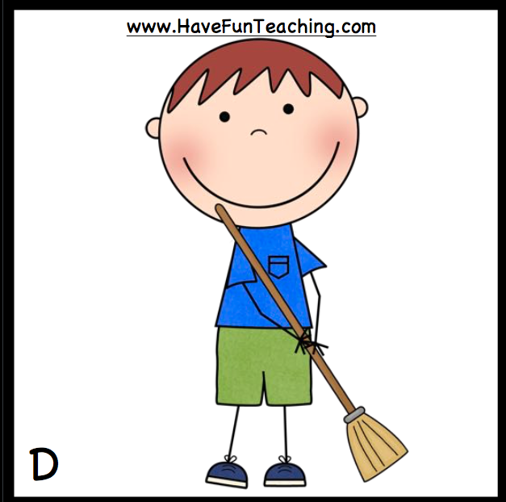

Description: Smiling cartoon boy sweeping with a broom.
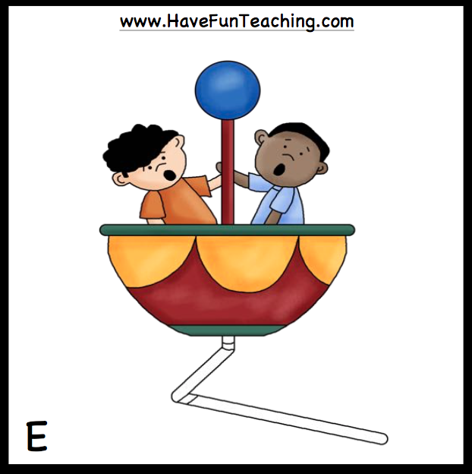

Description: Two cartoon boys with wide open mouths hanging onto the pole while sitting in a carnival ride.

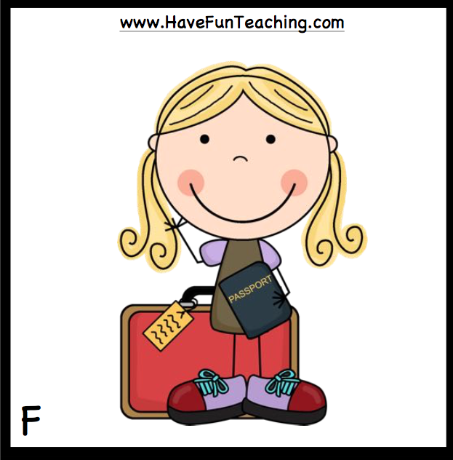

Description: A smiling, waving cartoon girl holding a passport and standing in front of a suitcase with a tag on it.

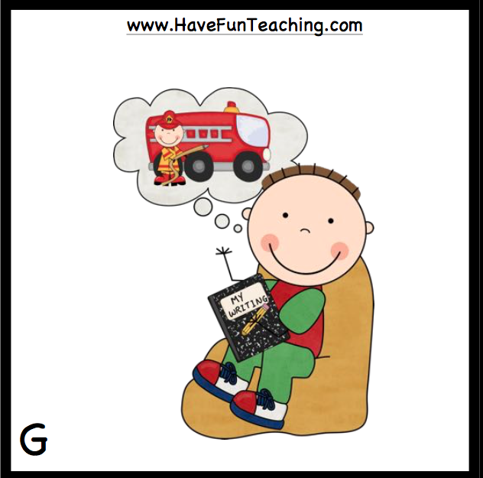

Description: A smiling cartoon boy sitting in a chair holding a book with the title, "My Writing" and a thought cloud above his head with the image of a fireman standing beside a red firetruck.
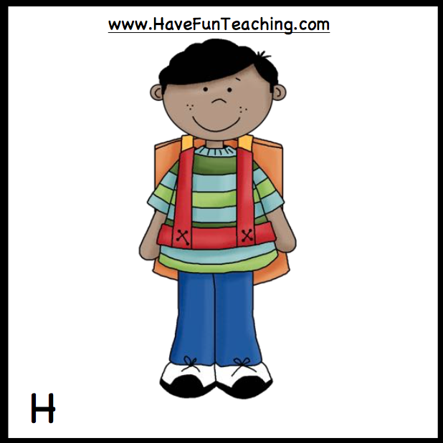

Description: A smiling cartoon boy wearing a striped shirt standing with a backpack on his back.

