Fire Service: Ideas for a theme based approach
- Fireman Sam Story Bucket
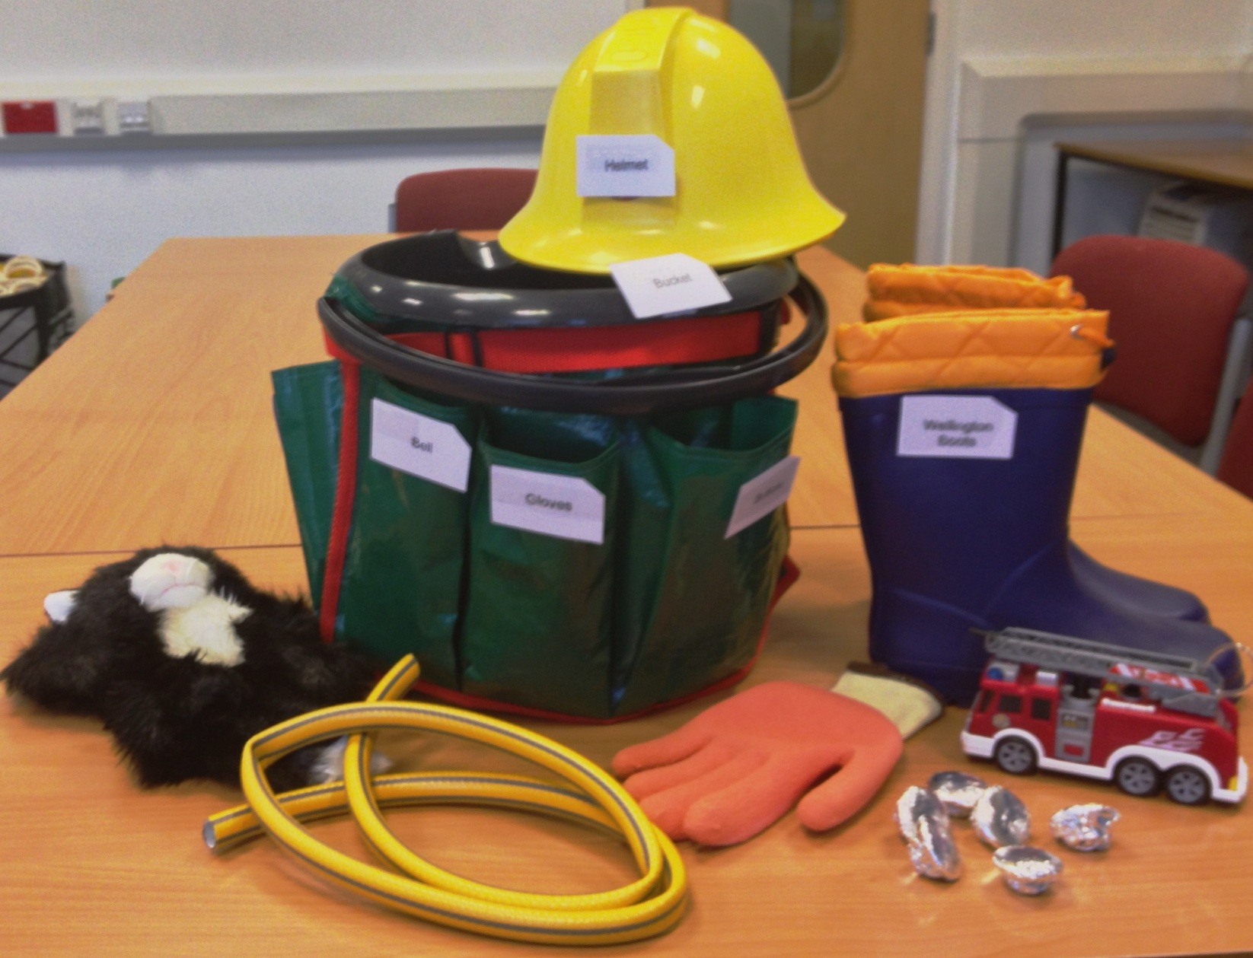
Picture of story bucket with objects (fire station, wellington boots, buttons, hose pipe, cat, fire engine toy)
This is a simple idea which is not dissimilar to the idea of story bags. However, I think children will love this bucket and it is an inclusive resource which would enhance other children’s literacy access too. It is really important to use real objects whenever possible, they offer more meaning than plastic toys, however sometimes using a plastic toy is the only option in place of the real object, e.g. the fire engine! Try and find a good model with some working parts to add to the child’s exploration and enjoyment during the story.
Fireman Sam is used here for the first story bucket idea, but the story could be changed and items and labels associated with each new story added.

Materials:
- 1 bucket
- 1 bucket apron £2.99 http://www.amazon.co.uk/Darlac-Bucket-Pocket-and-Apron/dp/B003VRHQEM/ref=sr_1_1?ie=UTF8&qid=1387364639&sr=8-1&keywords=bucket+apron
- I toy fire engine
- I Fireman Sam helmet
- 1 belt with buckle
- 1 cat puppet or soft toy to rescue (optional)
- 1 pair of gloves
- 1 bell
- 6 shiny buttons, cut up 6 circles of card and cover in shiny paper or foil
- I piece of hosepipe, (cut from large reel)
- 1 pair of wellington boots
- Set of labels for each item in the story bucket (at child’s print size or presented in Braille)
- Self adhesive velcro
Assembling the story bucket
- Attach the bucket apron around the bucket; you may need to knot it into position if it is a little big
- Add a small piece of velcro to each pocket front
- Add velcro to the back of each label and attach a label to each pocket plus add one to the edge of the bucket
- Place the items in each pocket and add the helmet and wellington boots to the bucket – remember to label the helmet and wellington boots too
Further option – record the name of each object to a recordable peg and peg on each pocket label for the child to play back. (Recordable pegs available from TTS Educational Suppliers. http://www.tts-group.co.uk/shops/tts/Products/PD1838921/Recordable-Pegs/)
Activity suggestions and ideas–depending on the child’s development and offered as ideas
- Read the story, child to feel the objects whilst reading the story
- Place the objects back in the correct pocket, read the initial letter sound, (listen to the recordable peg to aid location)
- Mix the objects up and place in the wrong pockets for the child to replace correctly
- Detach the labels from the pockets and ask the child to place the objects in the pockets with their corresponding label
- Dress up and role play the story of Fireman Sam using the objects from the bucket
- Make a model of a fire engine from cardboard
- Fill the bucket with objects beginning with F for Fireman from around the environment
- Repeat filling the bucket with objects beginning with S for Sam, H for hosepipe, G for gloves etc
- Make up a poem using each letter of Fireman Sam. Read the poem onto recordable pegs and attach to each pocket of the bucket apron
Numeracy
- Count the buttons, find six objects from around the environment that begin with B and place in the bucket, (count out 5 buttons and find 5 objects, count 4 buttons and find 4 objects etc, using a different letter e.g. 5 objects beginning with F, 4 objects beginning with S)
- Use the hosepipe as a unit of measurement to measure the width, length of the room, the length of the table, etc.
- Order the objects in the bucket by size, largest to smallest
- Order the objects in the bucket by weight, lightest to heaviest
- Categorise the objects by shape, material made of and items worn

Fire Service – more ideas for a theme based approach
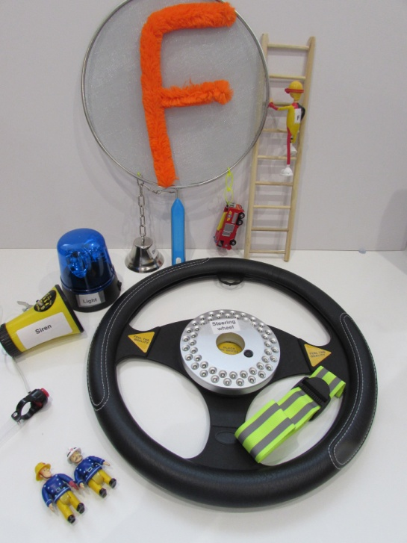
Picture of steering wheel, horn, flashing light, large letter F, models of Fire Officers
- Feel water (warm, cold, cool.)
- Use water spray to spray tepid, warm water on child’s hands and feet
- Feel hose pipe, unwind, wind up on reel, use hose pipe attached to water supply to spray grass outside school
- Represent the hose pipe by feeling rubber piping, or if possible feel a real hose pipe
- Use cardboard tube and paint to look like a hose pipe, cover with textured paper or bright coloured, fluorescent shapes
- Use plastic drain pipe and pour water down the pipe, experiment and have fun
- Make spiral patterns to represent the hose pipe in its wound up state using string (different thicknesses) or wikki stix. Make a collage of different sized reels or spiral patterns using string, rope, cord, wikki stix etc.
- Play with yo-yo’s, (yo-yo’s with lights, sounds.)
- Feel heat from fire
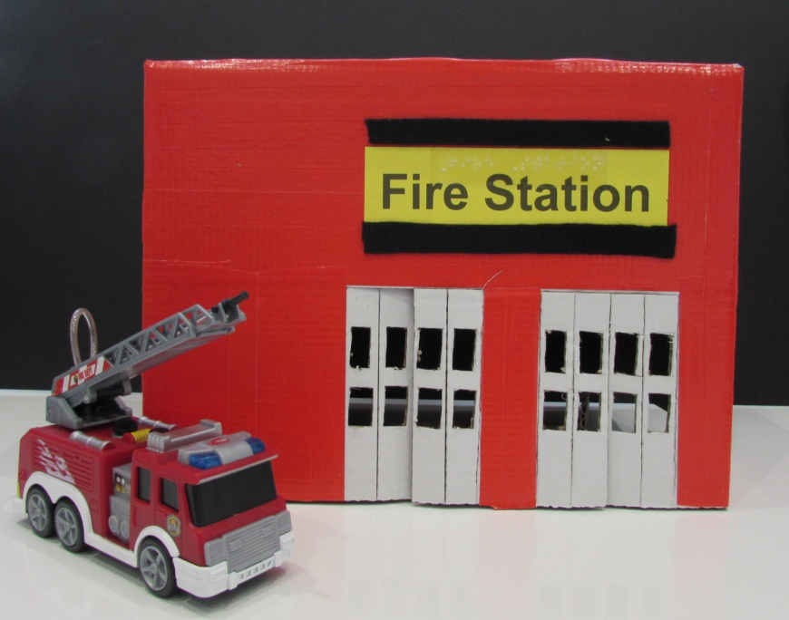
Model of fire station and fire engine
- Decorate wellington boots with fluorescent shapes, hang up as a large mobile in classroom
- Explore model fire engine, ladder, real ladder, blue flashing lights
- Make tactile book about fire engine
- Feel a fireman’s helmet, the shiny buttons on the fire person’s uniform
- Children to decorate wellington boots with fluorescent shapes, hang up as a large mobile in classroom
- Make large card buttons covered in silver foil or shiny, fluorescent paper
- Dress up in uniform of fire woman/man
- Wear wellington boots and make footprints in textured paint
- Feel and explore thermal gloves and waterproof jacket and trousers
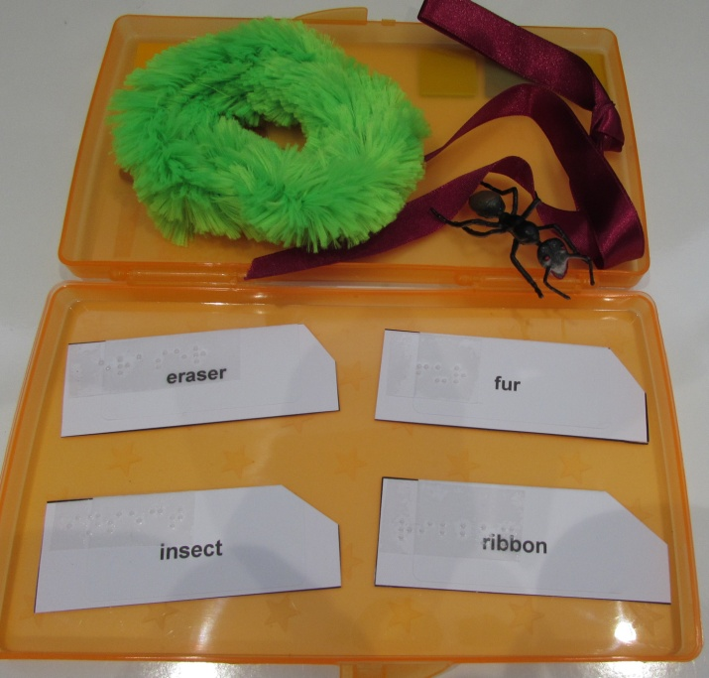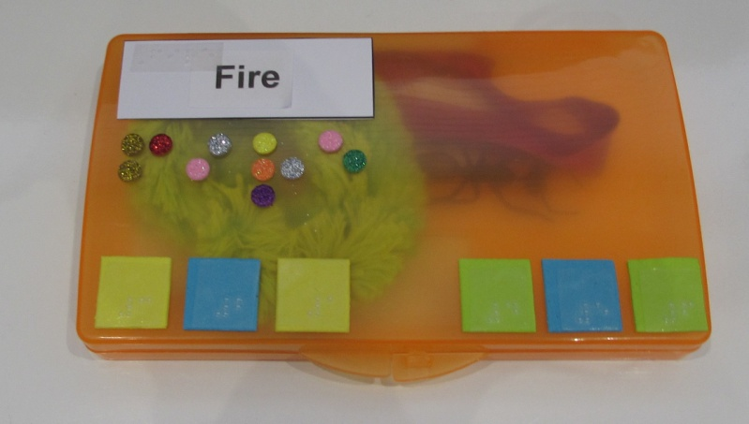
‘Fire’ themed word boxes
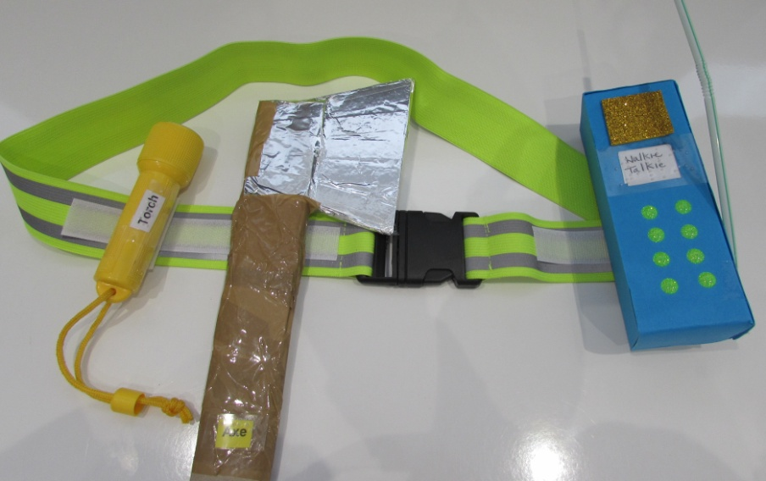
Fire Officer’s belt, walkie talkie, torch, axe

