BRAILLE
CODE

Braille Code is our learning mode. To share in our fun, here’s a treat for one.
But to eat your treat, you must decode the Braille code.

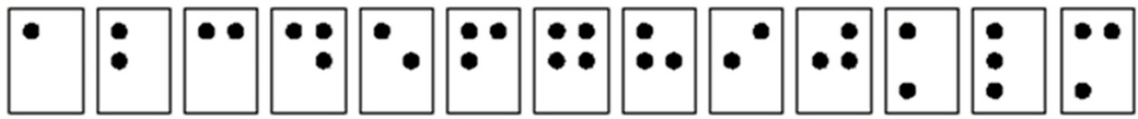
a b c d e f g h i j k l m
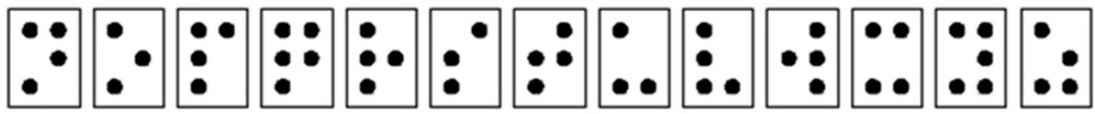
n o p q r s t u v w x y z
Braille dots are numbered as 1, 2, 3, 4, 5, and 6, as illustrated. Braille does not have
a separate alphabet of capital letters as there is in print. Capital letters are indicated
by placing a dot 6 in front of the letter to be capitalized.

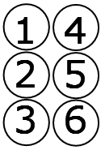
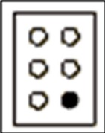
Dot 6 represents a capital letter.

